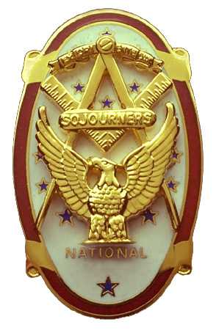
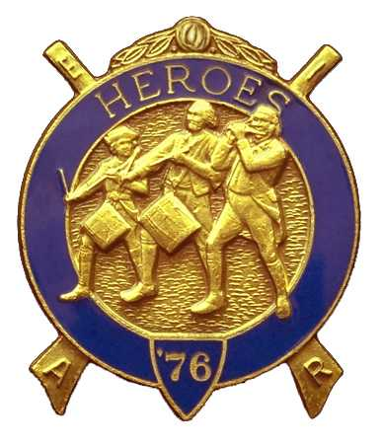
Olympic Chapter No.539
National Sojourners
And
Marvin Shields Camp of Heroes of ‘76
Edwin C. Marion P.O..Box 364
Secretary?Treasurer Forks, WA 98331-0364
edwin028@centurytel.net http://www:telebyte.com/masons/sojourn/ (360) 374-6777
October 27, 2010 Meeting Minutes

Grip - N'- Grin portion started at about 5:30 PM, with Sue Porter being ahead of everyone. She had to arrange her raffle prizes. Most everyone ordered dinner while they were greeting their friernds. Once dinner was over, our distingushed President Paul J. Carmean opened the meeting with the “Toast to the Flag” followed by thr Pledge of Allegence to the flag. This in turn was followed with President Paul officially opening the meeting accoding to Orders of Cermonies, page 3.. Once again, great job WB Paul.

Still looking for some guest speakers. If you know of any person who may have an interesting subject they could speak on, just let me know. They don't have to be mason. If I'm given thieir name, I will invite them. This could be a person we could schedual for a date down the line. Look around brothers and ladies and see if you don't know somone who would be willing to be one of our guest speakers.

Our treasury is still solvent. At this time we have $1707.22 in our operations funds. We also have $50 in our YLC fund, with $58.00 in our JROTC fund. A $50.00 donation was added to our uniform fund bring the total uniform fund to $450.00. The names of the persons making these donations to our uniform fund are kept anonymous. Once we have the rules established on the unifoirm fund, we will be assisting some of our brothers
in purchasing uniforms for Heroes of '76.

On the Sojourners website, it was noticed that we will be honored by a visit of our Nationasl President at our 25 May meeting. To get into every portion of the Sojourners websit, consult the message from MWB Wayne Smith. There is one part of the website that you must be registered to get it open. Just follow the instructions that MWB Wayne has setforth in his message. It works, aleast it did for me.

When I informed the members that I had made a donation to cover the brothers that hadn't paid their 365 dues yet, I was reminded that the chapter voted to cover MIP's and 365 dues life memberships. I must admit this had slipped out of my mind. I guess you can say I have no excuse, other than just forgetting something like this.

Once again, we will be holding a “White Elephant Gift” program. Each person attending the meeting will be requested to bring an inexpensive wrapped gift. These will be drawn for by all. If you are a couple, and you both want to take part in this program, you bring two gifts, one for each of you.. It was alot of fun last year. Remember we will be meeting on15 December for our December meeting.

Another $55.00 was raised by Sue Porter's raffle program, Thanks very much Sue.

Once again we didn't have anyone that could give us “Old Glory Speaks”. Steve you are just going to have to come back and do “Old Glory” for us. Of course one of our new heroes could learn “Old Glory Speaks” for us.

There being noting further business to come before the meeting, our President Paul closed the meeting according to the Order of Ceremonies, page 8.
Don”t forget that our November meeting will be held on NOVEMBER 17th because of the Thanksgiving Holiday.

_______________________________________________________________________

HERE IS THE LIST OF YOUR OFFICERS FOR 2010-2011

OLYMPIC CHAPTER MARVIN G. SHIELDS CAMP

President------ ------CPO Paul J. Carmean Commander-----Mr. Darel E. Maxfield Sr.
360-928-3358 pjcarmean@q.com 360-374-9330 maynard@olynet.com

1st Vice President---LCD Dr. John R. Richardson Chief of Staff-------------GYSGT C. Earl Riggs
360-385-3117 djohnone@cablespeed.com 360-380-4944 jarhead1949@netzero.com

2nd Vice President--Joe G. Anticevich A/C of Staff-----Joe G. Anticevich
360-432-4843 acn@olypen.com 360-432-4843 ace@olypen.com

Chaplain-----SGT Fredrick W. Johnson Chaplain---SGT Fredrick W. Johnson
360-385-3130 fjohnson-30@q.com 360-385-3130 fjohnson-30@q.com

Secretary-----LtCol Edwin C. “Ed” Marion Adjutant—---LtCol Edwin C. “Ed” Marion
360-374-6777 Edwin028@centurytel.net 360-374-6777 Edwin028@centurytel.net

Area Representive and Regional Representive
SMSGT Robert S. Colton
206-439-2320 rshgcolton1@netzero.net
Deputy Area Representive and Regional Representive
LtCol Wendell A. Dutt
253-565-5264 wadutt@comcast.net

NEXT MEETING

EVENING MEETING
17 November 2010
Pardise Restaurant
Sequim, WA

Our meeting this month will be held on the 17 November 2010.. Our November meeting will be at 1800 Hours (6 PM), our normal meeting time and day of the week. Our November meeting will be on 17 November and our December meeting will be on 15 December, and we will be having our “White Elephant” Christmas gift program at our 15 December meeting.

DIRECTIONS TO THE MEETING PLACE. No matter from which direction you come, as you must come by Highway 101, east or west, when you see the road sign for Sequim Avenue, you take that exit. If you come from the east, turn right onto Sequim Avenue, if you come from the west, turn left onto Sequim Avenue. This will place you heading north along Sequim Avenue. You will stay on Sequim Avenue until you reach the restaurant, which will be approximatly one mile. There will be one traffic light , which is at Main Street, this means you are about half way there.

Approximatly ¾ miles along the way, you will come to Sequim High School on your left. It is a large brick building. There will be a chain-link fence around the practice field part of the High School. At the end of the fenced off area is a cross street, which forms a three way intersection, or a “T” bone intersection. The Paradise Restaurant is on the north west corner of the intersection. The parking lot is in the front, so just pull into the parking lot. Come into the restaurant, walk straight back to the private dinning room. This is where we have our meetings.

Now remember, YOU DON'T HAVE TO COME FOR THE DINNER, YOU DON'T EVEN HAVE TO BUY COFFEE. If you need a ride to and from the meeting, give me a call and I will arrange for someone to pick you up and take you home. Call me at 360-374-6777.

HAPPY BIRTHDAY

Edwin C. Marion 8th
Graham Kent 25

Happy Birthday to you both, may your day be a memorable one. Hope to see you at Chapter soon? And ladies please send me the month and day of your biurth so I can post it for you. Don't send the year of birth.

BLUE LODGE

Meetings: Quilcene-Jefferson #107 will meet on 1 November and 6 December., dinner 6:30 lodge 7:30, Installation 6 December at 2:00 PM; Mt. Olympus #298 on , 3 November and 1 December, dinner 6:30 Lodge 7:30; Pt. Angeles #69 on 9 November and 14 December, dinner 6:30 lodge 7:30 Installation 4 December at 3:00 PM.; Sequim #213, 11 November and 9 December, dinner 6:30 lodge 7:30, Installation 7:30 PM 20 November;. Pt Townsend #6, 10 November 8 December, dinner 6:30 Lodge 7:30, Installation 11 December 7:00 PM..
HEIP NEEDED

Brothers, please check this out and see if you can be of help to me on this. Following Pacific Beach, I realized that I need help, or I may have to pass this job on to someone else. I will be 83 in December, and I need to return to being just the Secretary, not the Quatermaster and Storekeepoer. Some of you please step forward and take over some of these jobs that have nothing to do with being the Secretary.

WISH LIST

- An enclosed trailer to haul all our equipment needed for our “Build the Flag” program. My truck has short bed which will not hold everything needed for our Hero Programs.
- An awards chairman as suggested by David MacNeill. David can't take the job as he has moved out of area, and is travel most of time.
- We need more members in uniform. We are working on a solution.
- Guest speakers are needed very badly. Subject is of their choosing, but they must work for dinner only, can't afford pay them more than that.
- More brothers and their wives at our meetings
- A phone committee. Open not only to brothers, but to their ladies too.
- A slide projector. I have one but I need two, I have two sets of slides. I will even pay you for a used slide projector. If you have one and want to get rid of it, just give me a call. I'll be there with the money in my hot little hand.
- Sure could use someone to take over the responceablity for some of this equipment I have. Sometimes it gets more than an 82 year old can handle.
- Somone to take over the “Traveling Bar”.

