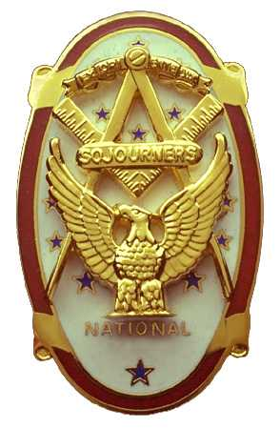
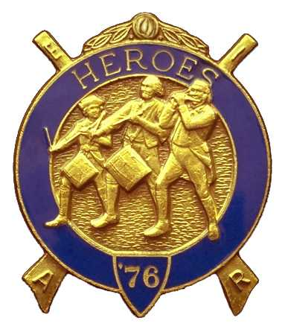
Olympic Chapter No.539
National Sojourners
And
Marvin Shields Camp of Heroes of ‘76
Edwin C. Marion P.O..Box 364
Secretary?Treasurer Forks, WA 98331-0364
edwin028@centurytel.net http://www:telebyte.com/masons/sojourn/ (360) 374-6777
22 September 2010
Meeting Minutes

As we have done in the past, our meeting was opened with our President, Paul Carmean, doing the “Toast to the Flag.” Very nice job, Paul. This was followed by President Paul leading us in our pledge of Allegiance to the Flag.

We had no Guest Speaker. Sure wish someone would take over the job of providing us with Guest Speakers. Sorry, but I am not too good at picking people to be speakers. If you can handle this type of work then feel free starting to line us up with some speakers.. I will be glad to contact people that you may want to hear speak, I just need their names.

Our treasury is still solvent. We have at this time $1818.92 in our operations fund. Not counting the funds in operations, we have $50.00 in our YLC fund, $58.oo in our JROTC fund, $280.00 committed to MIP and Initiation, and $400.00 in our uniform fund, for a total of $2606.92. Most of this money, I would say about 99% of it is due to the efforts of Sue Porter's raffle program.

Well, I guess you know we have put another North West Area Encampment behind us. There was six of us plus five wives. The only single was Darel Maxfield, who isn't married. Not as big of a showing as we have had in the past, but we were the Chapter with the most members.

Our Chapter, on Friday evening, was called upon to do the “Build the Flag”. And build it we did with Paul Carmean starting things off with “A Toast to the Flag” followed by a pledge Allengence. Then David MacNeill gave his Common Man and Patroitism monologue. This was followed by the “Build the Flag”, narrated by Darel Maxfield, and Paul Carmean and David MacNeill handling placing the stars. Ed Marion did the introductions. Not too bad of a job by all members.

On Saturday we took part in the Heroes Degree. In the second section Darel Maxfield did the part of the Commander with Ed Marion acting as Adjuant for the initiation of Bob Caruthers. Welcome aboard Bob. We did the “Distruction of the Flag” in the afternoon. Our national commander,Col. Edward W. Nolte, did the part of the Commander of the detail. Thank you sir, your assistance was very much appreciated.

On Saturday evening at the banquet, Bob Caurthers was taken into the Lewis and Clark Expeditionary Force. Welcome aboard Bob, I think you will enjoy being an all around member of Heroes.

We all hit the road following the farwell breakfast. Plans are underway to prepare for our NW Area Encampment for next fall. Why don't you start to make plans to attend and join us in the fun and pleasure next year.

At our meeting on 18 August, we voted to join in with other Chapters to assist at bringing the National Convention to the Seattle area. We sure can use all the help we can get. This will mean a lot of hard work and time for all Chapters. If I understand correctly, Joe Illes will be heading up this program. Lets all get out and help Joe make this a success.

There being nothing else to come before the Chapter, we slowly folded our tents and faded away following Sue Porters raffle.
_______________________________________________________________________

HERE IS THE LIST OF YOUR OFFICERS FOR 2010-2011

OLYMPIC CHAPTER MARVIN G. SHIELDS CAMP

President------ ------CPO Paul J. Carmean Commander-----Mr. Darel E. Maxfield Sr.
360-928-3358 pjcarmean@q.com 360-374-9330 maynard@olynet.com

1st Vice President---LCD Dr. John R. Richardson Chief of Staff-------------GYSGT C. Earl Riggs
360-385-3117 djohnone@cablespeed.com 360-380-4944 jarhead1949@netzero.com

2nd Vice President--Joe G. Anticevich A/C of Staff-----Joe G. Anticevich
360-432-4843 acn@olypen.com 360-432-4843 ace@olypen.com

Chaplain-----SGT Fredrick W. Johnson Chaplain---SGT Fredrick W. Johnson
360-385-3130 fjohnson-30@q.com 360-385-3130 fjohnson-30@q.com

Secretary-----LtCol Edwin C. “Ed” Marion Adjutant—---LtCol Edwin C. “Ed” Marion
360-374-6777 Edwin028@centurytel.net 360-374-6777 Edwin028@centurytel.net

Deputy Area Representive and Regional Representive
LtCol Wendell A. Dutt
253-565-5264 wadutt@comcast.net

NEXT MEETING

EVENING MEETING
27 October 2010
Pardise Restaurant
Sequim, WA

Our meeting this month will be held on the 27 October 2010.. Our October meeting will be at 1800 Hours (6 PM), our normal meeting time and day of the week. Our November meeting will be on 17 November and our December meeting will be on 15 December, and we will be having our “White Elephant” Christmas gift program at our 15 December meeting.

DIRECTIONS TO THE MEETING PLACE. No matter from which direction you come, as you must come by Highway 101, east or west, when you see the road sign for Sequim Avenue, you take that exit. If you come from the east, turn right onto Sequim Avenue, if you come from the west, turn left onto Sequim Avenue. This will place you heading north along Sequim Avenue. You will stay on Sequim Avenue until you reach the restaurant, which will be approximatly one mile. There will be one traffic light , which is at Main Street, this means you are about half way there.

Approximatly ¾ miles along the way, you will come to Sequim High School on your left. It is a large brick building. There will be a chain-link fence around the practice field part of the High School. At the end of the fenced off area is a cross street, which forms a three way intersection, or a “T” bone intersection. The Paradise Restaurant is on the north west corner of the intersection. The parking lot is in the front, so just pull into the parking lot. Come into the restaurant, walk straight back to the private dinning room. This is where we have our meetings.

Now remember, YOU DON'T HAVE TO COME FOR THE DINNER, YOU DON'T EVEN HAVE TO BUY COFFEE. If you need a ride to and from the meeting, give me a call and I will arrange for someone to pick you up and take you home. Call me at 360-374-6777.

HAPPY BIRTHDAY

Steve Seteroff 6th

Happy Birthday VWB Steve, may your day be a memorable one. Hope to see you soon? And ladies please send me the month and day of your biurth so I can post it for you. Don't need the year.

BLUE LODGE

Meetings: Quilcene-Jefferson #107 will meet on 4 October and 1 December, dinner 6:30 lodge 7:30, Installation 6 December at 2:00 PM; Mt. Olympus #298 on 6 October and 3 November, dinner 6:30 Lodge 7:30, Installation on 30 October at 2:00 PM.. Pt. Angeles #69 on 12 October and 9 November, dinner 6:30 lodge 7:30 Installation 4 December at 3:00 PM.; Sequim #213, 14 October and 11 Novemberdinner 6:30 lodge 7:30, Installation 7:30 PM 20 November;. Pt Townsend #6, 13 October and 10 November, Dinner 6:30 Lodge 7:30, Installation 11 December..
HEIP NEEDED

Brothers, please check this out and see if you can be of help to me on this. Following Pacific Beach, I realized that I need help, or I may have to pass this job on to someone else. I will be 83 in December, and I need to return to being just the Secretary, not the Quatermaster and Storekeepoer. Some of you please step foirward and take over some of these jobs that have nothing to do with being the Secretary.

WISH LIST

- An enclosed trailer to haul all our equipment needed for our “Build the Flag” program. My truck has short bed which will not hold everything needed for our Hero Programs.
- An awards chairman as suggested by David MacNeill. David can't take the job as he has moved out of area, and is travel most of time.
- We need more member in uniform. We are working on a solution.
- Guest speakers are needed very badly. Subject is of their choosing, but they must work for dinner only, can't afford pay them more than that.
- More brothers and their wives at our meetings
- A phone committee. Open not only to brothers, but to their ladies too.
- A slide projector. I have one but I need two, I have two sets of slides. I will even pay you for a used slide projector. If you have one and want to get rid of it, just give me a call. I'll be there with the money in my hot little hand.
- Sure could use someone to take over the responceablity for some of this equipment I have. Sometimes it gets more than an 82 year old can handle.
- Somone to take over the “Traveling Bar”.

