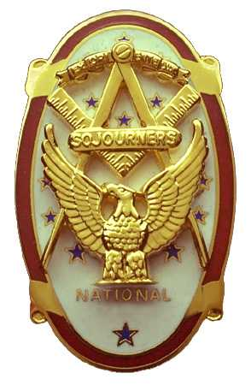
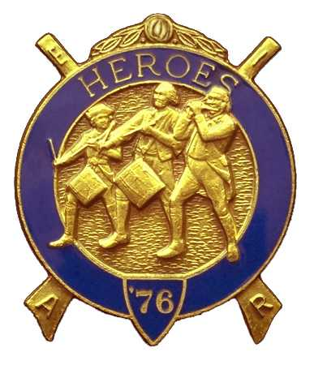
Olympic Chapter No.539
National Sojourners
And
Marvin Shields Camp of Heroes of ‘76
Edwin C. Marion P.O..Box 364
Secretary?Treasurer Forks, WA 98331-0364
edwin028@centurytel.net http://www:telebyte.com/masons/sojourn/ (360) 374-6777
18 August 2010
Meeting Minutes

Our president WB Paul Carmean called upon himself to do the “Toast to the Flag” and to lead us in the Pledge Allegiance to the Flag. He followed this by opening the Chapter according to the Orders of Ceremonies, page 3. Great job Paul. Keep doing this kind of a job and maybe you will get the job forever.

It seems that our treasury is safe and solovent. It slowly keeps growing with the money Sue Porter is able to raise with her raffle. Keep up the good work Sue.

Our President, Paul Carmean, called for a vote on the Amendment that has been in waiting for two months, to change the meeting time to 1800 hours for each meeting. For which you voted an overwhelming YES vote. So, now our meetings will all be at 1800 Hours each month. As for going dark for the summer, you said NO to that.

Our Chapter By-Laws now have been changed to reflect the results of your vote. Thank you for clearing this up for us. Thank you brothers, thank you!! It was good to see you out for this meeting. It was a very important subject matter we needed you to take care of it for us. And take care of it you did! By a unanimous vote, you said that you wanted to be meeting in the evenings only, but you wanted to still meet twelve months a year. So, now we will be meeting at 1800 Hours each month of the year, including the summer months. Thank you for taking care of this situation my brothers. It is one less problem we need to deal with.

WB Ed Marion, your Secretary reminded everyone to start getting their registration in for Pacfic Beach as our time is getting short. We will be doing the opening of the Encampment on Friday evening. This will mean we will be doing the “Build the Flag” Program. We have been requested to bring all our flags to the Encasmpment. Seems they like all the Flag we have been able to acquire over the years. And we will be in charge of the Distruction of the Flag on Saturday. afternoon. This we will do. So, if you are going to the Encampment, and you have a uniform, we could use your help. Let me know if you are willing to help.

Sue Porter once again held her raffle. You don't know how much this helps to have somone to do somerthing like this to raise money for the operation of the Chapter. It more than pays our way. Hugs and kisses Sue. Thanks a lot!

Following the raffle, President Paul proceeded to close the Chapter according to the Orders of Ceremonies, Page 8.

FALL ENCAMPMENT

Our Fall Encampment is almost upon us. Before you know it, it will be 24 September. I hope that there will be enough of us attending the Encampment that we have enough men to do the “Build the Flag”. We will be doing that for the public opening on Friday evening. Of course this will be done in continental uniform. We need David MacNeill to do his parts, if we don't have David, lets hope we have someone to step up to do his part. We will need some one to do “A Toast to the Flag.” This will be Fred Johnson or our President Paul Carmean. We will need one narrator, two flag builders and two men with muskets. We will finish off with “Old Glory Speaks.” So you can see we do need help, 7 Brothers in uniform to be exact. If you have a uniform and can perform any of these parts, or just hold a musket, and you are attending the Fall Encampment, please let me know.

HERE IS THE LIST OF YOUR OFFICERS FOR 2010-2011

OLYMPIC CHAPTER MARVIN G. SHIELDS CAMP

President------ ------CPO Paul J. Carmean Commander-----Mr. Darel E. Maxfield Sr.
360-928-3358 pjcarmean@q.com 360-374-9330 maynard@olynet.com

1st Vice President---LCD Dr. John R. Richardson Chief of Staff----GYSGT C. Earl Riggs
360-385-3117 djohnone@cablespeed.com 360-380-4944 jarhead1949@netzero.com

2nd Vice President-Joe G. Anticevich A/C of Staff---Joe G. Anticevich
360-432-4843 acn@olypen.com 360-432-4843 ace@olypen.com

Chaplain------------Fredrick W. Johnson Chaplain-------Fredrick W. Johnson
360-385-3130 fjohnson-30@q.com 360-385-3130 fjohnson-30@q.com

Secretary-------LCol Edwin C. “Ed” Marion Adjutant—LCol Edwin C. “Ed” Marion
360-374-6777 Edwin028@centurytel.net 360-374-6777 Edwin028@centurytel.net

Deputy Area Representive and Regional Representive
LCol Wendell A. Dutt
253-565-5264 wadutt@comcast.net

NEXT MEETING

EVENING MEETING
22 September 2010
Pardise Restaurant
Sequim, WA

Our meeting this month will be held on the 22 September 2010.. Our September meeting will be back to normal, it will be on 22 September at 1800 Hours (6 PM), our normal meeting time and day of the week.

DIRECTIONS TO THE MEETING PLACE. No matter from which direction you come, as you must come by Highway 101, east or west, when you see the road sign for Sequim Avenue, you take that exit. If you come from the east, turn right onto Sequim Avenue, if you come from the west, turn left onto Sequim Avenue. This will place you heading north along Sequim Avenue. You will stay on Sequim Avenue until you reach the restaurant, which will be approximatly one mile. There will be one traffic light , which is at Main Street, this means you are about half way there.

Approximatly ¾ miles along the way, you will come to Sequim High School on your left. It is a large brick building. There will be a chain-link fence around the practice field part of the High School. At the end of the fenced off area is a cross street, which forms a three way intersection, or a “T” bone intersection. The Paradise Restaurant is on the north west corner of the intersection. The parking lot is in the front, so just pull into the parking lot. Come into the restaurant, walk straight back to the private dinning room. This is where we have our meetings.

Now remember, YOU DON'T HAVE TO COME FOR THE DINNER, YOU DON'T EVEN HAVE TO BUY COFFEE. If you need a ride to and from the meeting, give me a call and I will arrange for someone to pick you up and take you home. Call me at 360-374-6777.

HAPPY BIRTHDAY

Morris “Mike” Moug 6
Eric Anticevich 21
Donald Patrick 23
Fred Johnson 29

Happy Birthday Brothers, may your day be a memorial one. And ladies please send me the month and day of your biurth so I can post it for you. Don't need the year.

BLUE LODGE

Meetings: Quilcene-Jefferson #107 will meet on 6 September and 4 October, dinner 6:30 lodge 7:30; Mt. Olympus #298 on 1 Sertember and 6 October, dinner 6:30 Lodge 7:30. Pt. Angeles #69 on 13 September and 12 October, dinner 6:30 lodge 7:30; Sequim #213, 9 September and 14 October dinner 6:30 lodge 7:30. Pt Townsend #6, 8 September and 14 October, Dinner 6:30 Lodge 7:30..

WISH LIST

- An enclosed trailer to haul all our equipment needed for our “Build the Flag” program. My truck has short bed which will not hold everything needed for our Hero Programs.
- An awards chairman as suggested by David MacNeill. David can't take the job as he has moved out of area, and is traveling most of time.
- We need more member in uniform. We are working on a solution.
- Guest speakers are needed very badly. Subject is of their choosing, but they must work for dinner only, can't afford pay them more than that.
- More brothers and their wives at our meetings
- A phone committee. Open not only to brothers, but to their ladies too.
- A slide projector. I have one but I need two, I have two sets of slides. I will even pay you for a used slide projector. If you have one and want to get rid of it, just give me a call. I'll be there with the money in my hot little hand.
- Sure could use someone to take over the responsiblity for some of this equipment I have. Sometimes it gets more than an 82 year old can handle.

