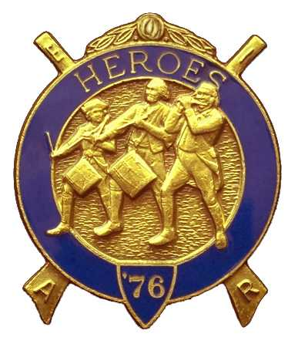
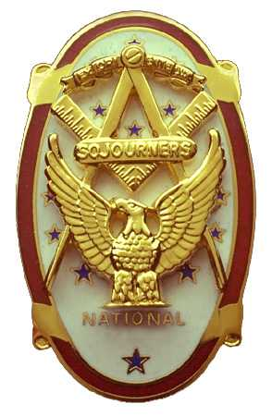
Olympic Chapter No.539
National Sojourners
And
Marvin Shields Camp of Heroes of '76
Edwin C. Marion P.O. Box 364
Secretary-Treasurer Forks, WA 98331-03654
edwin028@centurytel.net http//wwwtelbyte.com/masons/sojourn/ (360) 374-6777
Wednesday
23 June 2010

SUMMARY OF MAY 26th MEETING

Due to the fact that we didn't have a quorum, the meeting was canceled. So, by not having a meeting today, our guest speaker, WB Ed Marion , will be our guest speaker at our June 23th meeting. Once again he will be speaking on “Operations Crossroads”, the Atomic Bomb Test at Bikini Atoll in July 1946, which he took part in the test.
_______________________________________________________________________

SLIDES

At this time I have 2 sets of slides for “Build the Flag”, but have only one slide projector. I hope to get another projector so as to have one for each set of slides. If anyone has a slide projector they want to get rid of let me know. The idea behind this is if you want to do a “Build the Flag” program with just yourself, you will be doing all the work. I even have “Old Glory Speaks” on disk. I have done this program by my self to a group,, and it works very well, So, if there is any one of you that wants to use the slides, just let me know.

FALL ENCAMPMENT

Believe it or not, I have schedules and registration forms for the Fall Encampment to be held at Pacific Beach on Friday, Saturday and Sunday, September 24, 25, and 26, 2010. This is a great time for all, and wives are included. There is the “Camp Followers Degree” for the women which is given just after the Heroes Degree.

If you have never been to an Encampment you are missing something that is fun for all. Our National President and National Heroes Commander have always attended. This may be your only chance to meet the men at the head of our organization.

If you have never been to the Naval Resort at Pacific Beach, you will be pleasantly surprised. It is a large motel complex just like any other conference center. Has its own restaurant and bar, plus gift shop, bowling alley, swimming pool and such. Then we open our hospitality room every chance we get, which makes it nice for us. This is all on the bluff over looking the ocean. The only thing that is different than any other Motel Conference Center is that there is a large fenced off area around a single building in which the Navy has its Undersea Detection equipment employed.

If you would like a registration form just send me an e-mail or give me a call. edwin028@centurytel.net or 360-374-6777.

You must make your own reservations with the resort. Their phone number is 360-276-4414. Just tell them you are with the Sojourners, then send in you registration form with the price of registration attached, to Bob Colton, 17231 Ambaum Boulevard South, Burien, WA 98148-1642. This is the short and sweet of it, but you will be ready to go. I don't think you will ever regret it. Lots of fun.
________________________________________________________________________

HERE IS THE LIST OF YOUR OFFICERS FOR 2010-2011

The Officers were installed om June 5th

OLYMPIC CHAPTER MARVIN G. SHIELDS CAMP

President--------CPO Paul J. Carmean Commander-----Mr. Darel E. Maxfield Sr
360-928-3358 pjcamean@q.com 360-374-9330 maynard@olypen.com

1st Vice Pres----LCD Dr. John Richardson Chief of Staff---GYSGT C. Earl Riggs
360-385-3117 djohnone@cablespeed,com 360-380-4944 jarhead1949@netzero.com

2nd Vice Pres----Mr. Joe G. Anticevich A/C of Staff-----Mr .Joe Anticevich
360-477-5709 aen@olypen.com 360-477-5709 aen@olypen.com

3rd Vice Pres---Mr. Douglas W. Puckett Off. Of Day---CPO Robert K. Clubb
208-591-4540 360-765-3419 robertclubb@hotmail.com

Chaplain--------SGT Fredrick W. Johnson Chaplain------- SGT Fredrick W. Johnson
360-385-3130 fjohnson_30@q.com 360-385-3130 fjohnson_30@q.com

Secretary-------LTC Edwin C. “Ed” Marion Adjutant-------LTC Edwin C. “Ed” Marion
360-385-6777 Edwin028@centurytel.net 360-374-6777 Edwin028@centurytel.net

Deputy Area Representative and Regional Representative.
LTC Wendell A. Dutt
253-565-5264 wadutt@comcast.net
________________________________________________________________________
NEXT MEETING

Evening
23 June, 2010
Paradise Restaurant
Sequim, WA

Our next meeting will be held at 1800 on 23 June.. Our guest speaker will be WB Ed Marion who was to speak at our last meeting, but meeting was not held. Didn't have a quorum. So, WB Ed will be speaking on his adventures as a guinea pig for the Navy at “Operations Crossroads” in July of 1946, the two Atomic Bomb tests at Bikini Atoll.

Directions to Restaurant. At the Sequim Avenue exit from Hwy 101, from ether direction. Stay on Sequim Avenue, traveling North. Coming from the EAST, turn to your right as you exit Hwy 101, this will put you on Sequim Avenue headed west. Coming from the WEST turn left onto Sequim Avenue from Hwy 101 which will put you going west on Sequim Avenue.. Stay on Sequim Avenue until you pass Sequim High School, which will be on your left, approximately one mile from Highway 101 exit. Restaurant will be on the northwest corner of the three way intersection of the first street just beyond the end of the fence around the High School grounds.

This is just a reminder, if you don't want to eat lunch or dinner at the meetings, but do want to attend the meetings, feel free to attend. YOU DON'T HAVE TO ORDER ANYTHING!!! Once lunch or dinner is over, the doors to the back dinning room are closed, the back dinning room where we eat lunch or dinner then becomes our meeting room. Just be sure you get to the Restaurant before the meetings start. You need to be at the restaurant by 1245 Hours for afternoon meetings and 1845 Hours for the evening meetings. See you at the meeting? If you need a ride to the meetings, let us know so that we can arrange for someone to pick you up.
_______________________________________________________________________
HAPPY BIRTHDAY

I would like to take this opportunity, on behalf of our Chapter, to wish a Happy Birthday to the following brothers and sisters. I have miss place the birth dates for the women, so ladies would you please send your dates to me again?

JUNE

John Jones 5th
David Larson 5th
Marion Windell 9th

Ladies !?! Please send me your Month and Day of your birth so that I can add it in here.
_______________________________________________________________________

HEROES

In the last few months we have lost 4 (four) of our very active members of our Heroes team. Two by death and two by the fact they have moved from this area, making it difficult to participate in our Heroes Programs. If you are a member of the Heroes, we need you on the Program Team. This will mean that you need a Dress Uniform, and start learning some of the parts of the different programs. If you are interested, talk to Ed Marion or Darel Maxfield. Never know what we may be able to work out for you.
_______________________________________________________________________

WISH LIST

- An enclosed trailer for hauling our “Build the Flag” equipment and stuff I have
trouble hauling around in my pickup truck. My truck has a short bed and has a tono cover on it, which makes it not good for hauling a lot of equipment we need.
- Awards chairman, which was suggested by David MacNeill. This would be someone to take charge of overseeing our awards program. Will you take it Dave?
- We need more members with uniforms, both field and dress type. I have addresses for uniforms if you are interested.
- Guest speakers needed and wanted. If you know someone who may be an interesting Guest Speaker, give us his/her name, phone number and any other information you may have. We will need their phone number so we can set up a speaking date for them. They don't have to be a Mason to be a guest speaker for our “speakers program”. We do not pay anyone to be a speaker, but we will spring for their and their spouses lunch or dinner. We would like to bring this program back on line again. But your help is needed to provide speakers. This can be anyone that you may think who may have an interesting subject to speak on, even yourself!

Just to give you some idea, how about someone who can give us a talk on something of interest that happened to them while on duty in our military service. Example: A brother during his Navy Service was a crew member of the Battleship USS New York, BB34, one of main target ships of “Operation Crossroads” at Bikini Atoll in 1946. I don't know how many of you would be interested in a subject such as this, but it may be interesting and different.
- More Brothers at meetings..
- Phone Committee..

BLUE LODGE

Meetings: Quilcene-Jefferson Lodge #107 will meet on Monday June 7th and July 5th, ; Dinner at 6:30 PM, Lodge at 7:30 PM. Mt Olympus Lodge #298 will meet on Wednesday June 2nd and July 7th.. Dinner at 6:30 PM Lodge at 7:30 PM. Pt Angeles #69 will meet on Tuesday June 8th and July 13th, Dinner 6:15 PM, Lodge 7:30 PM. Pt Townsend Lodge # 6 will be meeting on Wednesday June 16th, Dinner 6:30 PM, Lodge 7:30 PM, no further meetings until September 8th. Sequim Lodge #213 will be meeting on Thursday June 24^{h} and July 8th., Dinner 6:15 PM, Lodge 7:30 PM. Remember Brothers, attend your Blue Lodge at least once . a year, if for no other reason than to let your lodge brothers know that you are still alive.

