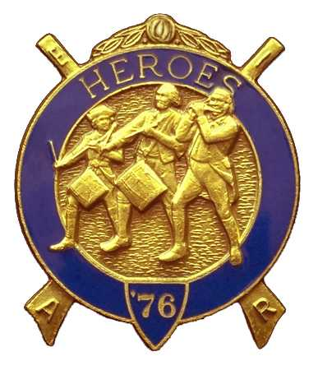
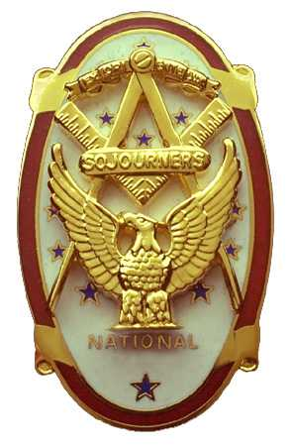
Olympic Chapter No.539
National Sojourners
And
Marvin Shields Camp of Heroes of '76
Edwin C. Marion P.O. Box 364
Secretary-Treasurer Forks, WA 98331-03654
edwin028@centurytel.net http//wwwtelbyte.com/masons/sojourn/ (360) 374-6777

MEETING SUMMY

Wednesday
March 24, 2010

The “Toast to the Flag” was given by Paul Carmean, followed by the Pledge of Allegiance to the Flag. Great job Paul, you get better every time you do the Pledge and Toast.

Paul Carmean took over as President Pro-tem for our President Mike Moug. It seems that due to Mikes condition with his back, he was unable to take care of his wife Coralee. So, Mike made arrangements for her to go into a assisted living home. Mike has now joined Coralee at the home. This is great that the two of them can be together. Good luck to you Mike!!

Our treasury is solvent and all bills are paid. There is $1936.64 in our treasury, with $650.00 Allocated to send two JNROTC Cadets to the Youth Leadership Conference. A check in the amount of $300.00 was sent to Commander of JROTC at Tacoma, as the Chapter had made a promise of a $300.00 donation to the leadership program. This check for $300.00 came from the $950.00 that was set aside for the Youth Leadership Conference, leaving $650.00 still in the fund.. We have $1214.64 to support our own operations of the Chapter.

President Pro-temp Paul called upon the brothers to assist him in the initiation of Robert Caruthers. Joe Anticevich, Darel Maxfield, Eric Antioevich, and Ron Chase all assisted in the initiation. Welcome aboard Bob. We still have one application for membership to act upon, BM 1/c John Charles Soy. This one will be done as soon as Brother Soy returns from a trip to the Far East.

Elections will be taking place at our April 28th meeting. If you are interested in running for one of the offices, Chapter or Heroes Camp, please let me know so I can get your name on the ballot.

Also for the officers being installed, start thinking about where you want the installation to be held. The joint installation, which we have always attended except last year when the bridge was out. The bridge is back in now so I suggest we join the rest of the Chapters and Camps at Des Moines June 5th at noon. We can car pool it.

It is with a great heavy heart that I must announce that we lost two of our main members. First of all, on March 17th at 4 PM, CBM Albert W. “Bud” Porter entered that Celestial Home of our Lord. Then on the evening of April 5th, our founding President Sgt Clarence Johnson pasted on to that Celestial Home. Our thoughts and prayers go out to Sue Porter and Kaye Johnson. They will be missed by us all.

What can I say? These two men were two of my best friends. “Bud” was my traveling companion, and room mate at Pacific Beach. They were two of our members of our ritual team for Heroes, who will be hard to replace

HEROES BIVOUAC

On March 27th the Heroes of '76 were in Bivouac at Fort Mt. Olympus in Forks, enjoy a well deserved rest when it was reported that two, so called recruits were caught trying to enter our Camp area. They claimed they were trying to join the Continental Army. They were brought before the Commander where they were examined to see if this was true. The names they gave were Darel Maxfield Jr. And Eric Anticevich. After a few trips across the Delaware it was determined that they were recruits. Much to their relief they were made our two newest members of the Heroes. Welcome aboard brothers, we can use you!

Our next Bivouac will be at the call of our commander
________________________________________________________________________

Believe it or not, I have schedules and registration forms for Pacific Beach. If you would like one, send me an e-mail or give me a call. Edwin028@centurytel.net or 360-374-6777.
________________________________________________________________________

HERE IS THE LIST OF YOUR OFFICERS FOR 2009-2010

OLYMPIC CHAPTER MARVIN G. SHIELDS CAMP

President-1stSgt Morris E. “Mike” Moug Commander------CPO Paul J. Carmean
360-385-4907 mecom@olypen.com 360-928-3358 pjcarmean@q.com

1st Vice Pres----CPO Paul J. Carmean Chief of Staff----Mr Darel E. Maxfield Sr
360-928-3358 pjcarmean@q.com 360-374-9330 maynard@olynet.com

2nd Vice Pres--. LCD Dr. John Richardson A/C of Staff- GYSGT C. Earl Riggs
360-385-3117 djohnone@cablespeed.com 360-380-4944 jarhead1949@netzero.com

3rd Vice Pres---Mr Joe G. Anticevich Off. Of Day---CPO Robert K. Clubb
360-432-4843 aen@olypen.com 360-765-3419 robewrtclubb@hotmail.com

Chaplain--------SGT Fredrick W. Johnson Chaplain---- SGT Fredrick W. Johnson
360-385-3130 fjohnson_30@q.com 360-385-3130 fjohnson_30@q.com

Secretary-------LTC Edwin C. “Ed” Marion Adjutant-----LTC Edwin C. “Ed” Marion
360-385-6777 Edwin028@centurytel.net 360-374-6777 Edwin028@centurytel.net

Deputy Area Representative and Regional Representative.
LTC Wendell A. Dutt
253-565-5264 wadutt@comcast.net
________________________________________________________________________
NEXT MEETING
Evening
April 28, 2010
Paradise Restaurant
Sequim, WA

Our next meeting will be our 8th Anniversary Meeting to be held on the evening of April 28th Our guest speaker will be MWB Wayne I. Smith, who is also a member of Olympic Chapter #539. MWB Wayne will be the restart of our speaker program. This will also be a catered dinner at $25 per person. Prime Rib, Prawns, Chicken or Fish. No Host Bar.

(Directions to Restaurant. Sequim Avenue exit, from ether direction. Stay on Sequim Avenue, traveling North, until you pass Sequim High School on your left, approximately one mile from Highway 101 exit/ Restaurant will be on corner on your left, first street past High School.)

This is just a reminder, if you don't want to eat lunch or dinner at the meetings, but do want to attend the meetings, feel free to attend. YOU DON'T HAVE TO ORDER ANYTHING!!! Just be sure you get to the Restaurant before the meetings start. You need to be at the restaurant by 1245 Hours for afternoon meetings and 1845 Hours for the evening meetings. See you at the meeting? If you need a ride to the meetings, let us know so that we can arrange for someone to pick you up.
_______________________________________________________________________
HAPPY BIRTHDAY
I would like to take this opportunity to wish a Happy Birthday to the following brothers and sisters.:
Darel E. Maxfield Sr - 4
Ralph “Digger” O'Dell -19
________________________________________________________________________
WISH LIST

- An enclosed trailer for hauling our “Build the Flag” equipment and stuff I have
trouble hauling around in my pickup truck. My truck has a short bed and has a tono cover on it.
- Awards chairman, which was suggested by David MacNeill. This would be someone to take charge of overseeing our awards program. Will you take it Dave?
- We need more members with uniforms, both field and dress type. I have addresses for uniforms if you are interested.
- Guest speakers needed and wanted. If you know someone who may be an interesting Guest Speaker, give us his/her name, phone number and any other information you may have. We will need their phone number so we can set up a speaking date for them. They don't have to be a Mason to be a guest speaker for our “speakers program”. We do not pay anyone to be a speaker, but we will spring for their and their spouses.. We would like to bring this program back on line again. This can be anyone that you may think who may have an interesting subject to speak on. Just to give you some idea, how about someone who can give us a talk on something of interest that happened to them while on duty in our military service. Example: A brother during his Navy Service was a crew member of the Battleship USS New York, one of main target ship of “Operation Crossroads” at Bikini Atoll in 1946. I don't know how many of you would be interested in a subject such as this, but it may be interesting and different.
- More Brothers at meetings..
- Phone Committee..

BLUE LODGE

Meetings: Quilcene-Jefferson Lodge #107 will meet on Monday May 3rd and June 7th, ; Dinner at 6:30 PM, Lodge at 7:30 PM. Mt Olympus Lodge #298 will meet on Wednesday May 5th and June 2nd. Dinner at 6:30 PM Lodge at 7:30 PM. Pt Angeles #69 will meet on Tuesday May 11th and June 8th, Dinner 6:15 PM, Lodge 7:30 PM. Pt Townsend Lodge # 6 will be meeting on Wednesday May 12th and June 9th , Dinner 6:30 PM, Lodge 7:30 PM. Sequim Lodge #213 will be meeting on Thursday May 11th and June 10th, Dinner 6:15 PM, Lodge 7:30 PM. Remember Brothers, attend your Blue Lodge at least once . a year, if for no other reason than to just let your Lodge Brothers see that you are still alive

