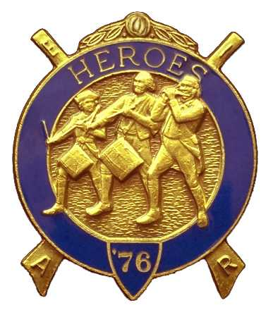
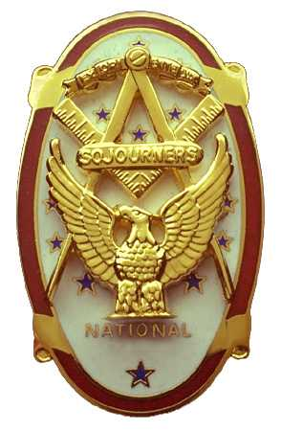
Olympic Chapter No.539
National Sojourners
And
Marvin Shields Camp of Heroes of '76
Edwin C. Marion P.O. Box 364
Secretary-Treasurer Forks, WA 98331-03654
edwin028@centurytel.net http//wwwtelbyte.com/masons/sojourn/ (360) 374-6777

MEETING SUMMARY

Wednesday
February 24, 2010.

We, my wife and I and Darel Maxfield, arrived at 1730 hours and were met by Bud Porter
and Gunny Riggs. Bud got sick and had to go home around 1800 hours. Ron Chase
and his wife, plus one of our new members, Bob Courthers and his wife Peggy
were also in attendance. Then had dinner while we waited, but no more brothers
showed up. So, we didn't have enough members present for a quorum. Too bad,
but we did sit around and discussed some points.

First of all, we will be having election of officers come May meeting. So, we will be needing to know the name of any person who wishes to run for office. Officers in line now will be running for the next highest office, so we will need at least some one for 3rd Vice President in Chapter, and a Assistant Chief of Staff for the Heroes Camp, plus the name of any person who may want to oppose any of our present officers. Give me a call at 360-374-6777.

Most Worshipful Wayne Smith, our Junior Past Grand Master will be our guest speaker for our April meeting. As this will start our guest speakers off, our speaker for our May 26th meeting will be giving a short talk about his adventures as a guinea pig at Bikini Atoll during the July 1946 Atomic Bomb test. If anyone would like to be a guest speaker, or know of anyone that would be a guest speaker, please let me know.

Shortly after lunch, we broke off the meeting and headed for home.

Believe it or not, I have schedules and registration forms for Pacific Beach. If you would like one, send me an e-mail or give me a call. Edwin028@centurytel.net or 360-374-6777.
________________________________________________________________________

HERE IS THE LIST OF YOUR OFFICERS FOR 2009-2010

OLYMPIC CHAPTER MARVIN G. SHIELDS CAMP

President-1stSgt Morris E. “Mike” Moug Commander------CPO Paul J. Carmean
360-385-4907 mecom@olypen.com 360-928-3358 pjcarmean@q.com

1st Vice Pres----CPO Paul J. Carmean Chief of Staff----Mr Darel E. Maxfield Sr
360-928-3358 pjcarmean@q.com 360-374-9330 maynard@olynet.com

2nd Vice Pres--. LCD Dr. John Richardson A/C of Staff- GYSGT C. Earl Riggs
360-385-3117 djohnone@cablespeed.com 360-380-4944 jarhead1949@netzero.com

3rd Vice Pres---Mr Joe G. Anticevich Off. Of Day---CPO Robert K. Clubb
360-432-4843 aen@olypen.com 360-765-3419 robewrtclubb@hotmail.com

Chaplain--------SGT Fredrick W. Johnson Chaplain---- SGT Fredrick W. Johnson
360-385-3130 fjohnson_30@q.com 360-385-3130 fjohnson_30@q.com

Secretary-------LTC Edwin C. “Ed” Marion Adjutant-----LTC Edwin C. “Ed” Marion
360-385-6777 Edwin028@centurytel.net 360-374-6777 Edwin028@centurytel.net

Deputy Area Representative and Regional Representative.
LTC Wendell A. Dutt
253-565-5264 wadutt@comcast.net
________________________________________________________________________
NEXT MEETING
Noon
March 24, 2010
Paradise Restaurant
Sequim, WA

(Directions to Restaurant. Sequim Avenue exit. Stay on Sequim Avenue until you pass Sequim High School, approximately one mile. Restaurant will be on corner on your left.)

This is just a reminder, if you don't want to eat lunch or dinner at the meetings, but do want to attend the meetings, feel free to attend. YOU DON'T HAVE TO ORDER ANYTHING!!! Just be sure you get to the Restaurant before the meetings start. You need to be at the restaurant by 1245 Hours for afternoon meetings and 1845 Hours for the evening meetings. See you at the meeting? If you need a ride to the meetings, let us know so that we can arrange for someone to pick you up.
_______________________________________________________________________
HAPPY BIRTHDAY
I would like to take this opportunity to wish a Happy Birthday to the following brothers and for the first time, to the sisters.:
Harry Houston 2 KC Carmean 20 (We will celebrate for you)
Vicky Larson 25
________________________________________________________________________
WISH LIST

- An enclosed trailer for hauling our “Build the Flag” equipment and stuff I have
trouble hauling around in my pickup truck. My truck has a short bed and has a tono cover on it.
- Awards chairman, which was suggested by David MacNeill. This would be someone to take charge of overseeing our awards program. Will you take it Dave?
- We need more members with uniforms, both field and dress type. I have addresses for uniforms if you are interested.
- Guest speakers needed and wanted. If you know someone who may be an interesting Guest Speaker, give us his/her name, phone number and any other information you may have. We will need their phone number so we can set up a speaking date for them. They don't have to be a Mason to be a guest speaker for our “speakers program”. We do not pay anyone to be a speaker, but we will spring for their and their spouses.. We would like to bring this program back on line again. This can be anyone that you may think who may have an interesting subject to speak on. Just to give you some idea, how about someone who can give us a talk on something of interest that happened to them while on duty in our military service. Example: A brother during his Navy Service was a crew member of the Battleship USS New York, one of main target ship of “Operation Crossroads” at Bikini Atoll in 1946. I don't know how many of you would be interested in a subject such as this, but it may be interesting and different.
- More Brothers at meetings..
- Phone Committee..

BLUE LODGE

Meetings: Quilcene-Jefferson Lodge #107 will meet on Monday March 1st and Monday April 5th, ; Dinner at 6:30 PM, Lodge at 7:30 PM. Mt Olympus Lodge #298 will meet on Wednesday March 3rd and Wednesday April 7th,. Dinner at 6:30 PM Lodge at 7:30 PM. Pt Angeles #69 will meet on Tuesday March 9th and Tuesday April 13th, Dinner 6:15 PM, Lodge 7:30 PM. Pt Townsend Lodge # 6 will be meeting on Wednesday February 10th and Wednesday April 14th , Dinner 6:30 PM, Lodge 7:30 PM. Sequim Lodge #213 will be meeting on Thursday March 11th and Thursday April 8th, Dinner 6:15 PM, Lodge 7:30 PM. Remember Brothers, attend your Blue Lodge at least once a year, if for no other reason than to just let your Lodge Brothers see that you are still alive.

