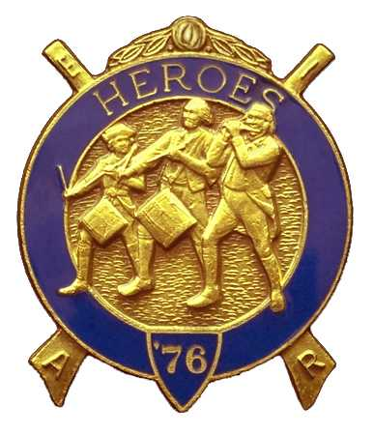
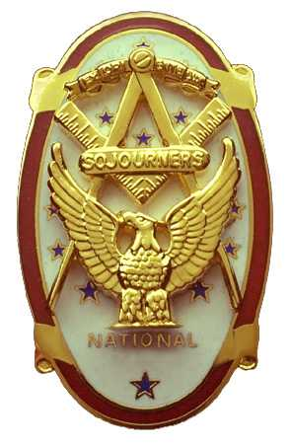
Olympic Chapter No.539
National Sojourners
And
Marvin Shields Camp of Heroes of '76
Edwin C. Marion P.O. Box 364
Secretary-Treasurer Forks, WA 98331-03654
edwin028@centurytel.net http//wwwtelbyte.com/masons/sojourn/ (360) 374-6777

MEETING SUMMARY

Wednesday
December 16, 2009

As always, after driving 75 miles one way for our meetings, my wife and I like to go to Costco and few places like that before we go to the meetings. But this time we didn't have that much to do. So, we decided that we would go on over to the Paradise restaurant where we have our meetings. Well, I guess you know, it seemed like most of the people had the same idea as us. They came earlier than usual, so, our Grip – N – Grin had an early start. We got there at a little after 5 PM , and there were already brothers there.

Once again, our President Mike Moug was unable to attend the meeting. Coralee, Mikes wife is in the hospital, and Mike was visiting her. So, 1st Vice President Paul Carmean was asked to sit in for Mike.

At the request of our President Pro-Tem, Bud Porter was asked to do the “Toast to the Flag”. Good job Bud. You get better all the time, even for an old Seal Chief Bos'en Mate. Bud followed this with the Pledge Allegiance to our flag. Thanks for a job well done Bud.

Meeting was opened by President Pro-Tem Paul Carmean according to page 3, Orders of Ceremonies. Opening prayer was given by our Chaplain Fred Johnson. Once again you guy's did the opening like you knew what you were doing. Thanks brothers.

Once again our treasury is still solvent. We have $1943.14 in the bank. $950.00 is committed to Youth Conference and $75.00 to our JROTC Medal Program. That's not too bad for the likes of us!

Once again we, the Chapter, received a streamer for our flag for having 100% donations for our 365 Club. Just to refresh your memory, the 365 Club, which you are a member of from the day you joined Sojourners, which means you will donate a penny a day to the National Charity fund, which comes out to $3.65 per member. Now, if you pay $36.50 up front, you become a paid-up life member of the fund. So brothers, think about becoming a life member of the 365 Club Fund.
We initiated Mr. Douglas W. Puckett to membership. Brother Puckett is a new member of Port Angeles Lodge #69, having moved into the area from Spokane. Welcome aboard Doug. Doug's wife is Cyndy, who we also welcomed aboard.

Due to the White Elephant Program, there was no raffle this month.

President Pro-Tem Carmean closed the chapter according to the Order of Ceremonies, page 8.

______________________________________________________________________

HERE IS THE LIST OF YOUR OFFICERS FOR 2009-2010

OLYMPIC CHAPTER MARVIN G. SHIELDS CAMP

President-1stSgt Morris E. “Mike” Moug Commander------CPO Paul J. Carmean
360-385-4907 mecom@olypen.com 360-928-3358 pjcarmean@q.com

1st Vice Pres----CPO Paul J. Carmean Chief of Staff----Mr Darel E. Maxfield Sr
360-928-3358 pjcarmean@q.com 360-374-9330 maynard@olynet.com

2nd Vice Pres--. LCD Dr. John Richardson A/C of Staff- GYSGT C. Earl Riggs
360-385-3117 djohnone@cablespeed.com 360-380-4944 jarhead1949@netzero.com

3rd Vice Pres---Mr Joe G. Anticevich Off. Of Day---CPO Robert K. Clubb
360-432-4843 aen@olypen.com 360-765-3419 robewrtclubb@hotmail.com

Chaplain--------SGT Fredrick W. Johnson Chaplain---- SGT Fredrick W. Johnson
360-385-3130 fjohnson_30@q.com 360-385-3130 fjohnson_30@q.com

Secretary-------LTC Edwin C. “Ed” Marion Adjutant-----LTC Edwin C. “Ed” Marion
360-385-6777 Edwin028@centurytel.net 360-374-6777 Edwin028@centurytel.net

Deputy Area Representative and Regional Representative.
LTC Wendell A. Dutt
253-565-5264 wadutt@comcast.net
________________________________________________________________________
NEXT MEETING
NOON
January 27,2010
Paradise Restaurant
Sequim, WA

This is just a reminder, if you don't want to eat lunch or dinner at the meetings, but do want to attend the meetings, feel free to attend. YOU DON'T HAVE TO ORDER ANYTHING!!! Just be sure you get to the Restaurant before the meetings start. You need to be at the restaurant by 1245 Hours for afternoon meetings and 1845 Hours for the evening meetings. See you at the meeting? If you need a ride to the meetings, let us know so that we can arrange for someone to pick you up.
_______________________________________________________________________
HAPPY BIRTHDAY
William R. Heckman 28th

Bill, hope you have a nice birthday down there in Yuma, AZ.
________________________________________________________________________
WISH LIST

- An enclosed trailer for hauling our “Build the Flag” equipment and stuff I have
trouble hauling around in my pickup truck. My truck has a short bed and has a tono cover on it.
- Awards chairman, which was suggested by David MacNeill. This would be someone to take charge of overseeing our awards program. Will you take it Dave?
- We need more members with uniforms, both field and dress type. I have addresses for uniforms if you are interested.
- Guest speakers needed and wanted. If you know someone who may be an interesting Guest Speaker, give us his/her name, phone number and any other information you may have. We will need their phone number so we can set up a speaking date for them. They don't have to be a Mason to be a guest speaker for our “speakers program”. We do not pay anyone to be a speaker, but we will spring for their and their spouses.. We would like to bring this program back on line again. This can be anyone that you may think who may have an interesting subject to speak on. Just to give you some idea, how about someone who can give us a talk on something of interest that happened to them while on duty in our military service. Example: A brother during his Navy Service was a crew member of the Battleship USS New York, one of main target ship of “Operation Crossroads” at Bikini Atoll in 1946. I don't know how many of you would be interested in a subject such as this, but it may be interesting and different...

BLUE LODGE

Meetings: Mt Olympus Lodge # 298 will meet on Wednesday January 6th and February 3, Dinner at 6:30 PM, Lodge 7:30 PM.; Quilcene-Jefferson Lodge #107 will meet on Monday January 4th and February 1st ; Dinner at 6:30 PM, Lodge at 7:30 PM. Pt Angeles #69 will meet on Tuesday January 12th and February 9th, Dinner 6:15 PM, Lodge 7:30 PM. Pt Townsend Lodge # 6 will be meeting on Wednesday January 13th and February 10th, Dinner 6:30 PM, Lodge 7:30 PM. Sequim Lodge #213 will be meeting on Thursday January 7th and February 11th, Dinner 6:15 PM, Lodge 7:30 PM. Remember Brothers, attend your Blue Lodge at least once a year, if for no other reason than to just let your Lodge Brothers see that you are still alive.

