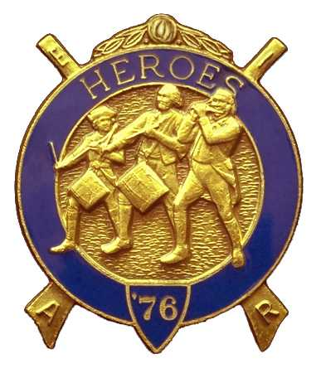
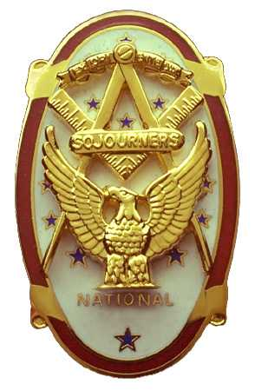
Olympic Chapter No.539
National Sojourners
And
Marvin Shields Camp of Heroes of '76
Edwin C. Marion P.O. Box 364
Secretary-Treasurer Forks, WA 98331-03654
edwin028@centurytel.net http//wwwtelbyte.com/masons/sojourn/ (360) 374-6777

MEETING SUMMARY

Wednesday
November 18, 2009

The Grip -N- Grin portion of the meeting started at about 1730 hours with the arrival of quite a few of the brothers, their ladies, who showed up early. This is one of the most pleasant parts of our meeting, is greeting old friends. It was determined that our president was not going to be able to make it to the meeting, so WB Paul Carmean, our 1st Vice President, was asked to fill in as president pro-tem.

At the request pf acting President Paul Carmean, CSCPO Bud Porter gave the “Toast to the Flag” followed by the Pledge of Allegiance. As always, very good job Bud!

Meeting was opened by Paul Carmean according to page 3, Orders of Ceremonies. Opening prayer was give by Darel Maxfield, Chaplain Pro-Tem. Both Paul and Darel did things just like they really knew what they were doing. Thanks brothers.

Our Treasury is still solvent following the purchase of 8 MIP'S for our brothers, who for one reason or the other haven't purchase one on their own. Having a Chapter that has all MIP'S is the only way to go. It is much easier on both your local secretary and the National Secretary.

WB Joe Anticevich presented a petition for membership for Mr. Douglas Puckett. Following a discussion of Mr. Puckett, WB Anticevich made a motion that we accepted the petition of Mr Puckett. Motion was seconded by VWB Darel Maxfield. A vote was taken and the vote was favorable. Secretary will notify Mr. Puckett that his petition was excepted, and will explain what steps he must take for his induction into the Chapter.

Secretary Ed Marion presented a National Presidential Citation to VWB Clarence Johnson for Meritorious Service to National Sojourners, Inc. for the year of 2008. Congratulations Clarence, which was very well deserved.

WB Hank Carmen, a member of Sinclair Inlet of Bremerton, and also a member of our Chapter, made a request for help from our Chapter to assist Sinclair Inlet to put on the Heroes Degree for two new brothers. WB Hank explained that Sinclair Inlet was trying to restart their Heroes Camp again, but needed help with the degree work. This will be held on November 21st, Saturday, at 10 AM, at the Bremerton Masonic Temple. WB Paul Carmean stated that they could count on him and he was sure our secretary will be there to assist. All brothers that are not going to the Sequim Installation are encouraged to be at that meeting.

With heavy hearts, the death of CSMSGT Francis “Bud” Worthington was announced. WB Bud served first in the Navy, then enlisted in the Army, retiring there from after 30 years service. The Chapter performed the Candle Light Service in honor of Bud. A job well done by Hank Carmen, Dick Dexter, Paul Carmean, and Darel Macfield. We know that Bud was looking down upon the ceremonies saying “Thanks Brothers”.

Bud and Sue Porter held their raffle, which added $70.00 more to our treasury. Thanks Bud and Sue. There was $7.00 in fines. $1.00 each from Sue Porter and Paul Carmean for forgetting to wear their name tags, and $5.00 from Ed Marion for missing the October meeting. Oh the perils of being secretary.

President Pro-Tem Paul Carmean called upon Dick Dexter to give his rendition of Old Glory Speaks, which he was more than happy to do. Very good job Dick. You have our permission to do the job for us anytime you are around. Thanks, great job Dick.

President Pro-Tem Paul closed our meeting according to the Order of Ceremonies, page 8.
________________________________________________________________________

HERE IS THE LIST OF YOUR OFFICERS FOR 2009-2010

OLYMPIC CHAPTER MARVIN G. SHIELDS CAMP

President-1stSgt Morris E. “Mike” Moug Commander------CPO Paul J. Carmean
360-385-4907 mecom@olypen.com 360-928-3358 pjcarmean@q.com

1st Vice Pres----CPO Paul J. Carmean Chief of Staff----Mr Darel E. Maxfield Sr
360-928-3358 pjcarmean@q.com 360-374-9330 maynard@olynet.com

2nd Vice Pres--. LCD Dr. John Richardson A/C of Staff- GYSGT C. Earl Riggs
360-385-3117 djohnone@cablespeed.com 360-380-4944 jarhead1949@netzero.com

3rd Vice Pres---Mr Joe G. Anticevich Off. Of Day---CPO Robert K. Clubb
360-432-4843 aen@olypen.com 360-765-3419 robewrtclubb@hotmail.com

Chaplain--------SGT Fredrick W. Johnson Chaplain---- SGT Fredrick W. Johnson
360-385-3130 fjohnson_30@q.com 360-385-3130 fjohnson_30@q.com

Secretary-------LTC Edwin C. “Ed” Marion Adjutant-----LTC Edwin C. “Ed” Marion
360-385-6777 Edwin028@centurytel.net 360-374-6777 Edwin028@centurytel.net

Deputy Area Representative and Regional Representative.
LTC Wendell A. Dutt
253-565-5264 wadutt@comcast.net
________________________________________________________________________
NEXT MEETING

December 16, 2009 at 1800 Hours
At the Paradise Restaurant in Sequin
There will be a “White Elephant Exchange of Gifts” for those that wish to participate.

This is just a reminder, if you don't want to eat lunch or dinner at the meetings, but do want to attend the meetings, feel free to attend. YOU DON'T HAVE TO ORDER ANYTHING!!! Just be sure you get to the Restaurant before the meetings start. You need to be at the restaurant by 1245 Hours for afternoon meetings and 1845 Hours for the evening meetings.
_______________________________________________________________________
HAPPY BIRTHDAY

Being as how I suffer from that rare mental condition called “ Blind Idiot Syndrome” (That is: Out of sight, out of Mind) it seems I fail at putting the correct names in the Happy Birthday Column, so I will put both November and December here at this time. It seems that I was reading the Birthday reminder sheet upside down and backwards at the same time.

NOVEMBER

Franklin Benson 15th
Wendell Dutt 15th
Theodore Shank 22nd
Ronald Novak 23rd

DECEMBER

Edwin C. Marion 8th
Graham Kent 25th

Well I hope you had a Happy Birthday anyway. And Graham, Merry Christmas I hope you get both Birthday and Christmas gifts. Ladies, let me know your day and month of birth, not the year, so I can add your birthday in the greetings. Your birthday is as important to us as that man of yours.

________________________________________________________________________
WISH LIST

- An enclosed trailer for hauling our “Build the Flag” equipment and stuff I have
trouble hauling around in my pickup truck. My truck has a short bed and has a tono cover on it.
- Awards chairman, which was suggested by David MacNeill. This would be someone to take charge of overseeing our awards program. Will you take it Dave?
- We need more members with uniforms, both field and dress type. I have addresses for uniforms if you are interested.
- The name, and any other information you may have, on anyone, doesn't have to be a Mason, that may be a guest speaker for our “speakers program”. We would like to bring that back on line again. This can be anyone that you may think who may have an interesting subject to speak on. Just to give you some idea, how about someone who can give us a talk on something of interest that happened to them while on duty in our military service. Example: A brother during his Navy Service was a crew member of the Battleship USS New York, one of main target ship of “Operation Crossroads” at Bikini Atoll in 1946. I don't know how many of you would be interested in a subject such as this, but it may be interesting and different...

BLUE LODGE

Meetings and installations. Mt Olympus Lodge # 298 will meet on Wednesday December 2nd, Dinner at 6:30 PM, Lodge 7:30 PM. Installation of Officers of Pt Angeles #69 on Saturday December 5th at 3 PM, Quilcene-Jefferson Lodge #107 will meet on Monday December 7th. Dinner at 6:30 PM, Lodge at 7:30 PM. Pt Angeles #69 will meet on Tuesday December 8th, Dinner 6:15 PM, Lodge 7:30 PM. Pt Townsend Lodge # 6 will be meeting on Wednesday December 9th, Dinner 6:30 PM, Lodge 7:30 PM. Sequim Lodge #213 will be meeting on Thursday December 10th, Dinner 6:15 PM, Lodge 7:30 PM. Pt Townsend # 6 Installation 7:00 PM. Remember Brothers, attend your Blue Lodge at least once a year, if for no other reason than to just let your Lodge Brothers see that you are still alive.

NEXT MEETING

Will be held on December 16th at 1800 Hours. This will be our Christmas Meeting. There will be a White Elephant Gift Program for all who want to participate.

