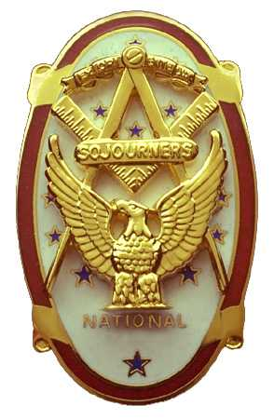
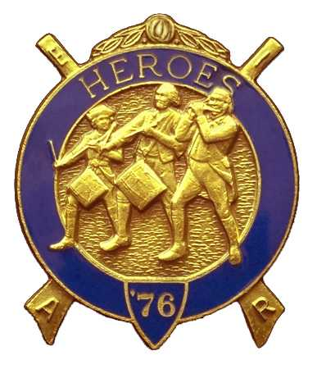
Olympic Chapter No.539
National Sojourners
And
Marvin Shields Camp of Heroes of '76
Edwin C. Marion P.O. Box 364
Secretary-Treasurer Forks, WA 98331-03654
edwin028@centurytel.net http//wwwtelbyte.com/masons/sojourn/ (360) 374-6777
Wednesday
May 27, 2009

The Grip -N- Grin portion of our meeting started about 1130 hours with a small contingent of brothers present. It was nice to see some of our friends that we only get to see at meeting such as this. Before noon we had more than enough brothers present for a quorum. Meeting was opened as per Orders of Ceremonies, page 3.

Our president, VWB Darel Maxfield, called upon WB Bud Porter to give the Toast to the flag. As usual, WB Bud did an excellent job on the Toast, then he followed it up with the Pledge of Alleglance. Bud you get better each time.

There was no guest speaker this time, so VWB Darel went forward with our Treasure report. Our treasury is solvent with a total of $4007.89 of which $1500.00 is set aside for Youth Leadership Conference, and $85.00 set aside to purchase JROTC Medals and certificates. This money donation was started by a donation by Luann Yager in honor of her husband Dee. Dee had been our second President prior to his death. Others made donations to get the price up to $85.00.

It was announced, by WB Ed Marion our Secretary, that due to the bridge being closed that our installation would be held at Quilcene-Jefferson Lodge, in Quilcene, on Saturday June 6th at 1400 PM. This would give our President Darel a chance to make the JROTC presentation at 1100 hours at Pt Angeles High School. It was suggested that instead of having any refreshments, maybe we could then go to the “Loggers Landing” res truant for an early dinner.

VWB Steve Seteroff gave a short talk on what was being planed for Pacific Beach, to be held on September 25, 26, and 27. Spokane Chapter is to be in charge of everything this year, but we have been informed that it seems they aren't going to make it. So, WB Bob Colton asked that our chapter to take over and do the Building of the Flag and such. Of course, we will be doing the best that we can on this. We will be bring all our flags and stuff to the conference. Should be fun!?!.

Bud and Sue Porter conducted their raffle, bring in a total of $70.00. There was a $5.00 fine against our secretary, for what I don't know. Seems it might have been for some snide remark he made to Bud at one point.

There being no other business to come before the Chapter, VWB Darel proceeded to close the Chapter, following a rendition by VWB Steve of Old Glory Speaks. Thanks Steve. We seem never to get tired of hearing you do this.

The meeting was closed at 1330 hours by VWB Darel for his last time according to the Orders of Ceremonies, Page 8.

Edwin C. Marion, Secretary/Treasurer

