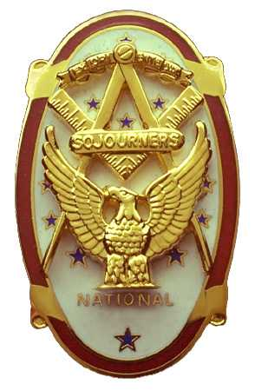
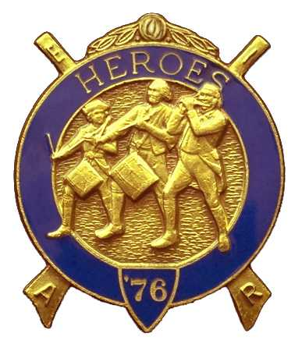
Olympic Chapter No.539
National Sojourners
And
Marvin Shields Camp of Heroes of '76
Edwin C. Marion P.O. Box 364
Secretary-Treasurer Forks, WA 98331-03654
edwin028@centurytel.net http//wwwtelbyte.com/masons/sojourn/ (360) 374-6777
Wednesday
April 22, 2009

The Grip-n-Grin portion of our meeting got started at approximately 1730 Hours (5:30 PM). There were 32 persons present, and it was good to see so many of our brothers and sisters out for our Seventh anniversary meeting. If you were not at the meeting, you missed a very good one.

WB Bud Porter opened the meeting with his rendition of “Toast to the Flag”. Great job Bud, you get better each time you do the Toast. President VWB Darel Maxfield opened the meeting according to the Orders of Ceremonies, page 3.

Our guest speaker for the evening was MWB James N. Reid. Seven years ago, MWB Jimmy was the person that brought our Charter making us a legal Chapter of National Sojourners Inc. MW Jimmy spoke on the subject of Demolay and Rainbow Girls. This was a very informative subject. MWB Jimmy should know a lot about this subject as he has been the Chairman of the committee that oversees their activities for the Grand Lodge.

Following the information given by MWB Jimmy, VWB Darel called upon WB Ed Marion to come up and make his presentation. WB Ed came forward and called up VWB Clarence L. Johnson to join him. WB Ed presented VWB Clarence with a certificate naming him the “Sojourner of the Year for 2003”. WB Ed informed everyone that he felt that there were a certain group of men who had not been honored for their hard work in our Chapter, and at this time he has taken it upon himself to extend this honor to these Brothers.

WB Ed then also presented VWB Clarence with a trophy that WB Ed had made and worked on for almost a year. The trophy was on a wood stand, 4”X6”. There was a gold colored minuteman, 6” high, standing in front of three flags, US Flag, Bennington Flag, and a Sojourners Flag. The Sojourners Flag had the words “Olympic Chapter” embroided across the bottom. There was a brass plate that read “Clarence L. Johnson Sojourner of the Year for 2003”.
Certificates and duplicate trophies were awarded to Donald Patrick for the Year of 2004, VWB Dr. S. Steve Seteroff for the year of 2005, WB Fred W. Johnson for the Year 2006, WB David MacNeill for the Year 2007 and WB Albert W. “Bud” and Sue Porter for the Year of 2008. It is about time that we honored these men and Lady for all the work they have done for the Chapter.

Now that the men for the years up to 2008 have been chosen, the men who were awarded the trophies were appointed as a committee to select the Sojourner for the coming year. So, if you have someone that you feel who should be named the “Sojourner of the Year”, you need to suggest that person to the committee. The committee in turn will select the winner, who will be named at the next anniversary meeting. So, be looking at and watching all members who are working hard for the good of the Chapter. If you feel that one of the previous winners has been working hard for this year, you can nominate him again. A person can win each year if he is doing that good. So, watch your members and nominate someone for the year 2009, someone you feel deserves the honor. Make your person you would like to see be selected “Sojourner of the Year 2009” be known to this committee.

The election of officers for the year of 2009 – 2010 with the following results for the Chapter:
President –---------- Mike Moug
1st Vice President –Paul Carmean
2nd Vice President—John Richardson
3rd Vice President—Joe Anticevich
Chaplain-------------Fred Johnson
Secretary--------------Ed Marion

Results for the Heroes of '76 Camp:
Commander----------Paul Carmean
Chief of Staff----------Darel Maxfield
Asst Chief of Staff—Earl Riggs
Officer of the Day----Bob Clubb
Chaplain---------------Fred Johnson
Adjutant----------------Ed Marion

Motion was made and seconded that the Chapter donate $100.00 to Quilcene-Jefferson Lodge No. 107 for the use of their meeting room for all our Heroes meetings. The motion passed. The Secretary will take care of this.

There were $11.00 in fines for the evening.

It was decided that due to the bridge closure this June, we will be doing our own installation of officers at Quilcene-Jefferson Lodge No. 107 on Saturday June 6, 2009. The start time will be announced later.

Bud and Sue Porter conducted their raffle, raising an additional $125.00 for our treasury.

There being nothing else to come before the Chapter, President VWB Darel proceeded to close the Chapter according to the Order of Ceremonies, Page8.

Edwin C Marion, Secretary/Treasurer

