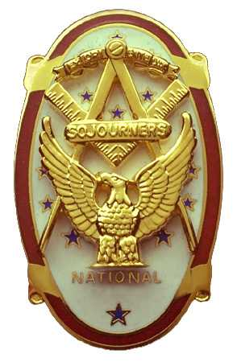
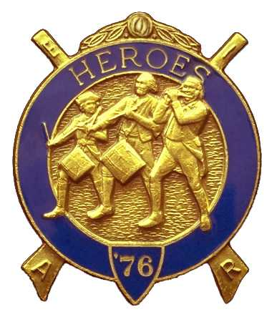
Olympic Chapter No.539
National Sojourners
And
Marvin Shields Camp of Heroes of '76
Edwin C. Marion P.O. Box 364
Secretary-Treasurer Forks, WA 98331-03654
edwin028@centurytel.net http//wwwtelbyte.com/masons/sojourn/ (360) 374-6777
Wednesday
February 25,2009

The meeting was opened with Paul Carmean doing the Toast to the Flag, followed with Brother Paul leading us in the Pledge Allegence to the Flag. President Darel Maxfield proceeded to open the meeting in accordance with ther Order of Ceremonies, Page 3. There was no scheduled guest speaker, so, WB Ed Marion was asked to give his Operations Crossroads presentation..

At this time CPO Ryan R. Lewis, of the United States Coast Guard was introduced, and VWB Darel prceeded to to induct Brother Lewis into the Chapter. VWB Dr. Steve Seteroff acted as the Marchall, and gave the Medal Lecture. WB Ed Marion did his thing as the Secretary. Welcome aboard B. Ryan.

A general discussion was held on different subjects, but there was no action that was taken on any of them, We talked about the up and coming Flag Presentation at Renton Lodge on Monday the 9th of March. It seems we will have enougfh brothers to cover this with Don Patrick joining us. VWB Don will be doing the Toast to the Flag, and he will do the narrattion. VWB Steve will be doing Old Glory and will build the flag. WB David MacNeill will be doing his Common Man and Patriot talks. VWB Darel Maxfield and WB Ed Marion will be handling the Brown Bess Muskets. Everything will be covered this way.

WB Bud and Sue Porter did their thing will their raffle. Thanks Bud and Sue, don't know what we would do without you. VWB Steve finished off with his rendition of Old Glory.

We have tickets for the Seventh Anniversary Meeting to be held on April 22, 2009 at 1800 hours. Our guest speaker will be MWB Jimmy Reed. Contact Ed Marion for tickets. We will be having Prime Rib, Prawns, Salmon, or Chicken with all the trimmings,all the way to dessert. Price is $25.00 and the tickets are limited. Call Ed Marion at 360-374-6777 or contact him at Edwin028@centurytel.net. No ticky no dinner.

Reminder: Ther will be a Heroes camp on Saturday March 21st at 10:00 am at Fort Quilecene-Jefferson.

Edwin C. Marion, Secretary
Olympic Chapter #539

.

