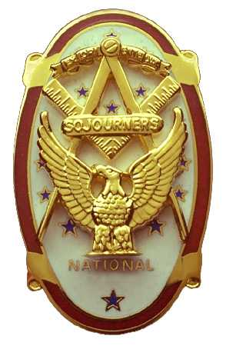
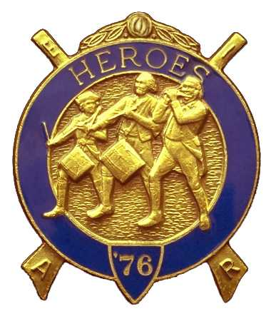
Olympic Chapter No.539
National Sojourners
And
Marvin Shields Camp of Heroes of ‘76
Edwin C. Marion P.O..Box 364
Secretary-Treasurer Forks, WA 98331-0364
Edwn028@centurytele.net http:www:telebyte.com/masons/sojourners/ (360) 374-6777
Wednesday 28 January 2009

The “Grip – n – Grin” portion of our meeting began with the arrival of the early-bird portion of our membership. It was a very nice portion of our meeting as we hadn't seen most of the membership for almost two months. The December meeting had to be canceled due to the heavy snow in the area. Very unsafe to travel during the night hours. The roads were very slick, and dangerous. I know I wasn't about to get out on the road that night.

Following dinner, President VWB Darel, ”Short Meeting”, Maxfield called upon WB Bud Porter to open the meeting with w “Toast to the Flag”. This WB Bud did, and then lead us in the “Pledge of Allegiance to the Flag.”” Great job Bud. President Darel then proceeded to open the meeting according to page 3 of the opening ceremonies.

The reason we have not had guest speakers lately is that I have a problem knowing or finding guest speakers. I just don't get out and around too much anymore. If there is any member that knows any person who would make a good guest speaker, contact that person and commit them to our speaking program. To get things going on the speaker circuit, I will volunteer myself to give my “Operations Crossroads” talk, that is unless someone can come up with some other speaker. If you don't want to hear me talk, then get me some other speakers.

There were thirteen brothers and six wives present today. That is good. Keep up the good work brothers. Let's see more at our next meeting. It is nice to get out among your friends with your wife along for lunch or dinner. Try it, you may find that you enjoy it!

Wendell Dutt, our Area Representative gave us run down on the Mid-Winter Convention, and good words from our National Officers.

VWB Arnie Finley was inducted into the Chapter. Welcome aboard Arnie, bring your wife to the meetings next time. She is more than welcome. We find that the women work just as hard as the men to make the Chapter strong.

WB Bud and Sue Porter did their thing with the raffle. More money in the pot again.

VWB Dr. S. Steve Seteroff gave his stirring “Old Glory” talk. To say it was a good job is a misnomer. It was a hair raising on the arms type of presentation. Thanks Steve, it always gets to me.

Our next meeting will be dinner meeting on 25 February at 1800 hours. See you then?

At this time we would like to extend birthday greetings to Brother William R. “Bill” Heckman who was born on January 28th. Happy birth day Bill from all of the members of Olympic Chapter #539. If I knew the birth dates of the wives, then I could wish them a Happy Birthday too. How about it ladies, will you send me you month, day and year of birth? I also need the information for my records too.

Edwin C. Marion, Secretary/Treasure
Olympic Chapter # 539.

