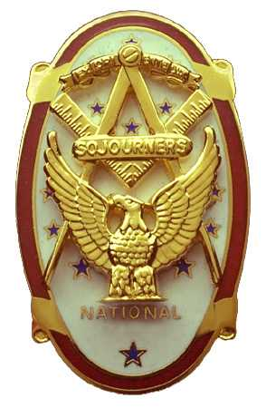
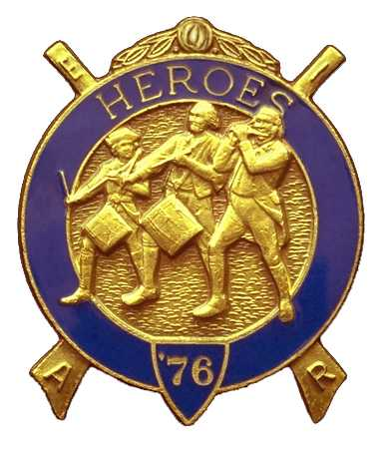
Olympic Chapter No.539
National Sojourners
And
Marvin Shields Camp of Heroes of '76
Edwin C. Marion P.O..Box 364
Secretary-Treasurer Forks, WA 98331-0364
Edwin028@centurytel.net http//www:telebyte.com/masons/sojourn/ (360) 374-6777
Wednesday 19 November 2009

Grip –N- Grin portion of our meeting began round 1130 Hours when most of our members began to arrive. Once again it is good to see some of our brothers whom we only get to see at our meetings.

We started the meeting by ordering from the menu, Good way of doing it, that way you get what you want to eat, not what someone has decided for you. Following lunch, at about 1300 hours, President Darel Maxfield opened our meeting according to the Orders of Ceremonies, page 3. As he does in Blue Lodge, he doesn't let any grass grow under his feet. And this year is Darel third time as Master of Mt. Olympic Lodge. Like some of us, he is a glutton for punishment. He can't say no.

There was no guest speaker and no one to initiate this time, so the meeting rolled right along. Due to the fact that my printer had ran out of red ink and failed to print some of our Agenda Sheet, President Darel read the left out parts of the agenda. Worked out good.

Our treasury is solvent with $3, 948.24 available for operations. This started a discussion as to what we should do with this money. VWB Steve Seteroff proposed that we establish four scholarships for the Youth Leadership Foundation., one of scholarships being set aside for JROTC. And if the scholarships were not taken up by students from our high schools in our area, then we would make all four of the scholarships available to the JROTC program. The total of the scholarships not to exceed $1500.00. Motion made, seconded and passed.

Robert Mitchell be contacted to find out when the applications will be available, and when is the dead line as to when applications must be turned in. VWB Steve Seteroff was appointed as the point man for this.

The second reading on the application for membership by Arnie Finiley and Ryan Lewis was read and voted upon. I am happy to say that they both were approve. We hope to induct them at our December meeting. Brother Ryan Lewis is an active duty Coast Guardsman. On December 1, Bud Porter, President Darel, Terry Domining (A member of Mt. Olympus Lodge) and myself went to the Quillute Coast Guard Station to be present as Brother Ryan was promoted to Chief Petty Officer. Congratulations Ryan.

The meeting was turned over to Bud and Sue Porter for their raffle. $60.00 was made for our general operations fund. Thanks Bud and Sue.

There being nothing else to come before the meeting, President Darel closed the meeting according to the Orders of Ceremonies, Page 8.

Edwin C. Marion, Secretary/Treasurer

