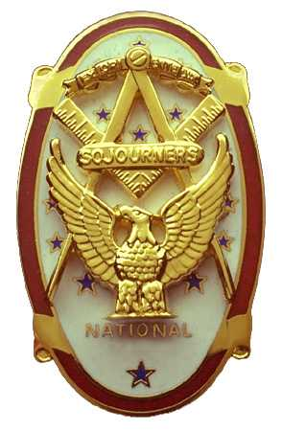
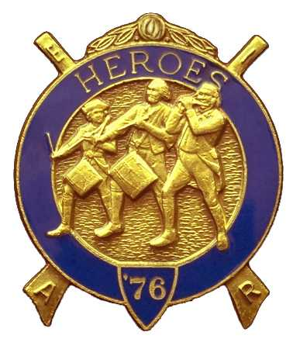
Olympic Chapter No.539
National Sojourners
And
Marvin Shields Camp of Heroes of ‘76
Edwin C. Marion P.O..Box 364
Secretary-Treasurer Forks, WA 98331-0364
edwin028@centurytel.net http://www:telebyte.com/masons/sojourn/ (360) 374-6777
Wednesday October 22, 2008

The Grip – N – Grin part of our meeting began with the arrival of most of our membership at about 1730 hours. It was good to see so many of our brothers out for this evenings festivities.

At about 1800 hours, the Prime Rib was brought in from the kitchen by the chef to President Darel to see if the meat was prepared properly and to see if it was fit for human consumption. So, President Darel carved a small piece of the meat, and proceeded to give it a good testing. After much thought and sampling, President Darel determined that the meat was suitable for the masses. So he gave his approval to serve the meat.

During the dinner, different toast were give by some of our brothers, beginning a toast to the President of National Sojourners Joseph H. Baker Jr. and Richard D. Sutton our National Commander of Heroes. These Toast were followed by many other Toast, ending up with a final Toast to the Commander-in-Chief of our nation.

Following dinner, President Darel called upon WB Fred Johnson to give us the :Toast to the Flag”. Fred then asked everyone to join him give the Pledge of Alleghence to the Flag. VWB Darel then proceeded to open the Chapter according to the Order of Ceremonies, page 3 of the manual.

Following the opening, President Darel introduced RWB Gale H. Kenney, our guest speaker. In his opening remarks, RWB Kenney reminded everyone that he was a member of Omaha Chapter #19, but his initiation into Joseph Warren Camp Heroes of '76 was dome at Quilicene-Jefferson Lodge by members of Marvin G. Shields Camp.

RWB Kenney spoke on the subject of generations, starting with the babyboomers right on to the Generation X. Hadn't thought much about the subject, but it sure opened my eyes, and gave me something to think about. I don't speak for everyone, but I found the subject matter was very interesting. Following his talk, RWB Kenney was presented a Certificate of Appreciation by our President Darel.

First reading was given on the petitions of VWB Arnie Finily and B. Ryan Lewis (who is still on active duty with the Coast Guard). The second reading will be on November 19, our noon meeting. If elected, and they are present, they will be initiated at that time.

WB Bud ands Sue Porter took over at this point with their raffle. The five unknown prizes were awarded, with Bud and Sue raising an additions $130.00 for our Chapter. Thanks for a great job WB Bud and Lady Sue.

Following the Raffle, two sets of Real Pearls, donated by VWB Dr. Steve Seteroff, was given as door prizes. One was won by, I believe, by Kay Johnson, and the other won by Bud Worthington's wife.

Following an outstanding rendition of “Old Glory” by VWB Clarence Johnson, President Darle proceeded to close the Chapter according to the Orders of Ceremonies, page 8.

Edwin C. Marion
Secretary/Treasurer

