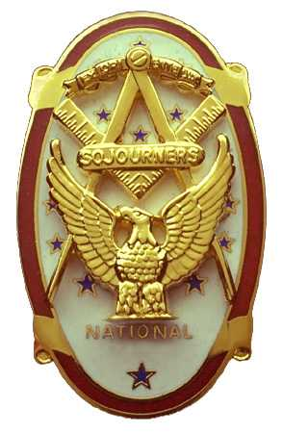
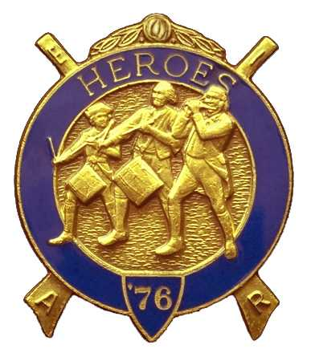
Olympic Chapter No.539
National Sojourners
And
Marvin Shields Camp of Heroes of ‘76
Edwin C. Marion P.O..Box 364
Secretary-Treasurer Forks, WA 98331-0364
edwin028@centurytel.net http://www:telebyte.com/masons/sojourn/ (360) 374-6777
Wednesday
August 27, 2008

President Darel Maxfield called upon Brother Paul Carmean to give the toast to the flag and the Pledge of Allegheny's. An outstanding job was done by Brother Paul. Lookout Fred, Paul is coming on strong and may try to replace you. Just kidding Fred. You are a hard man to replace.

Following the Toast to the Flag WB David Mac Neill did his Common Man monologue. Great job Brother David.

VWB Mike Moug was our guest speaker tonight. He gave us a look at Marvin Glenn Shields the mason from a masonic view. I found this very interesting and very informative. Thanks VW Mike, a job well done.

A letter was read from Sequim Lodge #213 requesting that Marvin G. Shields Camp Heroes of '76 once again retire the Lodge flag and replace it with a new one. This will be the flag we replaced two years ago. Seems the Lodge like what we did, they want us back a second time. WB Fred Johnson, Past President, was requested to start getting his crew together. Right off the bat Fred had most of the crew that would be needed. Answering the call was WB Fred, WB David Mac Neill, VWB Darel Maxfield, VWB Clarence Johnson, WB Bud Porter and WB Ed Marion. The job can be done with four Brothers, but is better with five or more We will use the Brown Bess Rifles.. If you have nothing to do, come on out and watch us do our stuff.

Our treasury is doing alright. We are having more income than out go. This is good, we will be using the money soon. As the old saying goes, “If you don;t spend it, then it gets old and moldy, so you got to throw it await.

Our Secretary exhibited one of four throw blankets that will be raffled off at {Pacific Beach. It was The Marine Corps one. There is a Army, Navy, and Air Force one. Sue Porter made the blankets from material given her by one of our members. We will bring them all to our meeting on the 24th, just encase someone wants to buy tickets on them if they won't be at Pacific Beach.

Sue and Bud Porter held the raffle. This helped our treasury. Thank Bud and Sue.

Before we closed, Darel called upon Steve Seteroff to do “Old Glory”. Well, Steve did it as only Steve can do it. Every time I still get that Goose Bump feeling. Great Job Steve, thanks so very much.

Darel is noted for his short meets. We closed before 2000 hours, 8 PM for you who doesn't know military time.

Edin C. Marion, Secretary/Treasure

