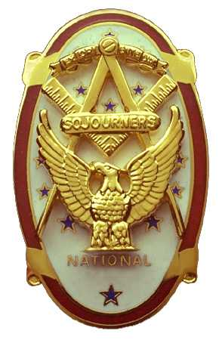
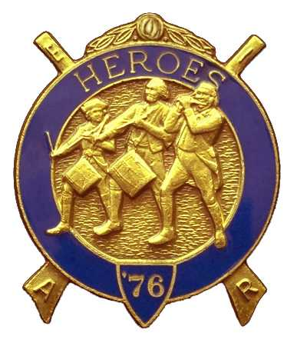
Olympic Chapter No.539
National Sojourners
And
Marvin Shields Camp of Heroes of ‘76
Edwin C. Marion P.O..Box 364
Secretary-Treasurer Forks, WA 98331-0364
edwin028@centurytel.net http://www:telebyte.com/masons/sojourn/ (360) 374-6777
Wednesday May 2,8 2008
Meeting Minutes

Prior to opening the meeting, President Fred Johnson called on Bud Porter to give the Toast to the Flag. Following the Toast, Bud called upon us all to stand and join him in the Pledge of Allegiance to the Flag. President Fred then proceeded to open the Chapter at 12:45 PM according to the Orders of Ceremonies, page 3 in the manual. Being that Frank Benson, our Chaplain, was unable to attend the meeting, President Fred called upon Clarence Johnson to fill in at the bible. Good to see you out and about Clarence, you are looking good.

Our treasurer reported that we have $2977.51 in usable funds in our account. We have $215.00 committed to the Youth Leadership fund, and $85.00 in our JROTC Medal fund.

There was no old business held over. Under new business, Steve Seteroff gave a report on our Encampment at Pacific Beach. Just to bring you up to date on the Encampment, let me go back to last years Encampment.

Being that I had attended four Encampments, and they were all the same, I felt we were missing the boat somewhere in not making the Encampment a learning experience for all who attend.. So, I wrote a letter to the ruling body of the encampment, suggesting that we used this time, not only for a time of fellowship, but also a time of improvement. I guess my letter must have hit home, as it was decided by the higher powers that we needed to come up with just more than we were doing at this time.

So, Marvin G. Shields Camp was appointed to come up with changing the way we do things at the Encampment. We were given a three years period in which to do this. Robert Colter was selected to act as Adjutant for the Encampment. It will be up to him to make the arrangements for the Encampment, but it will be up to Marvin Shields Camp, under the direction of Steve Seteroff, to come up with the way the Encampment is to be run and function.

The whole idea is to do something other than sitting around and spending all our time in the hospitality room. I know that it gets old fast. So, now we will at least have instructive classes that we can attend that may help us, we hope, to improve ourselves and our own camps. As there hasn't been much thought in the past given to activities for our ladies , to do, there has been some new activities added for the ladies. We are also open to suggestions as what we can plan for them.

Thought that I would explain about Pacific Beach for those of you that have never been there. It is run by the US Navy as a Recreational Resort and Conference Center. If you are at present in the Military Service or retired from the Military, then you and your family are eligible to use the resort. Also, the Navy rents the resort out for conventions such as we are having, just as long as someone in the group is retired military. The resort is built on the site of the Naval Undersea Warfare site, of which there is only one building that is still used. All the housing has been converted to Motel type quarters, plus they have built a motel, three stories high, plus restruant and convention facilities, plus there is a first class RV park, all over looking the ocean and beach, and all ran by civilian employees of the Navy. You would never know it has anything to do with the Navy. It is like any other tourist type resort, clean and modern. And the price is right.

Just to give you an idea, Bud Porter, Darle Maxfield and myself rent a 3 bedroom, two full bath house on the bluff over looking the beach, fully furnished, just needs us and our food, for $107.00 per night, and this is the weekend rate! This includes daily maid service, just like in the motel part. Can't beat that!

The registration fee for the Encampment has changed this year. It has gone up from $25.00 to $30.00. Everything is increasing, so, we needed to increase the registration fee.

Our Secretary, Ed Marion passed around a booklet on the Declaration of Independence and the Constitution of the United States. Ed got this booklet from his attendance at Grand Session of the York Rite. It was given to all members of the Knights Templars. Steve Seteroff made a motion, which was seconded by a group of people, that this booklet be purchased and a copy given to each member, and a few extra to hold onto for future members. This motion was passed. And at this writing, the booklets have been order and will be here before our next meeting

Sue and Bud Porter did their thing with the raffle. Some nice gifts were given out, and a total of $90.00 was raised for our treasury I know that at the Encampment at Pacific Beach, Bud and Sue have come up with some great items. I have them, but can't tell you what they are, except they are BEAUTIFUL. There was a total of $13.00 in fines.

After a very stirring rendition of Old Glory Speaks as only Steve Seteroff can do, President Fred proceeded to close the meeting, for his last time, according to the Order of Ceremonies, page 8.

Edwin C. Marion
Secretary/Treasurer

\

