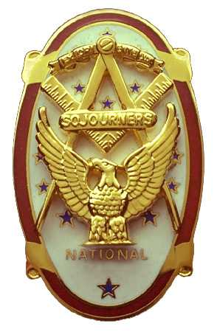
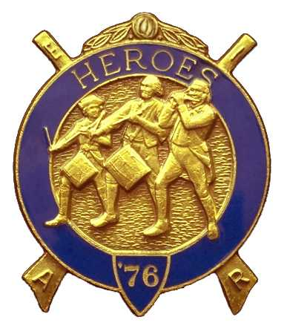
Olympic Chapter No.539
National Sojourners
And
Marvin Shields Camp of Heroes of ‘76
Edwin C. Marion P.O..Box 364
Secretary-Treasurer Forks, WA 98331-0364
edwin028@centurytel.net http://www:telebyte.com/masons/sojourn/ (360) 374-6777
Wednesday April 23, 2008
Meeting Minutes

The Chef sent in the Prime Rib to be tested, and tasted, by President Fred Johnson to see if it was fit to be eaten by those present (Almost wrote peasants)? After cutting off a nice piece and chewing it down, President Fred very reluctantly declared the meat was possibly suitable for human consumption, and that it could be served to us low mortals. So, a delicious meal was served to a very hungry group. It was GREAT!

Just a few minutes before 7 PM, President Fred Johnson opened the meeting by asking Donald Patrick, who is still a member even though he now lives in Spanaway, even though he hangs out with those Sojourner members of Fort Lewis, if he would honor us with a “Toast to the Flag”. Don did a bang up job, so we forgive you. Thanks Donald we appreciate what you did. Don then brought a special greeting to the Grand Master Wayne L. Smith, from an old and dear friend of the Grand Master, Robert Mitchell of Tacoma. Don then asked us all to stand and join him in the Pledge of Allegiance to our Flag.

Following the opening, President Fred called on our Grand Masters Wayne L. Smith, (who just happens to be a Charter Member of Olympic Chapter #539.) MW Wayne gave a very inspiring talk on a few subjects that needed talked about.. President Fred presented MW Wayne a Certificate of Appreciation for being our guest speaker for the evening, and on giving us his views on the subjects. When President Fred read the Certificate and when he got to the part where it states “I told you one of our boys would make it, and you see one did.”, everyone, including MW Wayne, got a kick out of that. Thank you MW Wayne for your inspirational talk. Just think, your great year is just about over, only two months more to go before you join the ranks of the has beens.

Ballots were passed out for election of officers to guide us for the year of 1 July 2008 to 30 June 2009. These officers will be installed at the Masonic Temple at Des Moines, WA on 7 June 2008 at the hour of 12 noon, at which time our new officers will take over. There will be a catered lunch before the installation. But keep in mind, if you are planning to attend the installation and want lunch, please let the Secretary know. We have to give them a head count before the 7th so the caterer know how many to prepare food for. Consequently, if you say you are coming and don't show, then our chapter must still pay for you. The installation is open to guests, and you must notify us if they are to be included in the head count The rule applies to your guest as well as you.

The following men were elected into Office:
Darel E. Maxfield, Sr President
Mike Moug 1st Vice President
Paul Carmean 2nd Vice President
John Richardson 3rd Vice President
Franklin Benson Chaplain
Ed Marion Secretary/Treasurer
Steve Seteroff Asst. Secretary?Treasurer

Officers elected for Marvin G. Shields Camp:
Bud Porter Commander
Paul Carmean Chief of Staff
Darel Maxfield, Sr. Assistant Chief of Staff
Robert Clubb Officer of the Day
Franklin Benson Chaplain
Ed Marion Adjutant
Steve Seteroff Assistant Adjutant

To all our new officers, may you have a great year in the office you were elected to. See you at Des Moines on 7 June 2008?

Our raffle, conducted by Bud and Sue Porter was next. Sue does all the shopping for the gifts, which they pay for, and Bud raffles them off. The money for the gifts are donated by Bud. The raffle raised total $170.00 for our treasury. Sue and Bud have a good raffle planned for PacBeach. Remember you can keep the prize in the sack, but you must return the sack. Replacements cost too much, 14 cents each. There was a $1.00 fine for not having his name tag. Shame on you Darel Sr.,and you being our President elect.

There being nothing else to come before the meeting, President Johnson proceeded to close according to Orders of Ceremonies Page 8.

Edwin C. Marion
Secretary

