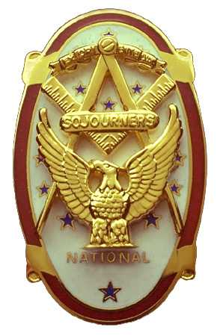
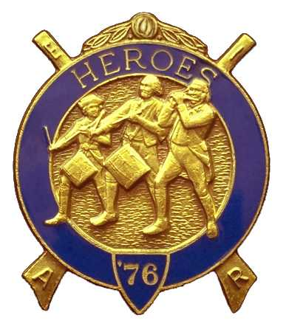
Olympic Chapter No.539
National Sojourners
And
Marvin Shields Camp of Heroes of ‘76
Edwin C. Marion P.O..Box 364
Secretary-Treasurer Forks, WA 98331-0364
edwin028@centurytel.net http://www:telebyte.com/masons/sojourn/ (360) 374-6777
Wednesday March 26, 2008
Meeting Minutes

President Fred Johnson opened the meeting in accordance with page 3 of the Orders of Ceremonies. President Fred then proceeded to give the “Toast to the Flag” as only Fred Johnson can do. Fred must practice now as he, and the team, has been asked to perform the “Toast to the Flag” at the opening of Grand Lodge, just as they did at the last Grand Lodge.

There being no Guest Speaker, so, President Fred asked that we tell just how we met our spouses. This led to many interesting and varied stores. Leave it to Fred to come up with some show stopping ideas. But Thanks Fred, I think I speak for most of us when I say we enjoyed it.

We are solvent. Our treasury stands at $2395.75 after we take out $215.00 for the Youth Leadership Conference, and $85.00 for the JROTC Awards Medal. And once again you can give a good Military Salute of thanks for the efforts of Bud and Sue Porter. Their Raffle brings in most of our available cash flow.

There were no committee reports at this time. Seems things are a bit slow right now, but we will keep trying. I will say that the membership committee is trying, they have given out a couple of applications, but haven't heard anything back on them yet.

A nomination committe was appointed by President Fred to fill the open spaces in our line officers. Those who are voted into the line will be installed on Saturday 7 June 2008. We will have a catered lunch and then the installation will take place. The installation will be done at the Des Moines Masonic Temple. May I suggest that with the price of gasoline that maaybe we car pool over and back?

It was announced that our Chapter will be holding our Annual Charter Night dinner on 23 April at
the Paradise Restruant in Sequim. Social hour will be from 5:30, with dinner to be at 6PM. You will have a choose of Prime Rib, Salmon, Chicken, or Prawns and all the trimming that goes along with them. The price will be $25.00 per person. Our speaker for the evening will be our Grand Master, Wayne L. Smith. Contact Steve Seteroff or myself for tickets reservations. This is a recommended Formal, Historical or Military Dress, if you have them, if not, what you wear at Lodge.

Bud and Sue Porter had their Raffle and raised another $60.00 for the Chapter Treasury. Once again Thanks Bud and Sue.

It was announced that the Northwest Area Encampment will be held at Pacific Beach again the weekend of the 26th, 27th, and 28th of September. This will be the first year for the new revised format that was suggested by Marvin Shields Camp, and in turn assigned our Camp to make the reivisions over the next 3 year period. It was our idea, so we get the job of implementing it.

There being no further business to come before the Chapter, President Fred closed the Chapter in accordance of page 8 of the Orders of Ceremonies.

Edwin C. Marion, Secretary/Treasurer

