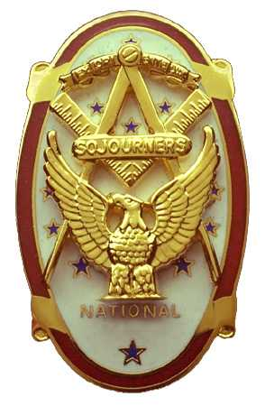
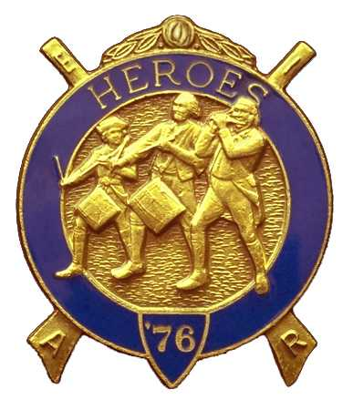
Olympic Chapter No.539
National Sojourners
And
Marvin Shields Camp of Heroes of ‘76
Edwin C. Marion P.O..Box 364
Secretary-Treasurer Forks, WA 98331-0364
edwin028@centurytel.net http://www:telebyte.com/masons/sojourn/ (360) 374-6777
Wednesday February 27, 2008

Our meeting was opened by President Fred Johnson according to Orders of Ceremonies page 3. For a while it seemed that we were going to have have 1st Vice President VWB Darel Maxfield take over the meeting. We had him primed and ready when in walked President Fred. The look on Darels face was something else. President Fred's excuse was he had a busy day, and he knew he was cutting it close to get to our meeting. Seems President Fred had to go to choir practice at his church where he is choir director, and then make his run to our meeting.. He said he had to drive fast, but refused to tell us how fast on the grounds that he might incriminate himself. You are forgiven President Fred, just don't let it happen too often.

Paul Carmean gave a very good Toast to the Flag, and then lead us in the Pledge of Allegiance to the Flag. Very good job Bro. Paul, you get better at this every time you do it.

President Fred introduced our guest speaker, Mrs. Heather Gilden, who is a member of the DAR, and who had done research on Marvin Glenn Shields for the DAR. She proceeded to give her talk on the results of her research It was very interesting. Every time someone does this we learn more about the man and his life. It seems we can never learn enough about him. Following this, President Fred presented to Mrs. Gilden a Certificate of Appreciation. Thank you Heather Gilden for making us more aware of Marvin Glenn Shields.

A petition for membership was read for SFC Henry Philip Liendecker retired US Army, Hank, as he is called by his friends, also just retired from the Clearwater Honor Camp where he was the Head Chef. A vote was taken and Hank was elected to membership. President Fred informed us that we had one member, Darel E. Maxfield Jr., Cpl US Army, who was waiting to be initiated into our organization, and if it was OK with everyone we would also initiate Hank at the sametime. Hearing no objections, President Fred proceeded to initiate our new members.

VWB Dr. Steve Seteroff, acting as marshal, escorted the two candidates to the front to start their journey into the National Sojourners. VWB Dr. Steve even gave the medal lecture, and stayed with the two new members. The new members were given a round of applause and a hardy welcome into Olympic Chapter 539.

WB Bud and Sue Porter conducted their raffle, raising $80.00 for our treasury. Thanks Bud and Sue your generosity helps keep us afloat. There were $5.00 in fines for not wearing their name badges.

VWB Steve Seteroff gave his rendition of “Old Glory Speaks”. What can I say about it? I still have a hard time with this. Really gets to me. Hard to keep a dry eye.

There being nothing further, President Fred closed Chapter according to Orders of Ceremonies as per page 8.

Edwin C. Marion, Secretary/Treasurer

