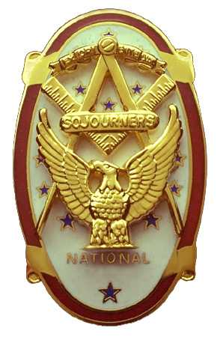
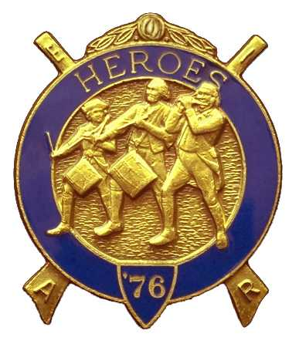
Olympic Chapter No.539
National Sojourners
And
Marvin Shields Camp of Heroes of ‘76
Edwin C. Marion P.O..Box 364
Secretary-Treasurer Forks, WA 98331-0364
edwin028@centurytel.net http://www:telebyte.com/masons/sojourn/ (360) 374-6777
Wednesday January 23, 2008

President Fred Johnson started off the meeting by proforming the “Toast to the Flag” followed by the Pledge of Allegence to the Flag. President Fred then opened the meeting according to page 3 of the Order of Cermonies.

Not too many brothers and their ladies in attendance today. At least we had a quarum. I guess it was too cold or the roads were too bad.

Being that we had no guest speaker, President Fred asked that if everyone would please tell some funny incident that had happen in their life, didn't have to be something that happened in the military, just something funny that happened to you. There were a lot of funny stories that were told.

Regional Represenitive Wendell Dutt gave a report on the Midwinter Conference. Most everything had to do with Black Brother of Prince Hall Masons, and Black Brothers such as our Brother Vern Long. They can join Sojourners and attend meetings in States that reconize and allow Black Brothers in their jurisdiction. It seems that the racial problem still exist in some states in the south.

A motion was made and seconded at our December meeting, that the By-Laws be changed to take care of the problem that we experienced over Thanksgiving of this year. Artical X Section 1. of our By-Laws now reads that the “meetings will be held on the 4th Wednesday of each month except the months of November and December, when the meetings will be held on the 3rd Wednesday.” It was proposed by Brother Steve Seteroff that the following words be added to Article X Section 1. as follows. “ when the holiday falls within the fourth week.” If we had this added to the By-Laws before the Holidays this year, then our November meeting would have been held on its regular meeting day of the 4th Wednesday, not like it was, the 3rd Wednesday of the month, which turned out this year to be the day before Thanksgiving. If you have any questions on this please call me. The new Article X Section 1 follows on a separate page.

The raffle was conducted by Bud and Sue Porter, raising a total of $55 for our treasury. Brother Bud fined himself $3.00 for not wearing his name badge. Brother Bud then fined my wife $3.00 for harassing me about money. I must admit I didn't understand what that was all about, but I did except the fines. Fred Johnson bought a new name tag and medals to go with it for $32.00. This made a total of $93.00 going into our treasury.

There being nothing else to come berfor the meeting President Fred closed the meeting according to page 8 of the Order of Ceremonies.

EDWIN C. MARION
Secretary

