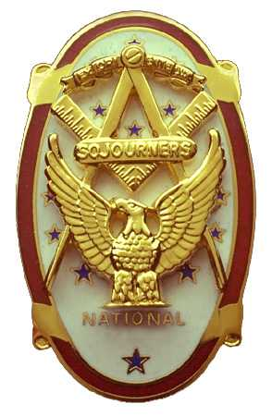
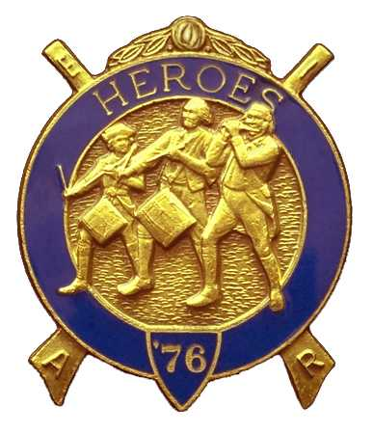
Olympic Chapter No.539
National Sojourners
And
Marvin Shields Camp of Heroes of ‘76
Edwin C. Marion P.O..Box 364
Secretary-Treasurer Forks, WA 98331-0364
edwin028@centurytel.net http://www:telebyte.com/masons/sojourn/ (360) 374-6777
December 21, 2007

Chapter was opened by President Fred Johnson in accordance with “Orders of Ceremonies, page 3”of the Sojourners manual.

Brother Paul Carmean gave the “Toast to the Flag” then lead us in the Pledge of Allegience to the Flag. Keep up the good work Brother Paul.

It seems that our guest speaker had to make a trip back East, so, she had to cancel o her scheduled speaking engagement with us. So, we just rode long with it, taking up the time with other things the Chapter had going. At least Brother Steve Seteroff was able to get a commitment from her that she would be more than happy to be our guest speaker in February, as she said, “Just remind her.”

The Candle Light Memorial Service was conducted by Brothers President Fred Johnson, Paul Carmean, Franklin Benson, and Steve Seteroff for our newly departed Brother Vern Long. Bother Vern passed away on December 16,, 2007 after a long illness. Great Arhitect of the Universe you are getting a good and great gentleman, a very active and great Mason. Take good care of him.

A discussion about the meetings for November and December was held. Dissatisfaction was had by many of the membership, both men and women, that it was inconvenient that Thanksgiving fell on the day following our meeting. I know my wife and I had to put off our trip to our son and his family for the holidays. Thanksgiving fell on the day after our scheduled meeting for November, the meeting day was moved to the moved to the 3rd Wednesday in accordance with our By-Laws. To keep this from happening again, Brother Steve Seteroff proposed an amendment to our By-Laws. This was seconded and will be voted upon at our January 23rd noon meeting.

Article X Section 1 of our By-Laws states, “Meetings will be held on the 4th Wednesday of each month, except November and December when meetings will be held on the 3rd Wednesday.” Brother Steve Seteroff proposed that we add the following words after “be held on the 3rd Wednesday “when the holiday appears in the fourth week”. If this had been in effect, then our November meeting would have been on the 4th Wednesday. The December meeting would have been as it was this year, on the third Wednesday as Christmas was in the fourth week. This next year, 2008, both Thanksgiving and Christmas appears in the fourth week, so our meetings will be in the 3rd week.

Now, we came to the raffle, which we didn't hold as we were having a White Elephant Gift Program. So, our controller of the Raffle, Bud and Sue Porter fined everyone $5 for not buying a $5 raffle ticket. This increased our funds by $100. We had a lot of fun at this and the fine was worth it.

There being nothing else to come before the meeting, President Fred Johnson closed the meeting by wishing us all a Merry Christmas and a Happy New Year.

Edwin C. Marion
Secretary

