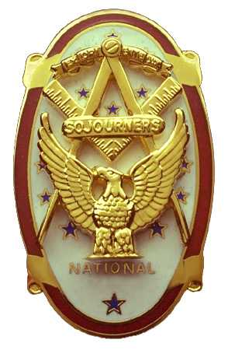
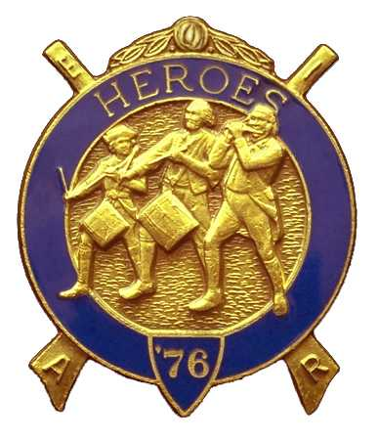
Olympic Chapter No.539
National Sojourners
And
Marvin Shields Camp of Heroes of ‘76
Edwin C. Marion P.O..Box 364
Secretary-Treasurer Forks, WA 98331-0364
edwin028@centurytel.net http://www:telebyte.com/masons/sojourn/ (360) 374-6777
November 21, 2007

The minutes of our meeting are going to be very short and sweet, as we didn't have a quarum at the meeting. But we did discuss a few things important to the Chapter. And of course we had the drawing for our raffle.

First of all, we discussed the fact that Marvin G. Shields Camp will be developing a new program for PacBeach. It seems that the ideas put forth by Marvin G. Shields Camp were good ideas and that we needed to see them take affect. So, of course, the “Powers to Be” decided that as how it was our idea for the change, then we should be the ones that should be doing the job.

Steve Seteroff will be spear heading this project, but he will be needing help snd input from all of us to make it happen. So, if you have any thoughts or ideas on this subject let Steve know. The plan is to improve on what we are doing at PacBeach, everything from how the hospitality room is going to work, to subjects that will help Chapters improve in their work.

This next meeting will be on December 19th. It will bve an evening meeting starting with our usual grip-n-grin session, followed by dinner, then the meeting. We will be holding a white Elephant Christmas Gift exchange program. This was a lot of fun last year, so we will do it again. Just bring a wrapped gift, doesn't have to be something that you just bought, it can be something you have at home that you have wanted to bless someone else with. Kathy MacNeill, if you are going to attend the meeting, we need you to be in charge of this as you were last year.

An idea has been kicking around the Chapter for about a year now, so, I am going to put this out there and see what you think. The idea is that we publish a news bulletin, containing things of interest to our members. This is encouraged by National. We would be submitting copies to National for judgement as to the news and such. Awards are given for good bulletins. Let us know what you thgink.

There being nothing else for us to talk about, the meeting broke up around 1;30 WITH EVERYONE HEADING OUT FOR TURKEY DAY.

______________________________________________
EDWIN C.. MARION, SECRETARY

