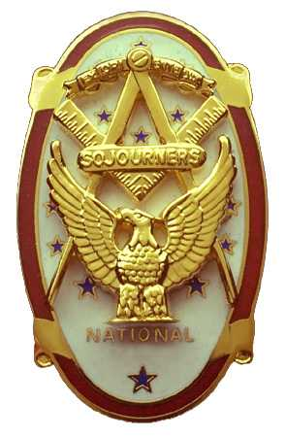
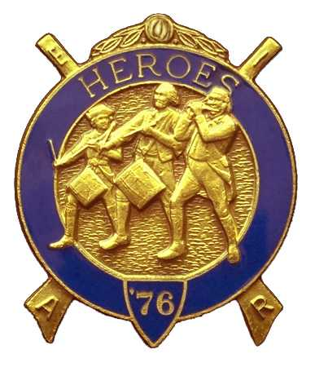
Olympic Chapter No.539
National Sojourners
And
Marvin Shields Camp of Heroes of ‘76
Edwin c. Marion P.O..Box 364
Secretary-Treasurer Forks, WA 98331-0364
edwin028@centurytel.net http://www:telebyte.com/masons/sojourn/ (360) 374-6777
Wednesday October 24, 2007

As this was our “Fall Dining Out”, Chapter was run just a bit differently than a normal meeting. “Dining Out” is planned as a serious meeting with a lot of fun thrown in There was no official”by the book” opening to the chapter. Our distinguished President, who was wearing a white dinner jacket, started things rolling by preforming the “Toast to the Flag”. A very good job was done as usual.

Our treasury is solvent. The amount available for operation is $2225.38. We are up to date on our bills. There will be two bills still to come for Marvin Shields Camp, as we have two Members of Sinclair Inlet that we have agreed to initiate on Saturday November 10th at Quilcene. We will be receiving the initiation fees for this, which will cover all needed supplies. This will go into our account to replace the money that we spent for the supplies.

There were no Committee Reports given. They will all be reported at our Luncheon Meeting in November.

There were 16 members and 12 wives or lady friends, and three guest s present.

About this time, the first of many Toast were given. The flood gates were opened and toasts to many of our present High Echelon Leaders were given. It was a very pleasurable part of the evening, not to say that the rest of the evening wasn't pleasurable.

A motion was made to pay $85.00 for the Patriot Medals given to our Flag Team members. It seems that the medals are given by Grand Lodge, as recommended by the Military Recognition Committee, but we have to pay the bill. Oh well, the Flag Team deserved this. They work hard on the Presentation Team, reminding the public how great this country is. A motion was made and seconded that we furnish one of the medals to the JROTC program each year, motion carried.

A motion was made and seconded that we reimburse David MacNeill for his cost of furnishing the medals in the past. Motion carried. David MacNeill then donated $35.00 to the future medal program. Louann Yeager then donated $15.00 to the medal program in memory of her husband Dee Yeager. This was followed by a $20.00 donation by Sue Porter. The Patriot medal Program is off to a great start!

Commander David MacNeill presented Janet Marion with a Certificate of Appreciation for jumping in and taking over running the hospitality room when it was found there was no one from Sinclair Inlet to do the job.

Steve Seteroff was called upon to give a report on Pacific Beach. Steve reported that the attendance was very poor this year, which prompted our Secretary to write a letter to the Powers to Be with suggestions as to how maybe this problem could be solved. Well, after Steve met with the heads, it was suggested that Marvin Shields Camp undertake the job of running and revamping the conference for the next three years, to initiate the recommendations made by the Command. Steve then made a motion that we accept the challenge, it was seconded by Mike Moug. A vote was called for with everyone voting for the motion.

We will be operating the bar for three years in an attempt to get into a profitable situation. Any impute or suggestions that anyone may have feel free to tell us. We will need lots of help on this. A few ideas about the bar were kicked around, but no definite plans were put forth. We will be working on this in the next few months. Like I say, if you have any ideas on this subject, please let us know.

Bud and Sue Porter did their raffle thing and they were able to raise $110.00 that will offset our Youth Leadership Program.

We received $16.00 in fines levied.

The Chapter was closed by President Fred, following the prayer by Frank Benson.

_______________________________________
Edwin C. Marion, Secretary

