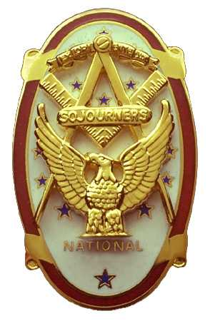
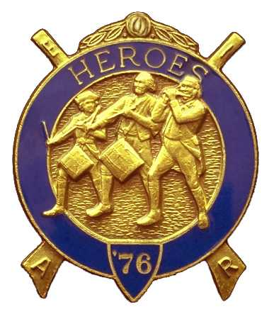
Olympic Chapter No.539
National Sojourners
And
Marvin Shields Camp of Heroes of ‘76
Edwin c. Marion P.O..Box 364
Secretary-Treasurer Forks, WA 98331-0364
edwin028@centurytel.net http://www:telebyte.com/masons/sojourn/ (360) 374-6777

September 26, 2007

Chapter was opened by VWB Mike Moug, our 2nd Vice president. Our 1st Vice President, Darel Maxfield was working, and our President was off playing somewhere I am told. Rumor has it that Brother Fred was down south, near Las Vegas. Need I say more on the subject? Franklin Benson attended the Bible and prayer.

The Toast to the Flag was given by VWB Steve Seteroff, and as usual, a very excellent job Steve! Steve also lead us in the Pledge of Allegiance.

Our treasury is still solvent. Available for operations is $1985.75. All our bills are paid, and we have money in the bank. What could be better than that? Of course, this is all due to the outstanding efforts of Bud and Sue Porter, who have been running our raffles. A tip of the hat to you two.

There was nothing to report on Committee Reports at this time. I guess it was a slow month.

There were 12 members and 6 ladies present. The only person who didn't have his name tag was Steve Seteroff. Steve was fined two dollars, one for not wearing his name tag, and one for throwing his fine money onto the table.

Brother Dick Dexter filled out an MIP application, (with money), for membership.

Pacific Beach was discussed at length. Seems our Chapter has been asked to do the Build the Flag and Disposal of the Flag programs, with just a few changes. Instead of Building the Flag itself there will be a slide program developed by Joe Illes and Wendell Dutt. We will do our regular introductions to the program, Toast to the Flag, by Fred Johnson; Patriotism program by David MacNeill; and Old Glory speaks by Steve Seteroff. The Brown Bess Musket team will be there.

Talking with Hank Carman, President of Sinclare Inlet #80, the Host Chapter at Pacific Beach, it turns out they don't have anyone to man the Hospitality Room. Joyce Seteroff and Janet Marion stepped forward and said they and some of the other ladies would see that was covered. If they do half as good of a job as they did when we were the host chapter, then Sinclare Inlet has nothing to worry about. Thanks ladies.

Speaking of raffle, we held ours and $60 was raised. Great job Bud and Sue.

Every one was reminded that our meeting on October 24th will be our Fall Dinning out night. This will be a catered dinner, the price is $25 per person which covers everything, and will be at the Paradise Restaurant in Sequim. The main course will be a choice of Prime Rib, Salmon, Chicken or Prawns. The cut off date on this will be October 22nd, so get your reservation as soon as you can. Call Ed Marion at 360-374-6777 to reserve your tickets, or drop him a line at edwin028@centrytel.net. Remember, to attend the dinner portion of the October meeting you must make reservations with Ed Marion by October 22nd . No ticky no food.

On Saturday September 29th, Marvin Shields Camp will be conferring the Heroes Degree on VWB Bill Heckman before he goes south for the winter. This will start at 1000 hours at Quilcene-Jefferson Lodge. No reservation required for this, just show up.

Following the raffle, the meeting was closed by Dick Dexter delivering Old Glory. Great job Dick.

Edwin C. Marion
Adjutant

