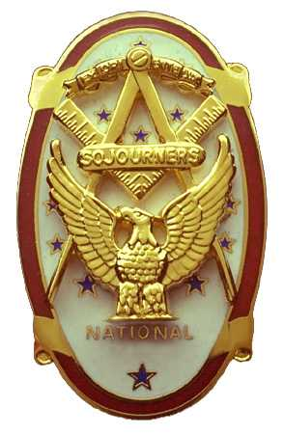
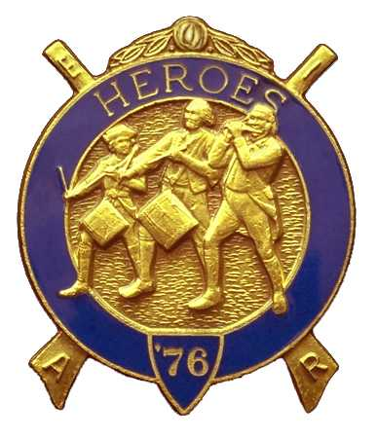
Olympic Chapter No.539
National Sojourners
And
Marvin Shields Camp of Heroes of ‘76
Edwin c. Marion P.O..Box 364
Secretary-Treasurer Forks, WA 98331-0364
edwin028@centurytel.net http://www:telebyte.com/masons/sojourn/ (360) 374-6777

August 22, 2007

Following the “Toast to the Flag” by Paul Carmean, who also lead us in the Pledge Alleglance to the Flag, President Fred Johnson opened the Chapter, assisted by the Chaplain Clarence Johnson, no relation to Fred, attending the Bible and Prayer. Thank you very much Paul, you did a good job. We at least now have another member who we can rely on for the “Toast to the Flag.”

Our treasury remains solvent, increasing just a little bit each month due to the efforts being put forth by Bud and Sue Porter. With out them our treasury wouldn't be in the good shape it is in. This allows us to purchase most everything we need to function as a Chapter. A tip of the hat to you, Bud and Sue.

President Fred called upon the Marshall, John Richardson, to check for members, including the ladies, who were not wearing their name tags. Of course the first one caught was our Marshall. Sorry about that John. Only one brother, Paul Carmean and one lady, Janet Marion were without their name tags. So, a fine of $1.00 was imposed upon these bad people. Helps our treasury to grow.

Following Name Tag Inspection, President Fred explained our new policy regarding the women wearing name tags. As the women are a virtual members of the organization, we thought that they too should have to wear a name tag, and be subject to the fines the same as the men. The ladies are requested to give their names to our Secretary so we can provide them with a name tag. The name tags cost $4.00. If you are going to be attending the noon meeting in September, and you don't have a name tag, call Ed Marion at 360-374-6777 or contact him by e-mail at Edwin028@centrytel.net and he will get one for you. This doesn't apply to the ladies that attended the meeting on the 22nd because he has already ordered your name tags.

One petition for membership was read for Darel E. Maxfield Jr. The petition was approved, and will be acted upon on October 24 at our evening meeting as he has to work.

President Fred requested that Darel Maxfield Sr. To come forward. Brother Darel was presented with a citation for his efforts and involvement in the Flag Presentation team. He was also give a certificate for his Honorary Membership.

President Fred then requested Kathy MacNeill come forward. President Fred then presented a National Presidents Citation to Kathy for all her work for the Chapter.

President Fred then called upon Brother Ron Novak, our guest speaker, who talked upon the subject of Ft. Worden, which is very close to his heart. Brother Ron is involved in the building the museum. He gave the talk on the history of Ft. Worden from its beginning to the present time. His committee is attempting to restore some of the gun inplacements and gun sites. It was a very interesting talk, and brought back good and bad memories to some of us ex-members of the Armed Forces. Thanks for the interesting trip down memory lane Ron.

The raffle was held and $145.00 was added to our treasury, along with the $3.00 we collected in fines. Following tradition, $22.00 of the money was used to cover the cost of our speakers dinner.

It was announced by Commander David MacNeill that there would be a joint bivouac with Lewis and Clark Camp at the Elks Lodge in Bremerton on September 14th at 1800 (6 PM) Hours. They need help to initiate a member. As many brothers that can make it are requested to do so.

There be nothing else to come before the Chapter, President closed the Chapter according to page 8 of the Order of Ceremonies.

Edwin C. Marion
Secretary/Treasurer

