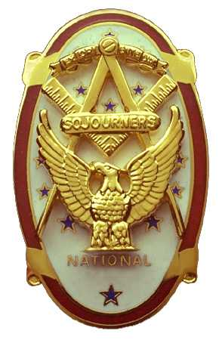
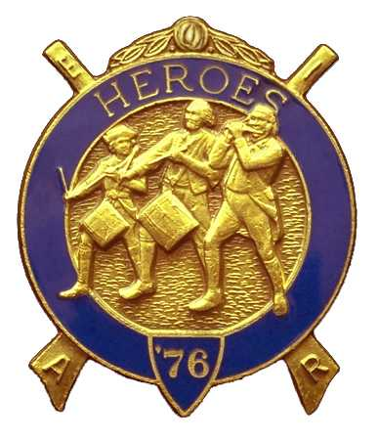
Olympic Chapter No.539
National Sojourners
And
Marvin Shields Camp of Heroes of ‘76
Edwin c. Marion P.O..Box 364
Secretary-Treasurer Forks, WA 98331-0364
edwin028@centurytel.net http://www:telebyte.com/masons/sojourn/ (360) 374-6777

July 25, 2007

Chapter was opened by our President, Fred Johnson, at 1250 Hours. There were 29 members, Ladies and guests present. President Fred called on Brother Don Patrick to give the toast to the flag, Good job, Don!

Wendell Dutt, our Regional Representative brought some citations to be awarded to members of our Chapter. First of all, Bud Porter was awarded a National President Citation for his efforts in fund raising and membership. Ed Marion was given a Presidential Citation for his efforts in procuring our new Historical Flags and for his efforts in getting the Brown Bess Muskets and honor guard. Steve Seteroff was given an award for 3rd place for the Best Secretaries job nation wide.

Following the opening of Chapter, President Fred introduced our guest speaker, Eric McKay, who was one of the delegates to the Youth Leadership Conference. (also is the Grandson of Sue and Bud Porter.) Eric told about his experience, everything from getting to drive personnel carrier, (Tank like vehicle), to meeting the governor. He thanked the Chapter for allowing him to go on this most rewarding and fun filled adventure..

Following Eric's rendition of his adventure, President Fred presented Eric with a Certificate of Appreciation, but there was one thing wrong with that. Eric's last name was spelled wrong. Before you get carried away on this one, remember I was born, raised and educated in the hill country of Kentucky. We weren't taught too much about spelling, just how to raise hogs, tobacco, and that liquid made from corn and molasses. Anyway, I have made a new Certificate for Eric, and will get it to him through Bud.

Our treasury is still solvent at this time. Our raffle is paying off. We do have a little more expense at this time of the year, but we can handle it. Sue and Bud Porter are doing a wonderful job with the raffle. We are able to purchase most everything we need for the Chapter, and take care of some of our special projects. Speaking of the raffle, it seems that Earl Riggs, our newest member, and his wife both won prizes. Good way to start off your membership.

We had one candidate for the Chapter to be initiated, C. Earl Riggs, a retired Gunnry Sgt. from the Marine Corps. President Fred was assisted in the initiation by Clarence Johnson, Chaplain; Fred did the medal lecture himself. And now we have a new junior member of the chapter.

On Saturday, July 21, 2007, Marvin Shields Camp was to have an initiation at Quilcene-Jefferson, but our candidate got sick and couldn't make it to the meeting. A new date will be set for some time next month. At this time we have this candidate and one other to bring into Marvin Shields Camp. I will notify everyone when the date for our next bivouac's has been decided.. If you are a member of Heroes, be sure to come out to assist us in this. The more members we have out, the better it is.

A new wrinkle has been placed in effect with the Chapter. We are asking the ladies wear a name tag similar to the one worn by the men. If you are not wearing one, you could be subject to a $1.00 fine the same as the men. Ladies wanting a name tag, please contact Ed Marion at 360-374-6777. The tags are $4.00 plus tax.

We made $105.00 from our raffle. There were two fines levied, a $1.00 from Steve Seteroff for forgetting his badge. I was fined $10.00, at the suggestion of my own wife, for failing to bring our newest member his manual and membership card. It is still setting on the counter by the back door so that I wouldn't forget. I walked out the back door and never thought of that stuff until I was supposed to present then to him.

President Fred proceed to close the Chapter according to the order of Ceremonies as show on page 8 of the manual.

Edwin C. Marion
Secretary/Treasurer

