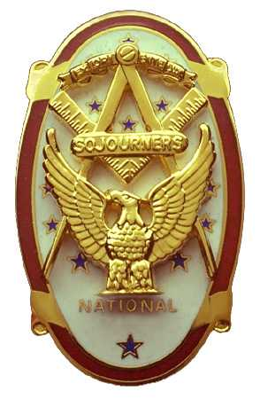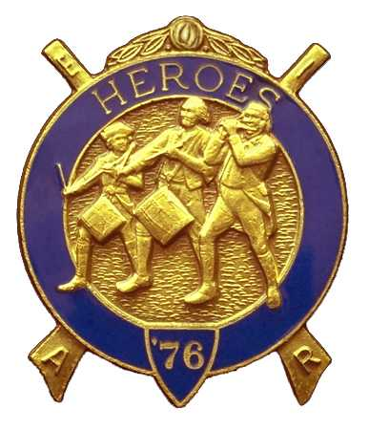
Olympic Chapter No. 539,
National Sojourners
And
Marvin Shields Camp of Heroes of 76

Edwin C. Marion P.O. Box 364
Secretary-Treasurer Forks, WA 98331-0364
edwin028@centrytel.net http://www.telebyte.com/masons/sojourn/ (360) 374-6777

June 27, 2007

Twenty-nine members and guest gathered at the Paradise Restaurant in Sequim for the first scheduled meeting of the up-and-coming new Chapter year. Our new President Fred Johnson opened the chapter meeting, with Franklin Benson, Chaplain Pro Tem, attending the bible. Ron Campbell delivered the “Toast to the Flag”. A good job was done by Fred for his first as president, even though he did n't have his usual “base” in his hands. All in all, the opening was good by all.

We remain solvent and the treasury stands at $2066.38, which includes $215.00 committed to the 2008 Youth Leadership Conference, leaving $1851.38 available for Chapter operations.

A request was made to President Fred Johnson by Robert Clubb, Officer-of-the-Day for Marvin Shield Camp, that the Camp be permitted to conduct a Candle Lighting Memorial Service for a deceased Brother, Chester Olszta. President Fred granted the request and Commander David MacNeill took charge of the service. Commander David assigned the Red Candle to Fred Johnson; the White Candle to Steve Seteroff; the Blue Candle to Mike Moug. And the Chaplain was Franklin Benson. A very good job was done by all. Comments were made of their memories of working with Brother Olszta by Steve Seteroff and Fred Johnson. We are going to miss you and remember you Chester.

Ron Chase introduced our guest speaker, Joan Bennett, widow of Marvin G. Shields MOH. Joan Bennett is a cousin of Ron's wife,

Joan Bennett gave a very inspiring insight into the life of Marvin Glenn Shields, an insight that could only be given by his widow. She told of his early years, his school years and his life growing up poor but honorable in the Port Townsend area. He graduated from the Port Townsend school system, playing football for Port Townsend High School. Following graduation, he worked at different jobs. One of these jobs was working in a saw mill owned by VWB George Brown and his father, both of whom were Mason's .. It was felt that this association with VWB George and his father prompted Brother Marvin Joint Jefferson Lodge at an early age.

Joan Bennett informed us that the new SeaBee Museum at Port Hueneme California, is being built outside the gate to the main entrance, so that more people could visit it without having to go through a lot of security check by coming on Post. To accomplish this, it required the front gate entrance to the post be moved back quite a ways. This was done as an honor to the first navy Seabee to receive the MOH. Also, there is one of the Camp of Heroes of '76 in Kentucky to make Marvin a MIP.

Following her presentation on the life of Marvin Glenn Shields, given from a widows point of view, she was presented a Certificate of Appreciation by Commander David MacNeill. The Certificate was our way of thanking Joan Bennett for allowing us to name our Heroes Camp in honor of her late husband.. Joan Bennett was given a standing ovation by all present.

Our treasury is solvent at this time. We have $2066.38 in our checking account. $215.00 is earmarked for 2007 Youth Leadership Conference, leaving us $1851.38 in operating funds.

We received two letters from Soroptomistr members, President Prue Miller and Pat Kaine, telling us how much they enjoyed our Building the Flag program

Two petitions were read for membership in our Chapter, both were first-time hopefuls. A vote was taken and Mr. (Cpl) Scot Alan Rodmsn (Army) and GunnerySgt, Cedric Earl Riggs (USMC) were elected to membership in Olympic Chapter 539 National Sojourners. They will be inducted at our next meeting.

Commander David MacNeill reported upon the activities at Grand Lodge involving Marvin G. Shields Camp. The Camp was led into the Grand Lodge by President Fred Johnson, followed by our Brown Bess Musket Team of David MacNeill and Ed Marion. Then came the US Flag, carried by Darel Maxfield and the Canadian Flag carried by Steve Seteroff.. They were followed by Don Patrick and a member of Spokane Chapter, ( sorry I didn't get his name.). All were in Continental Uniforms. After the entry, President Fred gave the Toast to the Flag. This was very well received by all present.

The Raffle added another $116.00 to our funds. Out of this $116.00, $18.00 was used to pay for the dinner of Joan Bennett, our guest speaker.

Steve Seteroff gave his rendition of Old Glory as only Steve can do. There were a few moist eyes around.

President Fred Johnson proceeded to close the Chapter by Order of Ceremonies on page 8.

Edwin C. Marion
Secretary?Treasurer7

.

CommCo

