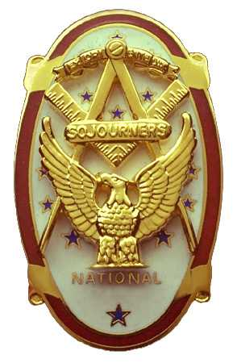 | Olympic Chapter No. 539,  National Sojourners  and  Marvin Shields Camp of Heroes of ‘76 |  |  | 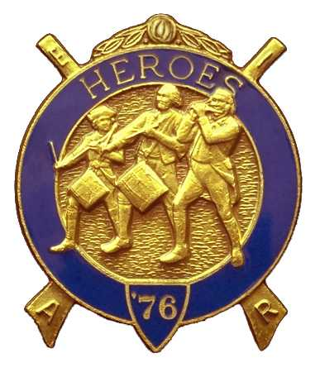
S. Steve Seteroff  Secretary-Treasurer |  |  | PO Box 847  Quilcene, WA 98376
seteroff@earthlink.net |  | http://www.telebyte.com/masons/sojourn/ | (360) 765-3050

May 23, 2007

Twenty-one members and guests gathered at the Paradise Restaurant for the last scheduled meeting of the current team. President Ed Marion opened the chapter meeting, with Clarence Johnson attending the Bible and Fred Johnson delivering the Toast to the Flag.

We remain solvent and the treasury stands at $2,020.05, which includes $110.00 committed to the 2008 Youth Leadership Conference, leaving $1,910.05 available for operations.

Our Americanism or Bridge of Light committees report no activity since the last meeting. Bud Porter reports one potential application remains pending. We have names for 10 high school students to attend the Northwest Youth Leadership Conference.

We were pleased to present Bud Porter with the Numeral “5” in recognition of his efforts in obtaining five new members.

President Ed Marion presented Certificates of Appreciation to Sue Porter, Janet Marion, Joyce Seteroff, and Kathy MacNeill for their individual efforts to further the purposes of national Sojourners. Additional Certificates of Appreciation were presented to members of the Presentation Team, consisting of Fred Johnson, Morris “Mike” Moug, David MacNeill, Clarence Johnson, Steve Seteroff, Bud Porter, Ed Marion, and Darel Maxfield. Ed Marion then presented a Certificate of Service to Morris “Mike” Moug as Camp Commander of Marvin Shields Camp.

David MacNeill reported a scheduled performance of the Toast, Patriotism, and Flag for the Order of the Eastern Start in Bremerton on the evening of June 7.

Our camp will be opening Grand Lodge in Kennewick on Thursday, June 14 with the Brown Bess Musket Team leading the colors. Fred Johnson will present a Toast to the Flag at the express request of the Grand Master who heard his rendition at Quilcene-Jefferson Lodge a few months ago.

The Joint Installation of 2007-2008 Officers will be held at 1300 on Saturday June 2, 2007 at the Des Moines Masonic Center. Sinclair Inlet Chapter 80 is the host chapter this year and Hank Carman is the tip of the spear for the arrangements. The following brothers were selected to lead our chapter and the Marvin Shields Camp of Heroes for the year 2007-2008.

President | Fred Johnson
First Vice President | Darrell Maxfield
Second Vice President | Morris “Mike” Moug
Third Vice President | Dave Larson
Chaplain | Clarence Johnson
Secretary-Treasurer | Ed Marion
Assistant to Sec-Treasurer | S. Steve Seteroff

Commander | David MacNeill
Chief of Staff | Bud Porter
Assistant COS | Paul Carmean
Officer of the Day | Robert Clubb
Chaplain | Clarence Johnson
Adjutant | Ed Marion
Assistant Adjutant | S. Steve Seteroff

We will be unable to send a representative to the national Convention this year because it conflicts with the Annual Communication of the Grand Lodge. Neither Joseph Illes not Wendell Dutt will be able to represent our chapter due to commitments to other chapters.

The raffle resulted in a donation of $105 and is added to fund our Youth Leadership Conference participation for 2008.

Our June meeting will be a dinner meeting at 1800 on Wednesday, June 27 at the Paradise Restaurant in Sequim. We will be honored to host Ms. Joan Bennett, widow of Marvin Shields for whom our Camp is named.

David MacNeill delivered the Patriotism Lecture and the meeting was closed by President Ed Marion with Clarence Johnson attending the Bible.

This is my last report as your Secretary-Treasurer and Camp Adjutant. I thank you for the privilege of serving our chapter for this past year and I will stand ready to assist as directed by Ed Marion, our incoming Secretary-Treasurer and Camp Adjutant, while I take on my duties as the Deputy of the Grand Master for District 11, Thank you very much for all your support this past year.

Steve Seteroff
Secretary-Treasurer

