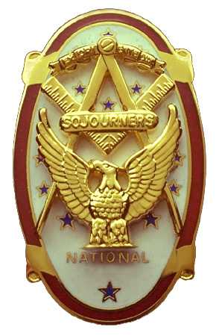 | Olympic Chapter No. 539,  National Sojourners  and  Marvin Shields Camp of Heroes of ‘76 |  |  | 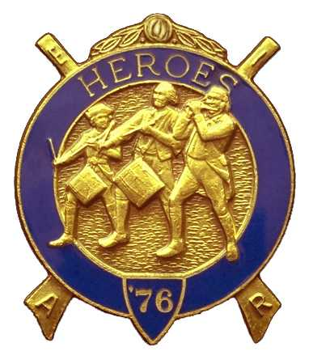
S. Steve Seteroff  Secretary-Treasurer |  |  | PO Box 847  Quilcene, WA 98376
seteroff@earthlink.net |  | http://www.telebyte.com/masons/sojourn/ | (360) 765-3050

April 25, 2007

Thirty-eight members and guests gathered at the Paradise Restaurant for our Fourth Anniversary Dinner meeting. President Ed Marion opened the chapter meeting, with Franklin Benson attending the Bible and Fred Johnson delivering the Toast to the Flag.

Our guest speaker was introduced by David MacNeill. Mr. David Gilliand from the WA State Senior Protective Services who spoke on elder abuse and scams aimed at elders. There were several questions and some discussion, so the talk was appropriate and apparently timely. President Ed Marion presented our speaker with a Certificate of Appreciation

We remain solvent and the treasury stands at $4,940.21, which includes $2,750.00 committed to the 2007 Youth Leadership Conference, $212 for Memorial MIP, and $814 reserved for the dinner, leaving $1,164.21 available for operations. Unpaid dinner reservation total $625 and the totals do not reflect the check for $211.68 in MIP Dividends received from nation but not incorporated into the account.

Since the last report, we have added 2 Americanism and 5 Bridge of Light performances to our annual total.

We received an MIP from our brother Henry Carman of Sinclair Inlet Chapter, and with the proceeds of the raffle will purchase two MMIPs for deceased charter members George “Don” Clark and John J. Freitas as previously voted by the members.

We have names for 10 high school students to attend the Northwest Youth Leadership Conference, but were unable to secure cooperation from the three schools in the West End to complete our 13-billet commitment, but nearly doubled our response from last year. The goal remains to fill 15 billets each year.

Our chapter will be opening Grand Lodge in Kennewick on Thursday, June 14 with the Brown Bess Musket Team leading the colors. Fred Johnson will present a Toast to the Flag at the express request of the Grand Master who heard his rendition at Quilcene-Jefferson Lodge a few months ago.

The following brothers were selected to lead our chapter and the Marvin Shields Camp of Heroes for the year 2007-2008. Installation will be on June 2 in Des Moines.

President | Fred Johnson
First Vice President | Darrell Maxfield
Second Vice President | Morris “Mike” Moug
Third Vice President | Dave Larson
Chaplain | Clarence Johnson
Secretary-Treasurer | Ed Marion
Assistant to Sec-Treasurer | S. Steve Seteroff

Commander | David MacNeill
Chief of Staff | Bud Porter
Assistant COS | Paul Carmean
Officer of the Day | Robert Clubb
Chaplain | Clarence Johnson
Adjutant | Ed Marion
Assistant Adjutant | S. Steve Seteroff

The raffle resulted in a donation of $110 to complete our MMIP objectives and begin to fund our Youth Leadership Conference participation for 2008. We were pleased to include a flag donated by Joseph Illes, in the raffle and a string of Chinese cultured pearls as a door prize.

Our May meeting will be a luncheon meeting at 1200 on Wednesday, May 23 at the Paradise Restaurant in Sequim.

David MacNeill delivered the Patriotism Lecture and Steve Seteroff delivered Old Glory. The meeting was closed by President Ed Marion with Franklin Benson attending the Bible.

Steve Seteroff
Secretary-Treasurer

