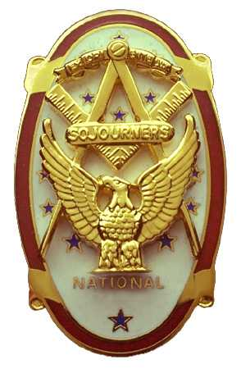 | Olympic Chapter No. 539,  National Sojourners  and  Marvin Shields Camp of Heroes of ‘76 |  |  | 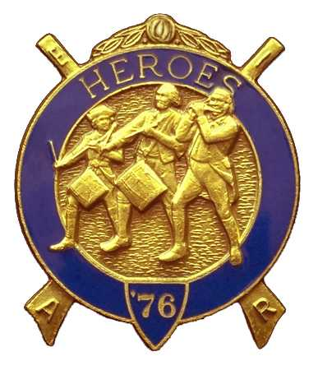
S. Steve Seteroff  Secretary-Treasurer |  |  | PO Box 847  Quilcene, WA 98376
seteroff@earthlink.net |  | http://www.telebyte.com/masons/sojourn/ | (360) 765-3050

March 28, 2007

Nine members and guests gathered at the Paradise Restaurant for our regular luncheon meeting. President Ed Marion opened the chapter meeting, with Fred Johnson attending the Bible and delivering the Toast to the Flag.

Our Grand Master has requested that our chapter present the colors and that Fred Johnson perform the Toast to the Flag at the opening session of Grand Lodge at 0800 on Thursday, June 14, 2007. The Broiwn Bess Musket Team will be available to assist.

We remain solvent and the treasury stands at $4,624.21, which includes $2,750.00 committed to the 2007 Youth Leadership Conference, and $172 for Memorial MIP, leaving $1,702.21 available for operations.

Br. Eric Anticivich was inducted with Robert Clubb serving as Marshall, David MacNeill delivering the monitor lecture, President Ed Marion administering the obligation, and Fred Johnson delivered the Medal Lecture.

Our April meeting is our 4th Anniversary Dinner at 1800 on Wednesday, April 25 at the Paradise Restaurant in Sequim.

The meeting was closed by President Ed Marion with Fred Johnson attending the Bible.

Five members and guests continued to Port Angeles for the Underground Tour.

David MacNeill for
Steve Seteroff
Secretary-Treasurer

