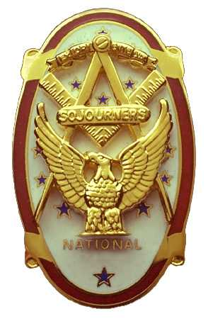 | Olympic Chapter No. 539,  National Sojourners  and  Marvin Shields Camp of Heroes of ‘76 |  |  | 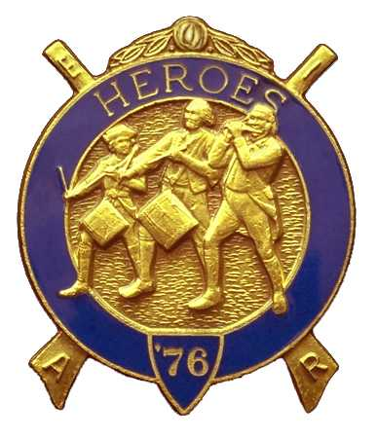
S. Steve Seteroff  Secretary-Treasurer |  |  | PO Box 847  Quilcene, WA 98376
seteroff@earthlink.net |  | http://www.telebyte.com/masons/sojourn/ | (360) 765-3050

February 28, 2007

Twenty-one members and guests gathered at the Paradise Restaurant for our regular evening meeting. President Ed Marion opened the chapter meeting, with Clarence Johnson attending the Bible. David Larson delivered the Toast to the Flag.

Our guest speaker, Kathy Charlton, spoke on wine micro-climates present on the Olympic Peninsula.

We remain solvent and the treasury stands at $4,639.08, which includes $2,750.00 committed to the 2007 Youth Leadership Conference, and $172 for Memorial MIP, leaving $1,707.08 available for operations.

Sadly, we had no Americanism performances since our last meeting, but did record three Toasts to the Flag and one Patriotism performances.

Br. Joe Anticivich was inducted with Dave Larson delivering the monitor lecture, President Ed Marion administering the obligation, and Clarence Johnson delivered the Medal Lecture.

A proposal to change the bylaws was tabled except that the portion related to holding election of officers in April passed.

Our March meeting is at 1200 on Wednesday, March 28 at the Paradise Restaurant in Sequim. Immediately following the meeting, we will caravan to Port Angeles for the long awaited tour of the Port Angeles Underground.

Clarence Johnson delivered the Old Glory Monologue and the meeting was closed by President Ed Marion with Clarence Johnson attending the Bible.

David MacNeill for
Steve Seteroff
Secretary-Treasurer

