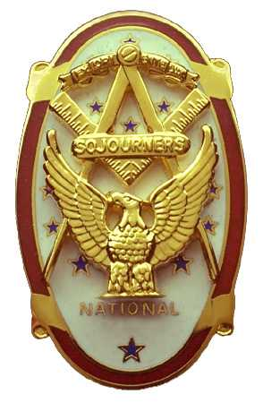 | Olympic Chapter No. 539,  National Sojourners  and  Marvin Shields Camp of Heroes of ‘76 |  |  | 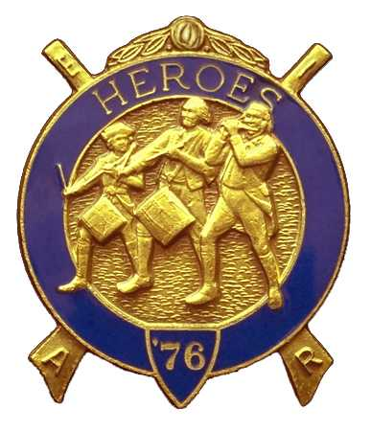
S. Steve Seteroff  Secretary-Treasurer |  |  | PO Box 847  Quilcene, WA 98376
seteroff@earthlink.net |  | http://www.telebyte.com/masons/sojourn/ | (360) 765-3050

January 24, 2007

Seventeen members and guests gathered at the Paradise Restaurant for our regular luncheon meeting. President Ed Marion opened the chapter meeting, with Clarence Johnson attending the Bible. Fred Johnson delivered the Toast to the Flag.

We remain solvent and the treasury stands at $2,446.63, which includes $750.00 committed to the 2007 Youth Leadership Conference, and $82 for Memorial MIP, leaving $1,614.63 available for operations.

Sadly, we had no Bridge of Light or Americanism performances since our last meeting.

Bud Porter sponsored two petition for membership for Br. Eric and Joe Anticevich, resulting in their election to honorary membership.

Br. Koyote Keen-Eye who inducted with Franklin Benson delivering the monitor lecture, President Ed Marion administering the obligation, and Joseph Illes delivered the Medal Lecture.

Steve Seteroff reported that the 2007 Youth Leadership Conference commitments to date include Port Townsend Lodge (2), Quilcene-Jefferson Lodge (2), Mt. Olympus Lodge (3), and Scottish Rite Bremerton Valley (2). Olympic Chapter has funds set aside for three (3) and we able to contribute 12 billets from the Olympic Peninsula.

Ed Marion provided a report on the mid-Winter Conference and Joseph Illes, President of NASOCOCO and a member of the Committee of 33 responded to questions.

A proposal to change the bylaws to read as follows

- Amend Section X Meetings to read as follows:

In order to appeal to a broad range of eligible individuals, we will alternate our meetings between daylight and evening on a schedule changes to meeting schedules will be determined by a majority of the members present at a scheduled meeting.

- Meetings will be held on the 4th Wednesday of each month, except November and December when meetings will be held on the 3rd Wednesday.
    - Odd numbered months, meetings will be held during the day.
    - Even numbered months, meetings will be held in the evening.

- The annual meeting and election of officers will be held at the scheduled April May meeting.

Was introduced and generated considerable discussion. The resolution is in proper order and will be brought before the members at the next meeting as required by the current by-laws. The secretary was directed to generate an email setting forth the rationale and seek advisory commentary by email to be presented to the members at the next meeting so that comments from those who are not present can be considered before balloting takes place.

The members passed a resolution to continue participation in sharing the area convention advertisement for the national convention.

Our March 2007 Meeting will follow our luncheon with a tour of the Port Angeles Underground, as previously offered by the operator. Kathy MacNeill is coordinating the event and will provide additional information at the next meeting.

LouAnne Yager has asked our Heroes to attend her Honor Night in continental uniform at 7:30 PM on Monday, March 12, at the Port Angeles Masonic Temple.

The raffle contributed $90 to the MMIP fund.

Our February meeting is at 1800 on Wednesday, February 28 at the Paradise Restaurant in Sequim..

Joseph Illes delivered the Old Glory Monologue and the meeting was closed by President Ed Marion with Clarence Johnson attending the Bible.

Steve Seteroff
Secretary-Treasurer

