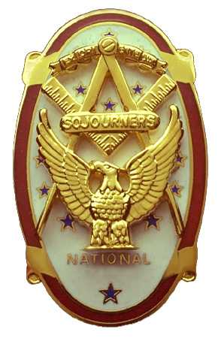 | Olympic Chapter No. 539,  National Sojourners  and  Marvin Shields Camp of Heroes of ‘76 |  |  | 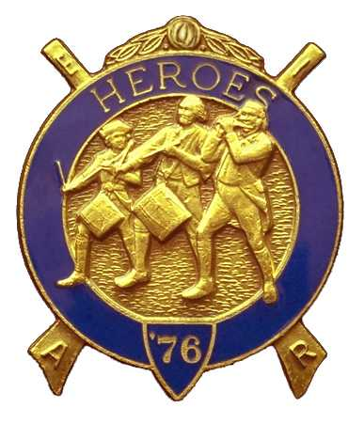
S. Steve Seteroff  Secretary-Treasurer |  |  | PO Box 847  Quilcene, WA 98376
seteroff@earthlink.net |  | http://www.telebyte.com/masons/sojourn/ | (360) 765-3050

December 20, 2006

Twenty-two members and guests gathered at the Paradise Restaurant for our regular evening meeting. In compliance with the chapter by-laws, we meet on the third Wednesday in November and December. President Ed Marion opened the chapter meeting, with Franklin Benson attending the Bible. David MacNeill delivered the Toast to the Flag.

We remain solvent and the treasury stands at $2,303.63, which includes $737.00 committed to the 2007 Youth Leadership Conference, leaving $1,566.63 available for operations.

Since the last meeting, we have recorded one Bridge of Light and one Americanism performances.

Bud Porter sponsored a petition for membership for Br. Koyote Keen-Eye who was elected to membership. Bud Porter also reported three additional petitions are pending presentation.

David MacNeill presented the chapter flag and John Rowe Richardson, our newest SEM Fund Member affixed the 3-6-5 streamer.

Steve Seteroff reported that the 2007 Youth Leadership Conference commitments to date include Port Townsend Lodge (2), Quilcene-Jefferson Lodge (2), Mt. Olympus Lodge (3), and Scottish Rite Bremerton Valley (2). At this point Olympic Chapter has funds set aside for two and will fund three after the raffle this evening. We should be able to contribute 12 billets from the Olympic Peninsula.

David MacNeill reported the National Sojourners 2007 Essay Contest had no response whatsoever, in spite of a concentrated effort to solicit support from the schools.

A motion to allocate raffle proceeds to the purchase of MMIP for our departed charter members, after the required $750 for three Youth Leadership Conference billets are funded, was passed.

Ed and Janet Marion, Bud and Sue Porter, David and Kathy MacNeill, and Steve and Joyce Seteroff will attend the January mid-Winter Conference in Salem, Oregon on January 17-20.

Wayne Smith, if elected Grand Master in June, has affirmed his desire to continue our effort to attend fill the lodge nights clothed in continental uniform.

Kathy MacNeill suggested that we follow our March 2007 Meeting with a tour of the Port Angeles Underground, as previously offered by the operator. There will be a small fee for the tour. The tour would immediately follow a brief luncheon meeting. This was agreeable to all and Kathy will coordinate with YouAnne Yager to schedule the event.

The raffle contributed $95 to the Youth Leadership Conference and MMIP fund.

Our January meeting is at 1200 on Wednesday, January 24 at the Paradise Restaurant in Sequim..

Clarence Johnson delivered the Old Glory Monologue and the meeting was closed by President Ed Marion.

Steve Seteroff
Secretary-Treasurer

