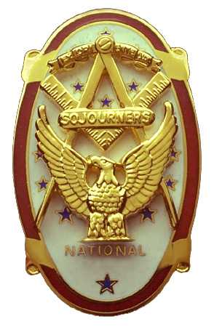 | Olympic Chapter No. 539,  National Sojourners  and  Marvin Shields Camp of Heroes of ‘76 |  |  | 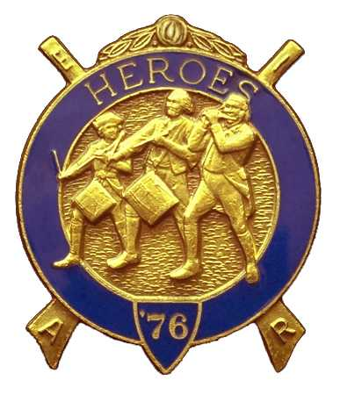
S. Steve Seteroff  Secretary-Treasurer |  |  | PO Box 847  Quilcene, WA 98376
seteroff@earthlink.net |  | http://www.telebyte.com/masons/sojourn/ | (360) 765-3050

November 15, 2006

Twelve members and guests gathered at the Paradise Restaurant for our regular noon meeting. In compliance with the chapter by-laws, we meet on the third Wednesday in November and December. President Ed Marion opened the chapter meeting, with Franklin Benson attending the Bible. Frede Johnson delivered the Toast to the Flag.

We remain solvent and the treasury stands at $2,219.63, which includes $692.00 committed to the 2007 Youth Leadership Conference, leaving $1,527.63 available for operations.

Since the last meeting, we have recorded three Bridge of Light and two Americanism performances.

Bud Porter reported three petitions are pending presentation.

Steve Seteroff reported that the 2007 Youth Leadership Conference commitments to date include Port Townsend Lodge (2), Quilcene-Jefferson Lodge (2), Mt. Olympus Lodge (3), and Scottish Rite Bremerton Valley (2). At this point Olympic Chapter has funds set aside for two and expects to fund at least one additional billet, depending on raffle proceeds. We should be able to contribute 12 billets from the Olympic Peninsula.

David MacNeill reported the National Sojourners 2007 Essay Contest was in progress.

Some discussion on the Mid-Winter Conference in Salem, Oregon on January 17-20 followed. Scheduled to attend at this time are Ed and Janet Marion, Bud and Sue Porter, and Steve and Joyce Seteroff.

The raffle contributed $45 to the Youth Leadership Conference and we received $20 in donations to add to our operating budget.

Our December meeting is at 1800 on Wednesday, December 20 at the Paradise Restaurant in Sequim. The meeting will include a White Elephant gift exchange. If you wish to participate, please bring a gift you have previously received that you have no desire to keep and would like to pass on to someone else as a gag, for fun, or in a serious vein.

David MacNeil delivered the Patriotism Monologue and the meeting was closed by President Ed Marion..

Steve Seteroff
Secretary-Treasurer

