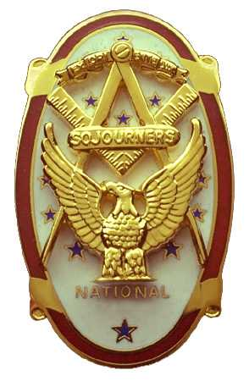 | Olympic Chapter No. 539,  National Sojourners  and  Marvin Shields Camp of Heroes of ‘76 |  |  | 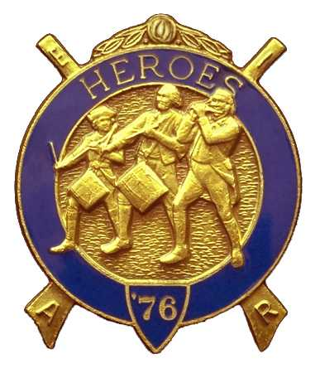
S. Steve Seteroff  Secretary-Treasurer |  |  | PO Box 847  Quilcene, WA 98376
seteroff@earthlink.net |  | http://www.telebyte.com/masons/sojourn/ | (360) 765-3050

October 25, 2006

Twenty-eight members and guests gathered at the Paradise Restaurant for our annual Dining Out and meeting. President Ed Marion opened the chapter meeting, with Franklin Benson attending the Bible. Marion Windell delivered the Toast to the Flag.

Following introduction fo visitors, Marion Windell offered a toast to the President of National Sojourners. Franklin Benson offered the response.

We remain solvent and the treasury stands at $2,779.70, which includes $627.00 committed to the 2007 Youth Leadership Conference and $750.00 in Dining Out ticket sales revenue. No bills remain outstanding.

John Richardson offered a toast to the National Commander and Paul Carmean responded.

Since the last meeting, we have recorded two Bridge of Light and two Americanism performances.

David Larson offered a toast to the MW Grand Master of F&AM of Washington. Darel Maxfield, DDGM in District 11 responded.

We were pleased to accept the application of Brother Ronald Chase. Bud Porter reports two additional applications are in the works.

Col. William Biscomb offered a toast to Our Prisoners of War and Missing in Action. AKCS Cathy MacNeil responded.

Steve Seteroff reported that the 2007 Youth Leadership Conference commitments to date include Port Townsend Lodge (2), Quilcene-Jefferson Lodge (2), Mt. Olympus Lodge (3), and Scottish Rite Bremerton Valley (2). At this point Olympic Chapter has funds set aside for two and expects to fund at least one additional billet, depending on raffle proceeds. We should be able to contribute 12 billets from the Olympic Peninsula.

David MacNeill reported the National Sojourners 2007 Essay Contest was in progress.

Digger O’Dell offered a toast to our Departed Brethren who served our country. LCDR Stephen Seyl responded.

Our guest speaker was LT Shaun Anderson, SC, USN who recently returned from a tour of duty at Tigrit, Iraq with EOD MU-11. He spoke of the daily events and the quiet valor of those who are deployed. He made himself available to questions and Brother Vice stepped in after a lengthy period in order to allow our speaker an opportunity to partake of the main course.
Following desert, LT Shaun Anderson offer a toast to The President of the United States. LCDR Digger O’Dell responded.

Following announcements, door prizes were awarded, and the raffle raised $65 to add to the YLC Reserve.

Our next meeting will be our annual dining out at Noon on Wednesday, November 15 at the Paradise Restaurant in Sequim.

The meeting was closed by President Ed Marion. Steve Seteroff delivered Old Glory and offered a toast to the United States of America.

Steve Seteroff
Secretary-Treasurer

