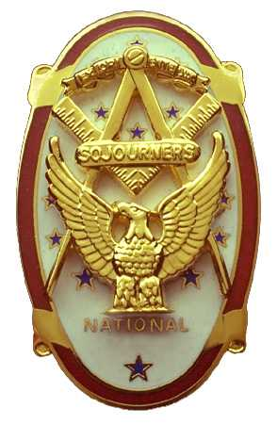 | Olympic Chapter No. 539,  National Sojourners  and  Marvin Shields Camp of Heroes of ‘76 |  |  | 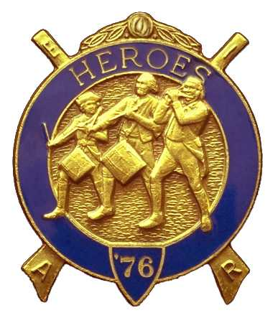
S. Steve Seteroff  Secretary-Treasurer |  |  | PO Box 847  Quilcene, WA 98376
seteroff@earthlink.net |  | http://www.telebyte.com/masons/sojourn/ | (360) 765-3050

September 27, 2006

Nineteen members and guests gathered at the Paradise Restaurant for our usual luncheon meeting. President Ed Marion opened the chapter meeting, with Franklin Benson attending the Bible. We remain solvent and the treasury stands at $2,008.04, which includes $566.00 committed to the 2007 Youth Leadership Conference and $225.00 in Dining Out ticket sales revenue. No bills remain outstanding.

Since the last meeting, we have performed one Building of the Flag for the District 11 Meeting and two Toasts to the Flag. One performance was by Fred Johnson at Port Angeles Fill-the-Lodge Night, and Steve Seteroff performed the Toast at Port Townsend Lodge.

We were pleased to accept the application of VW William Ray Heckman, a Past District Deputy, and initiated him as he is departing for Arizona before our next scheduled meeting. Bud Porter reports three additional applications are in the works.

Steve Seteroff reported that the 2007 Youth Leadership Conference commitments to date include Port Townsend Lodge (2), Quilcene-Jefferson Lodge (2), and Mt. Olympus Lodge (2). At this point Olympic Chapter has funds set aside for two and expects to fund at least one additional depending on raffle proceeds.

David MacNeill was not available to report on the National Sojourners 2007 Essay Contest but he was making significant progress before departure on his current trip.

Dining Out tickets sales are proceeding at the usual pace.

Final planning for the October 5 Historic Flag Program, Ritual Flag Disposal, and Replacement Flag Dedication at Sequim Lodge, open to the public, was finalized.

Ed Marion announced that we have a Washington Cruiser Flag and proudly pointed out the new, historically accurate, Bennington Flag requested by Joe Illes. Joe Illes being absent from the inaugural display of the new flag was fined $10 in absentia.

Following announcements, door prizes were awarded, and the raffle raised $55 to add to the YLC Reserve.

Our next meeting will be our annual dining out at 1800 on Wednesday, October 25 at the Paradise Restaurant in Sequim.

Steve Seteroff
Secretary-Treasurer

