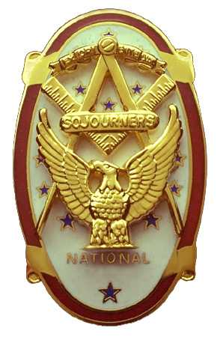 | Olympic Chapter No. 539,  National Sojourners  and  Marvin Shields Camp of Heroes of ‘76 |  |  | 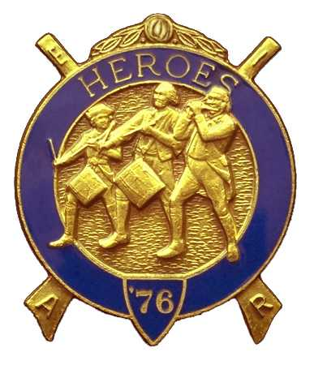
S. Steve Seteroff  Assistant Sec-Treas |  |  | PO Box 847  Quilcene, WA 98376
seteroff@earthlink.net |  | http://www.telebyte.com/masons/sojourn/ | (360) 765-3050

August 23, 2006

Twenty-four members and guests gathered at the Paradise Restaurant for our usual evening meeting. President Ed Marion opened the chapter meeting, with Franklin Benson attending the Bible. We remain solvent and the treasury stands at $2,045.19, which includes $456.00 committed to the 2007 Youth Leadership Conference. No bills remain outstanding.

Since the last meeting, we have performed two Toasts to the Flag. One performance was by Fred Johnson at the visit of our Grand Master to Sequim Lodge, and Franklin Benson reported performing the Toast to the Port Angeles yacht Club on July 4.

Bud Porter reported that we are expecting several petitioners. One was unable to join us this evening die to personal reasons. The chapter voted a MIP for our Brother John Vai, who is currently under the care of the Masonic Home.

Steve Seteroff reported that the 2007 Youth Leadership Conference will hold the line on scholarships at $250 per high school junior. We have again invited the lodges in District 11 to participate by sponsoring at least one junior from a high school in their area. The letters to the lodge secretaries were mailed on August 23.

David MacNeill reported that the National Sojourners 2007 Essay Contest is being advertised informally and he already has several applicants. We have invited the lodges in District 11 to participate by making the information available to high school in their area. The letters to the lodge secretaries were mailed on August 23.

The president reported that he is having difficulty in obtaining the Washington Cruisers Flag to complete our Historical Flag Set, and again stated that our Bennington Flag is not properly configured as it improperly displays the stripes and the stars are five instead of seven pointed.

[The secretary contacted a flag company and was able to obtain a properly configured Bennington Flag and the correct Washington Cruisers Flag at a cost of $93.60. They will be here in time for our next meeting and the next performance of the Historical Flags scheduled for October 5]

Following announcements, door prizes were awarded, and the raffle raised $110 to add to the YLC Reserve.

Our next meeting will be at 1200 on Wednesday, September 20 at the Paradise Restaurant in Sequim.

Steve Seteroff
Secretary-Treasurer

