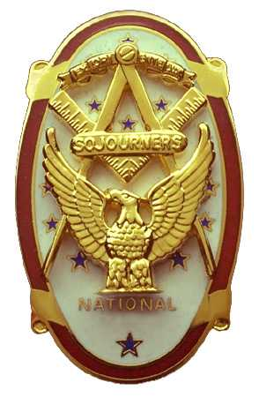 | Olympic Chapter No. 539,  National Sojourners  and  Marvin Shields Camp of Heroes of ‘76 |  |  | 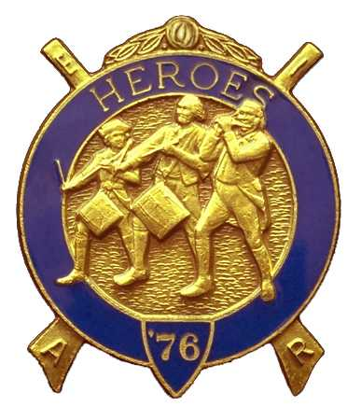
S. Steve Seteroff  Assistant Sec-Treas |  |  | PO Box 847  Quilcene, WA 98376
seteroff@earthlink.net |  | http://www.telebyte.com/masons/sojourn/ | (360) 765-3050

June 28, 2006

Seventeen members and guests gathered at the Paradise Restaurant for our usual evening meeting. President Ed Marion opened the chapter meeting. We remain solvent and the treasury stands at $1,816.56, which includes $336 committed to the 2007 Youth Leadership Conference. No bills remain outstanding.

Since the last meeting, we have performed 6 Toasts to the Flag, all but one under Bridge of Light, one rendition of Old Glory, and two Patriotism speeches. We performed the Building of the Flag for the State DAR Convention in Seattle on June 1, 2006, modified to deliver the Toast to the Flag and the Pledge of Allegience by Fred Johnson. This was followed by the Patriotism speech by David MacNeill, before beginning the Building of the Flag. Don Patrick delivered the introduction, Fred Johnson performed the narratyion, and Steve Seteroff delivered the Old Glory monologue.

Five juniors from the Olympic Peninsula will be attending the Youth Leadership Conference this year. Port Townsend Lodge No. 6 has sponsored Forest Little of Port Townsend High School. Our chapter has sponsored Evelyn Cox of Port Townsend High School, Cadet Kyle Carlson of Port Angeles NJROTC. Jade Williams and Alyssa Greene from Neah Bay High School were scheduled but did not participate. The unused scholarships were transferred to Port Angeles NJROTC Cadets Virginia Brady and Josie McGahan.

Robert K. Clubb, WM of Quilcene-Jefferson Lodge, was initiated at a special communication of our chapter authorized by the Area Representative Wayne Smith on June 10, 2006. He received his medal but was not present at this meeting to receive his dues card, which remains pending from National Sojourners.

William Biscomb, the outgoing President of our sponsoring chapter Sinclair Inlet No. 80 has extended an invitation for Olympic Chapter to join them at a Mongolian BBQ at their home in Quilcene on Saturday, July 8.

Chester Olszta is still assembling a cadre of Heroes in continental uniform for participation in station and places in the annual outdoor Master Mason Degree at Granite Falls on August 5. If you are available, please give Chester a call at (360) 331-7915 or drop him an email at colszta@whidbey.com.

Following announcements, door prizes were awarded, and the raffle raised $60 to add to the YLC Reserve.

Our next meeting will be at 1200 on Wednesday, July 26 at the Paradise Restaurant in Sequim.

Steve Seteroff
Secretary-Treasurer

