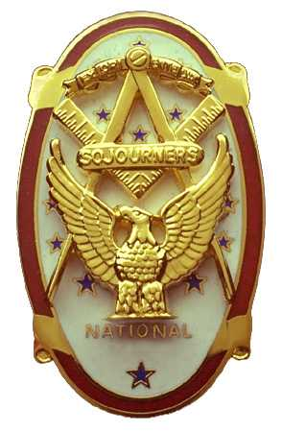 | Olympic Chapter No. 539,  National Sojourners  and  Marvin Shields Camp of Heroes of ‘76 |  |  | 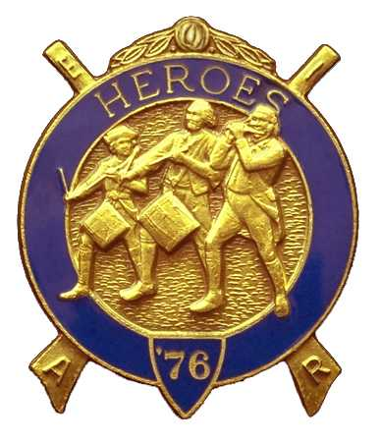
S. Steve Seteroff  Assistant Sec-Treas |  |  | PO Box 847  Quilcene, WA 98376
seteroff@earthlink.net |  | http://www.telebyte.com/masons/sojourn/ | (360) 765-3050

May 24, 2006

Ten members and guests gathered at the Paradise Restaurant for our usual noon meeting. As is our custom, we began with a Toast to the Flag, delivered by Br. Fred Johnson. President David MacNeill opened the chapter meeting and Don Patrick attended the Bible. We remain solvent and the treasury stands at $1,765.76, which includes $271 committed to the 2007 Youth Leadership Conference. No bills remain outstanding.

Since the last meeting, we have performed 3 Toasts to the Flag, all under Bridge of Light, and two renditions of Old Glory, both under Americanism. We are committed to perform the Building of the Flag for the State DAR Convention in Seattle on June 1, 2006.

Officers elected for 2006-2007 will be installed at the Des Moi8nes Masonic Center on Saturday, June 3, 2006. Informal social begins at 1100 with lunch at 1200, and the installation at 1300. Luncheon is $14 per person and reservations are required. Please contact the incoming Secretary Steve Seteroff to make your reservation.

Olympic Chapter |  | Marvin Shields Camp
President | Ed Marion | Commander | Morris “Mike” Moug
1st VP | Fred Johnson | Chief of Staff | David MacNeill
2nd VP | Darel Maxfield | ACOS | Bud Porter
3rd VP | Morris “Mike” Moug | OOD | Paul Carmean
Chaplain | Clarence Johnson | Chaplain | Clarence Johnson
Secretary-Treasurer | Steve Seteroff | Adjutant | Steve Seteroff

All elected officers will be attending, except for Clarence Johnson who is in Europe.

Five juniors from the Olympic Peninsula will be attending the Youth Leadership Conference this year. Port Townsend Lodge No. 6 has sponsored Forest Little of Port Townsend High School. Our chapter has sponsored Evelyn Cox of Port Townsend High School, Cadet Kyle Carlson of Port Angeles NJROTC, and Jade Williams and Alyssa Greene from Neah Bay High School. Two funded sponsorships were unused and the funds were returned to Quilcene-Jefferson Lodge. The scholarship pledged by Mt. Olympus Lodge was unused. We will be taking an early position on contacting the area high schools and Masonic bodies for 2007 in order to generate more enthusiasm and participation at the school level.

William Biscomb, the outgoing President of our sponsoring chapter Sinclair Inlet No. 80 has extended an invitation for Olympic Chapter to join them at a Mongolian BBQ at their home in Quilcene on Saturday, July 8. You are invited to arrive in the late morning bearing a salad or dessert to share, and your own beverages of choice. Reservations are essential so that our host and hostess can plan for the BBQ that they will provide. Please let the Secretary know that you are coming as we must provide a mouth-count no later than June 30. This is an excellent opportunity to not only enjoy the day but also mingle with members of our sister chapter.

Chester Olszta is still assembling a cadre of Heroes in continental uniform for participation in station and places in the annual outdoor Master Mason Degree at Granite Falls on August 5. If you are available, please give Chester a call at (360) 331-7915 or drop him an email at colszta@whidbey.com.

The raffles conducted during the past year have raised funds for the Youth Leadership Conference scholarships and has done so very effectively. The chapter voted to continue the raffles with proceeds dedicated for the 2007 Youth Leadership Conference. It is noted that we have a residual of $271 to support the first scholarship already.

Following announcements, door prizes were awarded, and the raffle raised $65 to add to the YLC Reserve and $1.00 was donated to the treasury.

Our next meeting will be at 1800 on Wednesday, June 28 at the Paradise Restaurant in Sequim.

Steve Seteroff for
Clarence Johnson on vacation in Europe
Secretary-Treasurer

