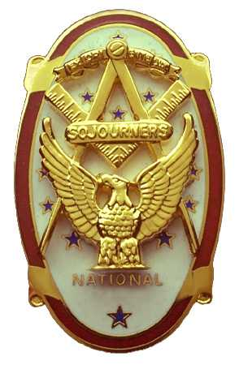 | Olympic Chapter No. 539,  National Sojourners  and  Marvin Shields Camp of Heroes of ‘76 |  |  | 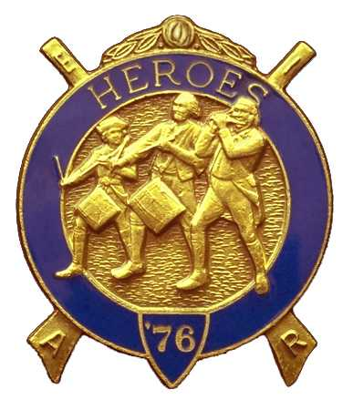
Clarence L. Johnson  Secretary-Treasurer |  |  | 1310 19th Street  Port Townsend, WA 98368
cjohnson@olympus.net |  | http://www.telebyte.com/masons/sojourn/ | (360) 385-6986

April 27, 2006

Twenty-seven members and guests gathered at the Paradise Restaurant last night for our anniversary meeting. We began the meeting with a Toast to the Flag and the Pledge of Allegiance delivered by Bro. Fred Johnson. President David MacNeill opened the chapter meeting and Chaplain Frank Benson attended the Bible. We remain solvent. The beginning balance in the treasury was $3311.36, expenses for guest speaker and husband was $43.04; income of $172.80 from MIP dividend, $115.00 from raffle and $1 for fines leaves a balance of $3557.12 which includes $2066.00 committed to the MOWW Youth Leadership Conference. No bills remain outstanding.

Minutes of the previous meeting were approved.

President Dave MacNeill reported on the Bridge of Light that WB Fred Johnson gave a Toast to the Flag at the Mt Olympus Stated meeting on April 1st.
Secretary Clarence Johnson reminded the contact leaders for the YLC to get in touch with the schools ASAP for names.

Unfinished Business: Norm Bright was inducted into Chapter 539 with Commander Ed Marion giving the Medal Lecture.

New Business: Election of officers for 2006-2007 were held.
Officers for Olympic Chapter 539 are:
President: Ed Marion
First Vise President: Fred Johnson
Second Vise President: Darrell Maxfield
Third Vise President: Morris “Mike” Moug
Chaplain: Clarence Johnson
Secretary-Treasurer: S. Steve Seteroff

Marvin Shields Camp of Heroes of ’76 are:
Commander: Morris “Mike” Moug
Chief of Staff: David MacNeill
Assistant COS: “Bud” Porter
Officer of the Day: Paul Carmean
Chaplain: Clarence Johnson
Adjutant: S. Steve Seteroff

President Dave MacNeill then introduced our guest speaker for the night: Bett Houston who asked, “Are You Just a Potato”? She spoke on the rewards of searching your geneology and gave several hints for finding the correct sources to document your findings.

Announcements:
Installation of next year’s officers will be June 3rd at the Des Moines Masonic Center. Anticipated cost is $10-$15. Schedule is: 1100 hr Social Hour, 1200 hr Luncheon, 1300 hr Meeting. Due to caterer considerations, it is necessary that we receive an RSVP no later than May 27th. Please call Bob Colton @ 206-439-2320 or Al Luberts at 206-799-7973.

The next meeting will be held on May 24th at 1200 hours in the Paradise Restaurant, Sequim WA.

Following announcements, door prizes were awarded, and the raffle raised $115 to add to the YLC Reserve.

The meeting was closed per Order of Ceremony.

Clarence Johnson
Secretary-Treasurer

