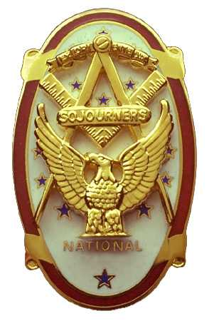 | Olympic Chapter No. 539,  National Sojourners  and  Marvin Shields Camp of Heroes of ‘76 |  |  | 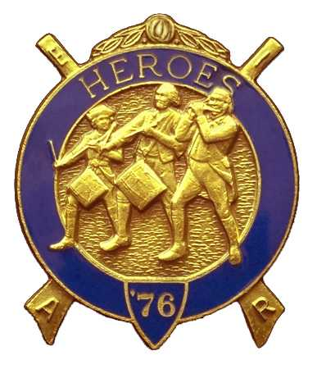
Clarence L. Johnson  Secretary-Treasurer |  |  | 1310 19th Street  Port Townsend, WA 98368
cjohnson@olympus.net |  | http://www.telebyte.com/masons/sojourn/ | (360) 385-6986

March 22, 2006

Sixteen members and guests gathered at the Paradise Restaurant for our noon meeting. We began the meeting with a Toast to the Flag and the Pledge of Allegiance delivered by Bro. Fred Johnson. President David MacNeill opened the chapter meeting and Chaplain Frank Benson attended the Bible. We remain solvent and the treasury stands at $3,234.36, which includes $1,951.00 committed to the MOWW Youth Leadership Conference. No bills remain outstanding. We received $70 from the raffle and $7 in fines.

A candlelight memorial was held for our late brother John J. Freitas. Brother Steve Seteroff represented the red candle, brother Fred Johnson, the white, and brother John Richardson the blue candle.

Minutes of the previous meeting were approved.

President Dave MacNeill reported on the Bridge of Light that Brother Fred Johnson gave the Toast to the Flag at the “Fill-the-lodge” night at Quilcene/Jefferson stated meeting.

Brother Steve Steroff reported on the Youth Leadership Conference. The 4 billets from Port Angeles have been withdrawn due to unforeseen boiler problems. All schools have received their packets.

Unfinished Business: Norm Bright will be inducted at the April meeting.

New Business: Brother Wendell Dutt reported that all material for the National Convention, to be held in Austin Texas June 13-17 has been received. Olympic Chapter still needs someone to represent them at that meeting. We need a volunteer.

Announcements:
Election of next year’s officers will be in April. Anyone wishing to file should let the Secretary know before April 20th.

The April meeting will be held at 1800 hours at the Paradise Restaurant in Sequim. Bett Houston will be the guest speaker: “Are You Just a Potato”?

Following announcements, door prizes were awarded, and the raffle raised $70 to add to the YLC Reserve.

The meeting was closed per Order of Ceremony and Brother Steve Seteroff gave “Old Glory”.

Clarence Johnson
Secretary-Treasurer

