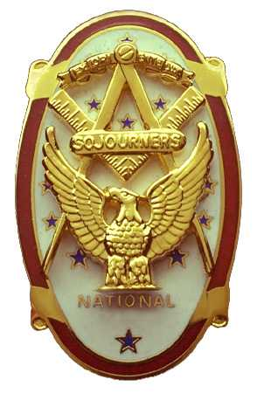 | Olympic Chapter No. 539,  National Sojourners  and  Marvin Shields Camp of Heroes of ‘76 |  |  | 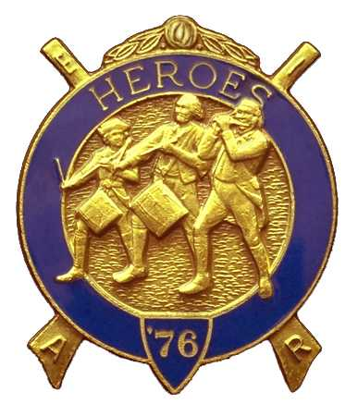
Clarence L. Johnson  Secretary-Treasurer |  |  | 1310 19th Street  Port Townsend, WA 98368
cjohnson@olympus.net |  | http://www.telebyte.com/masons/sojourn/ | (360) 385-6986

February 22, 2006

Twenty one members and guests gathered at the Paradise Restaurant for our evening meeting. We began the meeting with a Toast to the Flag, delivered by Bro. Fred Johnson. President David MacNeill opened the chapter meeting and Chaplain Frank Benson attended the Bible. We remain solvent and the treasury stands at $3,158.13, which includes $1,845.00 committed to the MOWW Youth Leadership Conference. No bills remain outstanding.

President Dave MacNeill reported on the Bridge of Light: The History of the Flag presentation made at the Grand Masters’ Official Visit to District #11 was well received. This was the first time that we had conducted this ceremony. Several ways to improve the presentation were identified and will be addressed at the next ceremony. Bro. Fred Johnson gave the Toast to the Flag at the Port Townsend special meeting on Feb. 17th.

Bro. Norman Bright was sick and unable to attend the evening’s activities, so his initiation into the National Sojourners is postponed until the April meeting.

Special guests were VWB Chuck Compton Deputy of the Grand Master in District #12 and Bro. Gordon Sumner, Past Master of Steadfast Lodge, who gave a very interesting slide show on the Japanese Attack on Pearl Harbor, December 7th, 1941.

WB Steve Seteroff expanded on a letter we had received from WB Joe Illes, President of NASOCOCO, asking for our support if the National Convention of National Sojourners were to be held in the Northwest in 2010. No specific funds are requested, however, we would need to provide bodies. We would assist in planning outings for the guests. It was moved; seconded and passed that Olympic Chapter 539 would support such an endeavor.

Announcements:
March meeting will be at the Paradise Restaurant at 1200 hours. Election of next year’s officers will be in March. Anyone wishing to file should let the Secretary know before March 22nd.

The April meeting will be held at 1800 hours at the Paradise Restaurant in Sequim. Bett Houston will be the guest speaker: “Are You Just a Potato”?

Following announcements, door prizes were awarded, and the raffle raised $106 to add to the YLC Reserve.

The meeting was closed per Order of Ceremony with President Dave MacNeill presenting a monolog in lieu of “Old Glory”. The monologue consisted of excerpts from the pre-amble of the Monitor and emphasized Love of Country and Patriotism.

Clarence Johnson
Secretary-Treasurer

