 | Olympic Chapter No. 539,  National Sojourners  and  Marvin Shields Camp of Heroes of ‘76 |  |  | 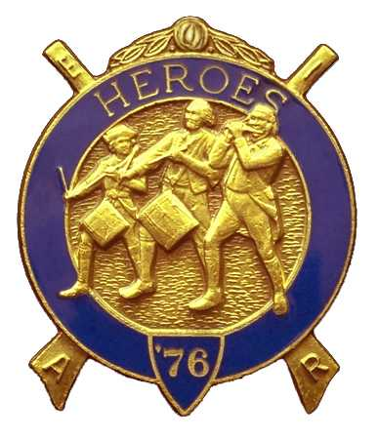
S. Steve Seteroff  Assistant Sec-Treas |  |  | PO Box 847  Quilcene, WA 98376
seteroff@earthlink.net |  | http://www.telebyte.com/masons/sojourn/ | (360) 765-3050

October 26, 2005

Twenty members and guests gathered at the Paradise Restaurant for the second annual dining out meeting. As is our custom, we began with a Toast to the Flag, delivered by Br. Fred Johnson. President David MacNeill opened the chapter meeting and attended the Bible. We remain solvent and the treasury stands at $1,831.79, which includes $500 committed to the MOWW Youth Leadership Conference. No bills remain outstanding.

Camp Commander Ed Marion reported on the PNW Area Encampment and presented certificates of appreciation to three ladies for their efforts in coordinating and operating the hospitality suite. Kathy MacNeill, Janet Marion, and Joyce Seteroff were recognized.

House keeping activities were conducted between courses and the traditional seven toasts were made.

Due to the success of the PNW Area Encampment, and the largess of our members we have exceeded the required $500 for MOWW Youth Leadership Conference scholarships. The chapter voted to approve a third scholarship and Bud Porter promptly contributed $100 to get it started.

Our chapter has been asked to perform the Building of the Flag for the National DAR Convention in Seattle on June 4, 2006. We were delighted to accept the verbal request.

Following announcements, door prizes were awarded, and the raffle raised $75 to add to the YLC Reserve and $57.19 remained in front of the secretary following the meeting to further expand the treasury. The generosity of our brothers has already funded the third YLC scholarship for 2006.

Our next meeting will be at High Noon on Wednesday, November 16 at the Paradise Restaurant in Sequim. Please remember that our by-laws specify the November and December meeting will be on the third Wednesday to avoid conflicting with the holidays.

Steve Seteroff
For
Clarence Johnson
Secretary-Treasurer

