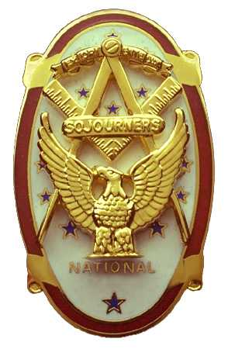 | Olympic Chapter No. 539,  National Sojourners  and  Marvin Shields Camp of Heroes of ‘76 |  |  | 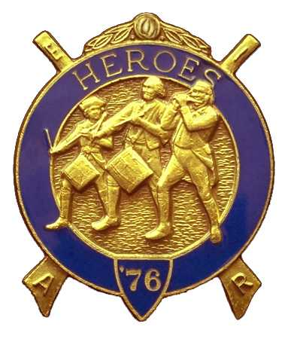
S. Steve Seteroff  Assistant Sec-Treas |  |  | PO Box 847  Quilcene, WA 98376
seteroff@earthlink.net |  | http://www.telebyte.com/masons/sojourn/ | (360) 765-3050

September 28, 2005

Fifteen members and guests gathered at the Paradise Restaurant for the first luncheon meeting of the fall. As is our custom, we began with a Toast to the Flag, delivered by Br. Fred Johnson. President David MacNeill opened the chapter meeting and attended the Bible. We remain solvent and the treasury stands at $4,575.09 which includes NPW Encampment Registrations and Flag Fund reserves.

Camp Commander Ed Marion encouraged all to attend the Pacific Northwest Area Encampment at Pacific Beach on September 30 to October .

Some discussion took place regarding the need to have better chapter representation at the National Convention in June and the Mid-winter meeting in January each year. The design of each is to have the President and Secretary attend and we have been represented by other members of the chapter, but not our officers and not our local members.

The chapter passed a resolution to earmark our raffle proceeds to fund sending students to the MOWW-National Sojourners Youth Leadership Conference after the flag set is paid for. Steve Seteroff is to obtain the information and make it available.

Following announcements, door prizes were awarded, and the raffle raised $65 to assist in our activities.

Our next meeting will be our annual Dining Out at 1800 on Wednesday, October 26 at the Paradise Restaurant in Sequim.

Steve Seteroff
For
Clarence Johnson
Secretary-Treasurer

