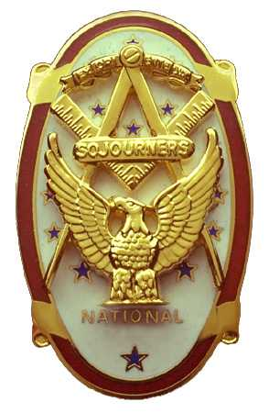 | Olympic Chapter No. 539,  National Sojourners  and  Marvin Shields Camp of Heroes of ‘76 |  |  | 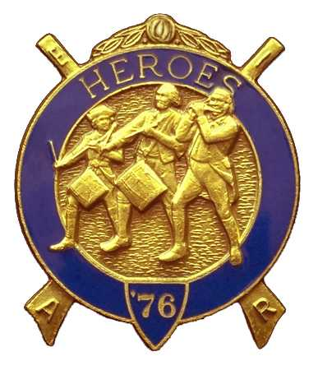
Clarence L. Johnson  Secretary-Treasurer |  |  | 1310 19th Street  Port Townsend, WA 98368
cjohnson@olympus.net |  | http://www.telebyte.com/masons/sojourn/ | (360) 385-6986

April 27, 2005

This is the 2nd anniversary of the formation of Olympic Chapter 539. Mary Lou Montgomery and “The Good Times” provided music during the social hour and dinner. There were 20 members and guests present.

President John Jones opened the chapter meeting with Br. Franklin Benson attending the Bible. Br. Mike Pursey, president of Sinclair Inlet Chapter #80, was recognized and presented a certificate in appreciation of Sinclair Inlet being our sponsoring chapter. Bros. Steve Seteroff, Dee Yager, and Clarence Johnson received certificates of appreciation for their service to the Chapter this past year.

Bro. Darel Maxfield was initiated into Olympic Chapter #539 and presented with his MIP certificate. Br. John Jones gave the lecture and medal lecture.

Committee reports were received amid an atmosphere of cheer and good will as we engaged in friendly banter. It was reported that National Sojourners were recognized and honored by the Port Townsend OES at their last stated meeting. Bro. Steve Seteroff spoke on behalf of MWB Jimmy Reid, Jr. on the Youth Leadership Foundation. Due to last minute conflicts, our Guest Speaker YN1(SS) Karl Rosenkranz, was unable to attend. Bro. Steve spoke on the role of members, not officers, as being the leaders of an organization. We need to recognize that we can’t please all of the people all of the time, but we must do our part. Leadership can happen at any level.

Ballots were spread and the following officers were elected for the ensuing year: Olympic Chapter #539: President: David MacNeill; 1st Vice President: Ed Marion; 2nd Vice President: Fred Johnson; 3rd Vice President: Darel Maxfield; Chaplain: Frank Benson; Secretary-Treasurer: Clarence Johnson. For Marvin Shields Camp of Heroes of ’76: Commander: Ed Marion; Chief of Staff: John Jones; Assistant COS: David Larson; Officer of the Day: Mike Moug; Chaplain: Frank Benson; Adjutant: Clarence Johnson.

Bro. Steve encouraged early registration at Pacific Beach for this fall. The meeting will be held September 30 – October 2, 2005 at the U.S. Navy’s Pacific Beach Resort and Conference Center.

Everyone was reminded of the Joint Installation of Officers scheduled for June 4th at the Des Moines Masonic Center in Des Moines, WA,

Following announcements, door prizes were awarded and the raffle raised $90 to assist in our purchase of a set of flags. Br. Paul Carmean won the silver money clip offered as a silent auction.

Br. Steve Seteroff honored our closing custom by delivering the Old Glory monologue. Following which, the meeting was closed by President John Jones with Br. Franklin Benson attending the Bible,

Clarence Johnson
Secretary-Treasurer

