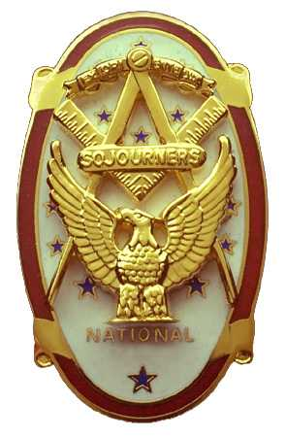 | Olympic Chapter No. 539,  National Sojourners  and  Marvin Shields Camp of Heroes of ‘76 |  |  | 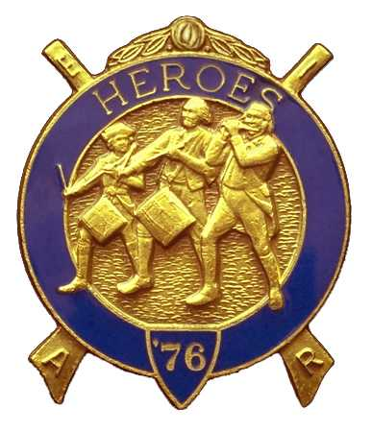
Clarence Johnson  Secretary-Treasurer |  |  | 1310 19th Street  Port Townsend, WA  98368
cjohnson@ olympus.net |  | http://www.telebyte.com/masons/sojourn/ | (360) 385-6986

March 23, 2005

The meeting was called to order by Bro. John Jones at 1255 hour. Bro. Frank Benson gave the prayer and Bro Fred Johnson gave the Toast to the Flag. There were 9 members and visitors present.

Unfinished Business: The April dinner meeting will be the 2nd Anniversary for the Chapter. Music is confirmed for the grip-n-grin portion. We will have a guest speaker.

Americanism:
March 8th: Fred, Steve and Clarence built the flag for a Boy Scout Troop in Port Townsend.
March 16th: John Jones gave Old Glory at DeMolay in Port Angeles. John also received his 50 year pin as a member of DeMolay at that meeting.
May 19th: Will Build Flag two times in Forks.
July ?: Will Build Flag for the Kala Point Membership meeting.

Unfinished Business:
It was determined that we do not have the funds to support a representative to the Youth Leadership conference at Pacific Lutheran University this year.

New Business:
Brother Chester Olszta (Acting Commander for the Pacific Beach Bivouac in October 2005) identified the following items to be addressed:
- Need committee to track Pacific Beach Activities.
- Need to issue order to Brother for Pac. Beach.
- Need leader for Camp Followers. (Perhaps Mary Campbell?)
- In May, need to go to Pac Beach to set up Flag Building Schedules. (Bro Ed Marion and Chester agreed to take the lead. Remember: Ft. Lewis Chapter is planning to build the flag on Friday evening.)
- Need to send letters to National Officers inviting them to Pac. Beach. The Chapter needs to decide which National Officer(s) are “invited” guests. It was moved, seconded and passed that we will pay the meals and registration ($81/pp) only for the National Line Officers who accept the formal invitation.
- Need to select Guest Speaker: (suggested: All Jorganson, Bill Woods, Vern Wertz)
- Need to establish leader for Hospitality Room. WB Al Avery will help but does not want to be stuck there 24/7.

Olympic Chapter 539 is the Host Chapter for the joint Installation of Officers on June 4th in Des Moines Lodge. The following items need to be determined:
- Check again for reservations.
- Who is caterer: Cost?
  - Mike Bonneyham (conflict?)
  - Longhorn
  - Des Moines OES
- Who is guest speaker: Grand Lodge Line Officer: Chuck, Sat, Dave Owens:

Be aware that Area Representative Wayne Smith will be sending the Chapter a bill for the following:
- National Convention Program
- Open House at Grand Lodge in June.

Good of the Order:
April 9th: Joint Bivouac at Bremerton Elks at 1000 hour.

There being no further business, Bro. Clarence Johnson gave the Old Glory presentation and Bro. John Jones closed the Chapter with peace and harmony prevailing at 1410 hour.

Repectfully Submitted:

Clarence Johnson,
Secretary

