 | Olympic Chapter No. 539,  National Sojourners  and  Marvin Shields Camp of Heroes of ‘76 |  |  | 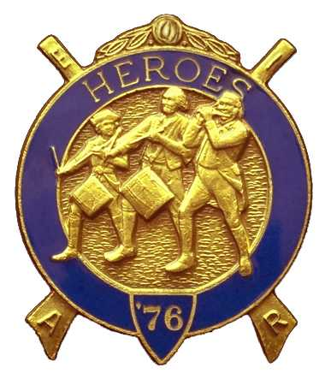
Clarence Johnson  Secretary-Treasurer |  |  | 1310 19th Street  Port Townsend, WA 98368
Cjohnson@olympus.net |  | http://www.telebyte.com/masons/sojourn/ | (360) 385-6986

February 23, 2005

The meeting was called to order by Bro. John Jones at 7:37 PM. Bro. Frank Benson gave the prayer and Bro. Dave MacNeill gave the Toast to the Flag. There were 17 members and visitors present.

President John Jones conducted the Candlelight Service in memory of Bro. Don Clark.

Unfinished Business: The April dinner meeting will be the 2nd anniversary for the Chapter. Music is confirmed for the grip-n-grin portion. We will have a guest speaker.

New Business:
Bro. Bob Mitchell, member of the Military Order of the World Wars, urged the Chapter to participate in the Youth Leadership Conference to be held this year at Pacific Lutheran University in Parkland. He brought the wrong pamphlet and will send one to us as soon as he gets home.

There was discussion about the ROTC Award. Emphasized the need to select a Junior so he/she will be back next year to stimulate continued interest.

Americanism: Will build Flag for Port Townsend Boy Scouts in March. Two sessions scheduled for Forks in May.

A petition for membership from Darel Maxfield was read. By unanimous ballot he was elected a member of Olympic Chapter 539 of the National Sojourners. Initiation will be at the April meeting.

Bro. Fred Johnson identified a possible conflict for the bivouac scheduled for April 9th, since Quilcene Lodge will be conducting a 1 day conferral.
Good of the Order:
Brother Mike Dew, Worshipful Master of Quilcene/Jefferson Lodge, and his wife Gisselle were introduced as guests.

VWB Dee Yager was reported in the hospital with respiratory problems.

WB Steve Seteroff is absent because he and his wife are celebrating their 40th wedding anniversary.

There being no further business, Bro. Clarence Johnson gave the Old Glory presentation and Bro. John Jones closed Chapter at 20:45 hour.

