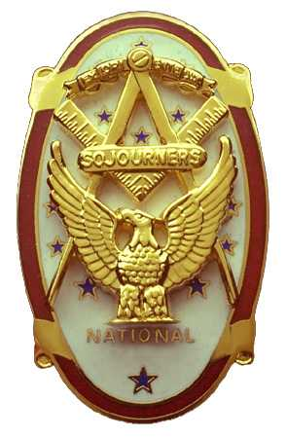 | Olympic Chapter No. 539,  National Sojourners  and  Marvin Shields Camp of Heroes of ‘76 |  |  | 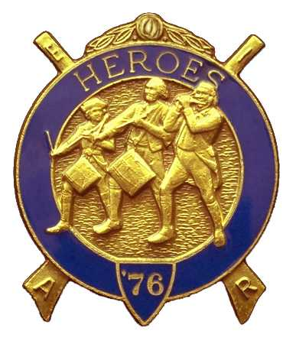
Clarence Johnson  Secretary-Treasurer |  |  | 1310 19th Street  Port Townsend, WA 98368
Cjohnson@olympus.net |  | http://www.telebyte.com/masons/sojourn/ | (360) 385-6986

January 26, 2005

The meeting was called to order by Bro. John Jones. Bro. Frank Benson gave the prayer and Bro. Fred Johnson gave the Toast to the Flag. There were 15 members and visitors present.

Unfinished Business: after some discussion, it was moved, seconded and passed that we use the raffle funds to augment donations for the Flag fund until the $500 is raised.

Bro. Don Patrick submitted his resignation as 2nd Vice President since they are moving and he will not be able to attend. It was agreed that Bro. Ed Marion would move from 3rd to 2nd VP.

Bro. Steve Seteroff moved and it was seconded that we have an anniversary party as part of our April evening meeting. The consensus was that we receive greater support from other chapters by holding special celebrations and it also induces more of our members to attend.

The motion passed. Steve will do the program, Fred will arrange for music.

Bro. Joe Illes discussed the National Convention to be held in Bloomington, Minnesota June 21-25th. Bro. Frank Benson announced that the host Chapter is also his home Chapter. He also anticipated that annual dues will be raised and urged everyone to get their MIP prior to the increase.

Olympic Chapter was asked to hold off their planning for the Building of the Flag at Pacific Beach this fall. Ft. Lewis Chapter is developing a special ceremony.

There being no further business, Bro. Clarence Johnson gave the Old Glory presentation and Bro. John Jones closed Chapter at 1345 hour.

