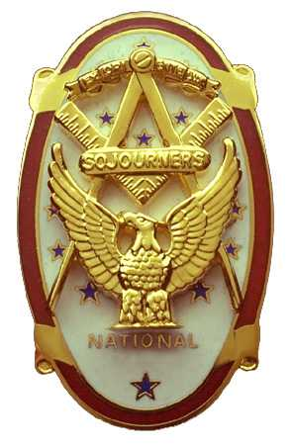 | Olympic Chapter No. 539,  National Sojourners  and  Marvin Shields Camp of Heroes of ‘76 |  |  | 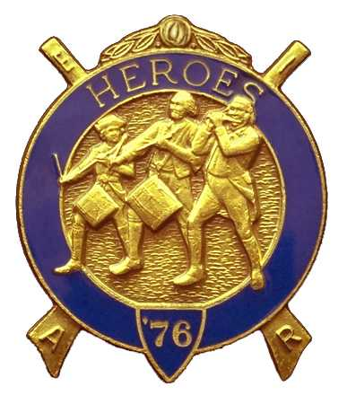
Clarence Johnson  Secretary-Treasurer |  |  | 1310 19th Street  Port Townsend, WA 98368
Cjohnson@olympus.net |  | http://www.telebyte.com/masons/sojourn/ | (360) 385-6986

December 15, 2004

Thirteen members and guests gathered at the Paradise Restaurant in Sequim for a Dining Out. We regret that several were unable to attend due to last minute changes and the pressures of the Holiday Season.

As is our custom, we began with a Toast to the Flag, delivered by Bro. Don Patrick. President John Jones opened the chapter meeting with Br. Franklin Benson attending the Bible. We remain solvent and the treasury stands at $746.92 with accounts payable and receivable outstanding.

Committee reports were received amid an atmosphere of cheer and good will as we engaged in friendly banter. Brothers are working on programs for Port Townsend Boy Scouts, P.T. Girl Scouts, P.T. Elks in July 05 and Soroptimists Club in Forks. Dates have not been finalized at this time.

Ed Marion had identified a potential conflict at Pacific Beach next October since the National York Rite Body will also be holding its annual convention. After discussion, it was determined that there will not be a problem.

A query had been sent from our Area Representative, Wayne Smith, regarding the induction of Chuck McQuery into Hero’s Camp in October, also who was inviting GM Al Jorgensen to be the guest speaker. It was determined that Ed Marion would respond to the query.

Discussion followed about purchasing a set of flags for future presentations. The total cost will be around $500. Ed Marion agreed to lead the movement.

Following announcements, door prizes were awarded and the raffle raised $50 to assist in our activities. $71 was contributed towards the purchase of the set of flags. Thank you to all who participated
There being no further business, the meeting was closed by President John Jones with Br. Franklin Benson attending the Bible,

Our next meeting will be at Noon on Wednesday, January 26, 2005 at the Paradise Restaurant in Sequim

Clarence Johnson
Secretary-Treasurer

