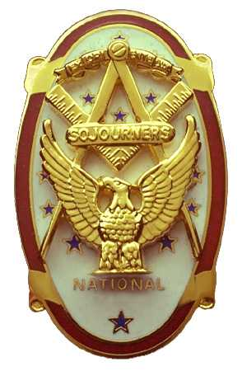 | Olympic Chapter No. 539,  National Sojourners  and  Marvin Shields Camp of Heroes of ‘76 |  |  | 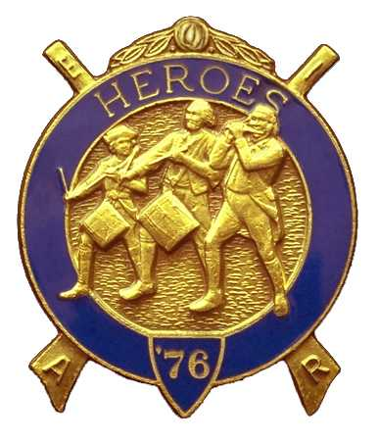
Clarence Johnson  Secretary-Treasurer |  |  | 1310 19th Street  Port Townsend, WA 98368
cjohnson@olympus.net |  | http://www.telebyte.com/masons/sojourn/ | (360) 385-6986

Minutes for November 17, 2004 Meeting

Twelve members and guests gathered at the Paradise Restaurant in Sequim for lunch and camaraderie.

As is the custom, we began with a Toast to the Flag, delivered by Br. Fred Johnson. President John Jones opened the chapter meeting with Br. Franklin Benson attending the Bible.

There were three Americanism ceremonies this past month and two Bridges of Light performed at Masonic functions.

Discussion followed a proposal to raise approximately $500 to purchase all of the flags of the U.S.A. It was the consensus of the members to pursue this endeavor but no plan of attack was specified.

It was agreed that we should have an Honor Guard for burial ceremonies. Br. Bud Porter offered to chair this project with John Jones, Roy Scott, Fred Johnson, Dee Yager, Dave MacNeill and Clarence Johnson volunteering to assist.

Under Sickness and Distress, it was reported that Br. Don Clark was in a car accident and Br. Bob Austin was in the hospital for blood transfusions.

Following announcements, door prizes were awarded and the raffle raised $50 to assist in our activities. Thank you to all who participated.

Br. John Jones honored our closing custom by delivering the Old Glory monologue. Following which, the meeting was closed by President John Jones with Br. Franklin Benson attending the Bible.

Our next meeting will be Dec. 15th at 1800 hours at the Paradise Restaurant.

We broke formality and many of the brethren and guest engaged in dialogue and camaraderie before proceeding on our usual pursuits.

Clarence Johnson,
Secretary

